SI Appendix I
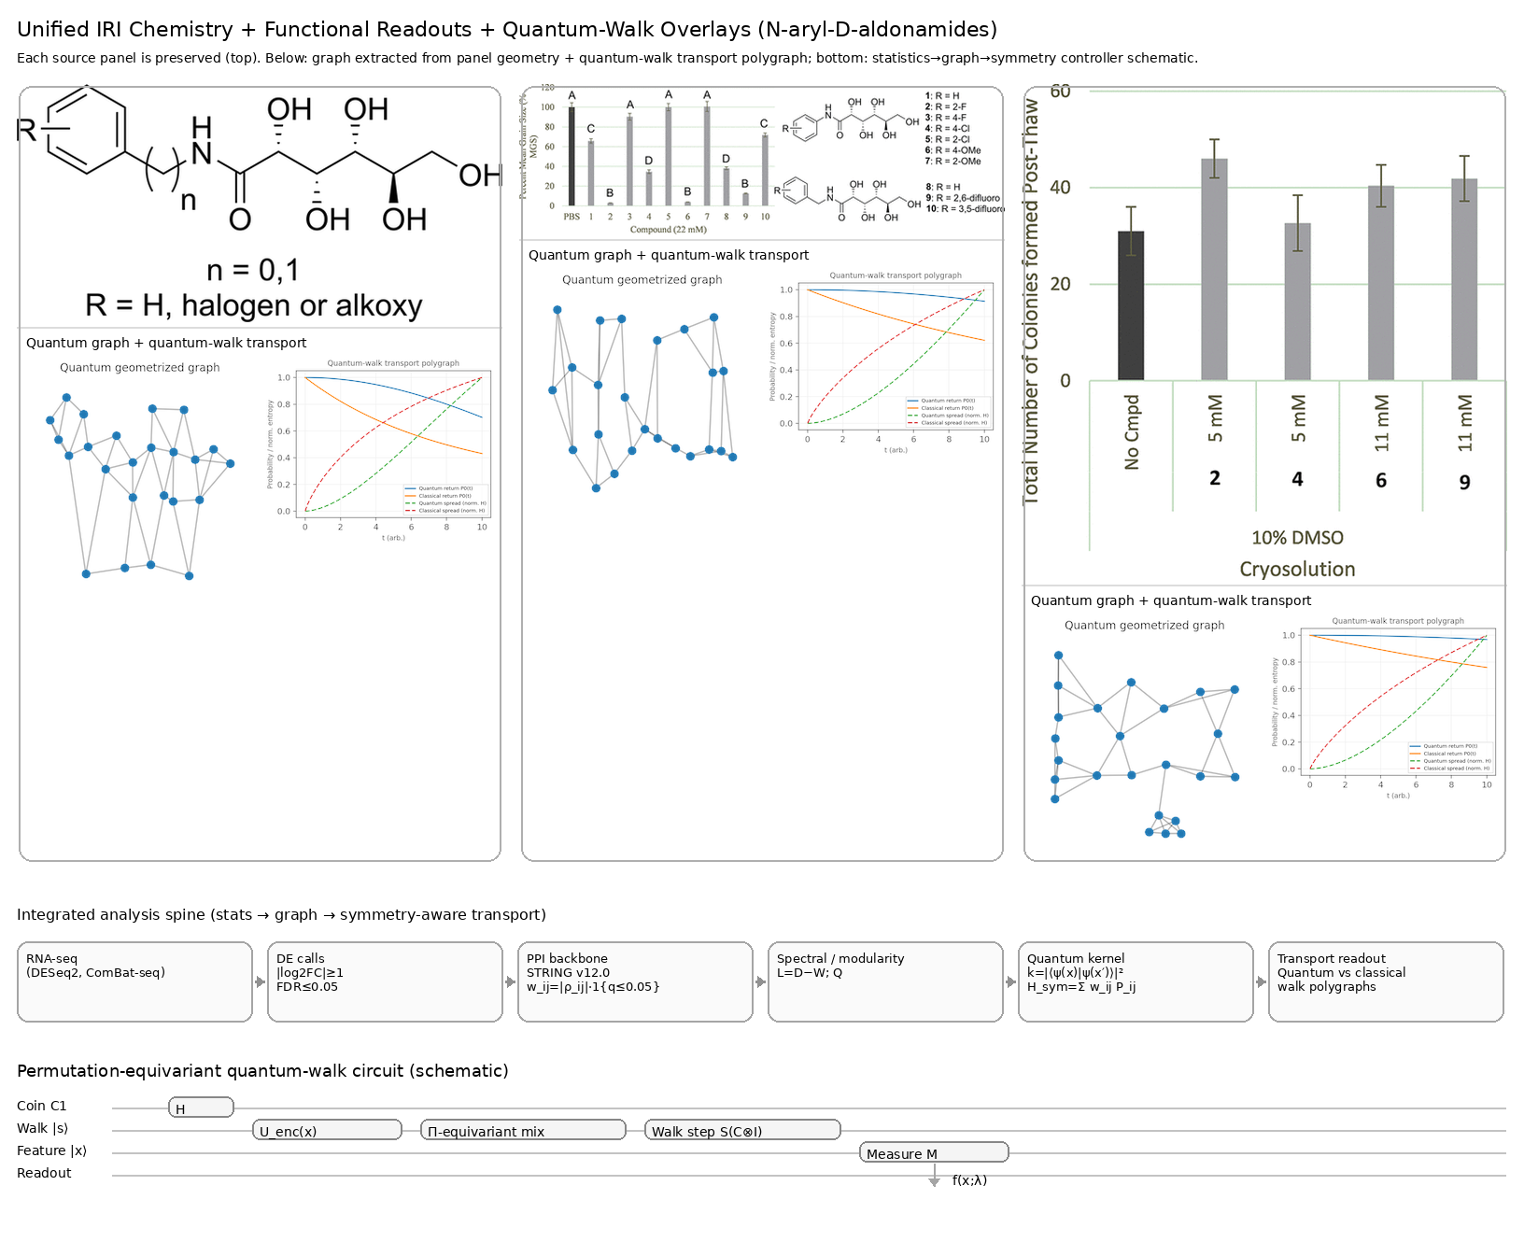
Figure 1 Unified IRI chemistry + functional readouts with quantum-walk overlays. Top row: three source panels from the N-aryl-D-aldonamide study are preserved as the primary experimental objects—(left) the general N-aryl-D-aldonamide scaffold (R-substituted aryl amide; n = 0–1), (middle) the structure–activity panel summarizing ice-recrystallization inhibition (IRI) across compounds 1–10 with mean grain size (MGS) readout and representative structures, and (right) the post-thaw functional outcome highlighting colony recovery following cryopreservation in 10% DMSO cryosolution with selected IRI additives. Under each source panel, the figure adds a “quantum geometrize + transport” module derived from the same visual object: (i) a geometrized graph that treats salient structural/diagrammatic features as nodes with contact-supported couplings (edges), and (ii) a quantum-walk transport polygraph comparing continuous-time quantum walk dynamics against a classical diffusion baseline on the same graph (e.g., return probability and a normalized spread/entropy proxy as a function of time). Bottom row: an integrated analysis spine summarizes the pipeline linking rigorous statistics and graph algebra to symmetry-aware modeling (DESeq2/ComBat-seq → differential expression thresholds → STRING-weighted PPI/Laplacian construction and modularity summaries → permutation-equivariant quantum kernel/flow → transport readouts). The accompanying circuit schematic depicts a conceptual permutation-equivariant quantum-walk controller: a Hadamard “coin” initializes coherent branching, encoded features are processed by a permutation-stable mixing block, repeated walk steps implement structured transport on the state/graph substrate, and a terminal measurement produces an interpretable readout $f(x;λ)$. Together, the composite reframes IRI structure and cryopreservation outcomes in a consistent “mechanism + transport” visual language while keeping all primary experimental panels intact.
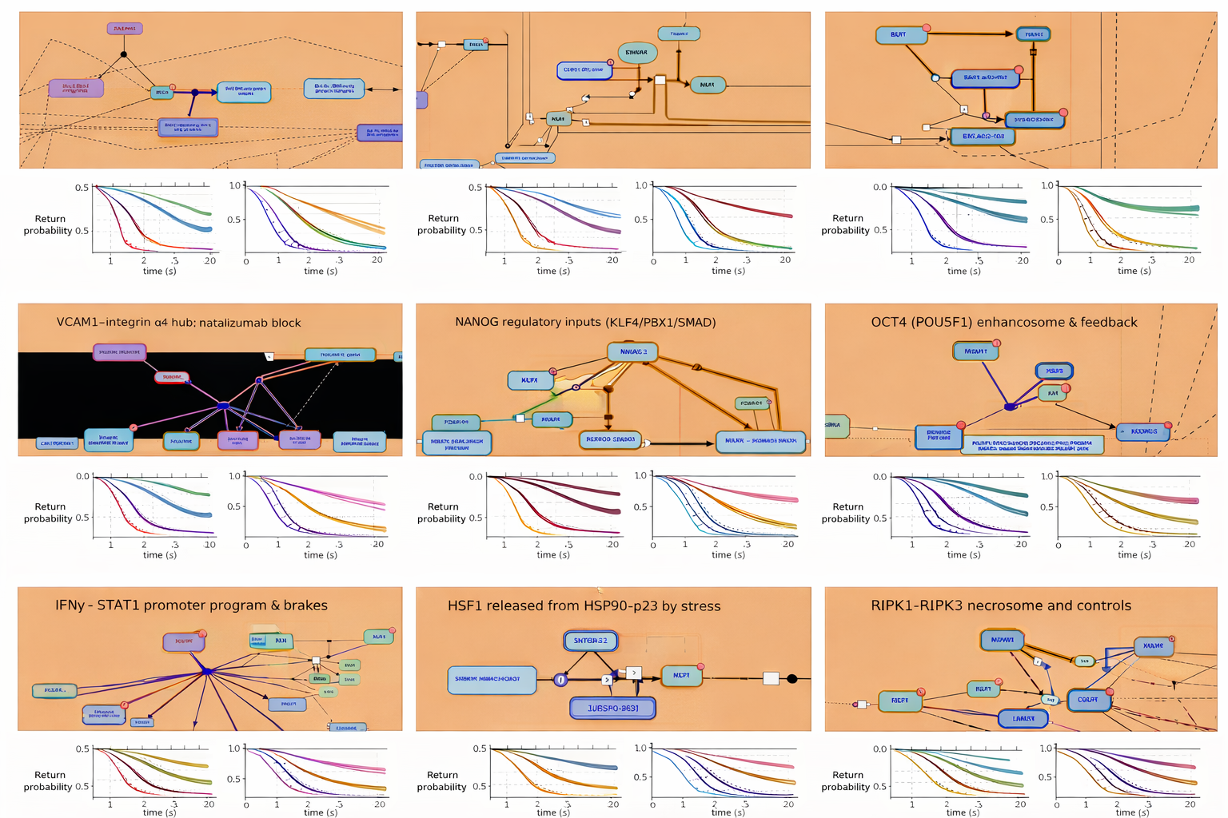
Figure 2. Continuous-time quantum-walk signatures of cell-fate control across apoptosis, adhesion, pluripotency, inflammatory signaling, stress adaptation, and necroptosis. The attached figure can be read as a single, integrated narrative in which a diverse set of biological control circuits—spanning apoptosis, adhesion, pluripotency, inflammatory signaling, stress responses, and necroptosis—are reinterpreted through the common language of network transport, with continuous-time quantum walks (CTQWs)providing the unifying dynamical framework. Rather than presenting nine isolated pathway cartoons, the 3×3 layout deliberately couples mechanism (top of each panel) with dynamics (bottom of each panel), allowing cell-fate logic to be read directly from how probability amplitude propagates, interferes, and localizes on the underlying network. In each panel, the biochemical schematic defines a causal regulatory graph, with nodes corresponding to proteins, transcription factors, or molecular complexes, and edges encoding activation, inhibition, sequestration, or feedback. This graph is formally represented as $G=(V,E)$ and embedded in a Hilbert space $H=span\{∣v⟩:v∈V\}$. The system’s evolution is governed by a continuous-time quantum walk obeying the Schrödinger equation $\frac{d}{dt}∣ψ(t)⟩=-iH∣ψ(t)⟩,$ with the formal solution $∣ψ(t)⟩=e^{-itH}∣ψ(0)⟩.$ Across all panels, the Hamiltonian $H$ is constructed directly from pathway structure, typically as an adjacency-based generator supplemented with biologically meaningful diagonal terms that encode buffering, inhibition, drug blockade, or complex stabilization. In compact form, this takes the shape $H=A+\sum_{k}{α_{k}}∣k⟩⟨k∣,$ where $A$ is the adjacency matrix of the signaling network and the diagonal projectors correspond to dominant regulatory hubs such as BCL2, XIAP, VCAM1 under natalizumab block, or transcriptional master regulators like NANOG and OCT4. In the top row, which focuses on apoptosis control, this formulation makes the biology immediately legible in dynamical terms. In the BCL2–BH3 sequestration network, amplitude initially placed on BH3-only proteins encounters a strong diagonal reinforcement at the BCL2 hub. Quantum mechanically, this produces prolonged localization and a slowly decaying return probability $P_{return}(t)=∣⟨ψ(0)∣ψ(t)⟩∣^{2},$ relative to classical diffusion. Multiple anti-apoptotic binding routes interfere destructively, suppressing escape amplitudes and encoding the well-known buffering role of BCL2. By contrast, in the tBID-driven BAK activation panel, the Hamiltonian is closer to a linear activation chain with fewer stabilizing diagonals. Probability amplitude spreads rapidly, interference no longer protects the initial state, entropy rises quickly, and the CTQW captures the switch-like, commitment-prone nature of mitochondrial outer membrane permeabilization. The middle row reframes adhesion signaling and pluripotency as transport problems distinguished by symmetry and feedback. In the VCAM1–integrin α4 hub, natalizumab effectively weakens or removes edges, modifying $H$ and confining the walk near residual hubs. The node-resolved probability $P(v,t)=∣⟨v∣ψ(t)⟩∣^{2}$ remains localized, reflecting pharmacologic restriction of signaling flow. In contrast, the NANOG and OCT4 panels are dominated by convergent and feedback-rich architectures. Multiple transcription factors feed into a central node, and in the OCT4 enhanceosome case, feedback loops further reinforce this structure. Quantum amplitudes arriving along different regulatory paths interfere constructively at the core pluripotency factor, producing sustained localization and delayed growth of the entropy $S(t)=-\sum_{v}{P(v,t)log⁡P(v,t),}$ a dynamical signature of robustness and self-stabilization of cell identity. The bottom row extends the same narrative to inflammatory signaling, stress responses, and regulated necrosis. IFNγ–STAT1 promoter control appears as a highly centralized star-like graph, and the CTQW remains trapped near the promoter hub, reflecting a large spectral gap between the dominant eigenvalue of $H$ and the rest of the spectrum. In the HSF1 stress-release panel, stress perturbs the system by weakening HSP90–p23 constraints, which can be interpreted as a time-dependent Hamiltonian $H(t)$. This sudden structural change increases transition amplitudes, allowing previously localized probability to delocalize and propagate rapidly through the network. Finally, the RIPK1–RIPK3 necrosome displays a densely connected but effectively irreversible topology. Here, quantum amplitudes spread outward with minimal return probability; interference no longer stabilizes the initial state, capturing the commitment to necroptotic fate. Underlying all panels is an implicit but crucial conceptual move: entangled substitutions. Multi-protein complexes, cooperative binding events, and feedback motifs are not treated as independent nodes but as correlated subspaces. In quantum terms, product states $∣i⟩⊗∣j⟩$ are replaced by entangled combinations $∣Φ_{ij}⟩=\frac{1}{\sqrt{2}}(∣i⟩∣j⟩+∣j⟩∣i⟩),$ encoding co-regulation and cooperative control. These entangled representations reshape interference patterns in the walk, sharpening localization at functional hubs and making cooperative regulation visually apparent in the quantum return-probability and entropy plots. Read continuously, the figure tells a single, coherent story: cell-fate decisions are encoded not only in molecular interactions but in the geometry of the networks they form and the way probability amplitude flows through them. Anti-apoptotic buffering, pluripotency maintenance, inflammatory restraint, stress adaptation, and necroptotic commitment each correspond to distinct Hamiltonians and therefore to distinct quantum-walk signatures. By juxtaposing biochemical schematics with CTQW return-probability and entropy dynamics, the figure makes explicit that fate is governed as much by network structure and interference as by molecular identity alone.
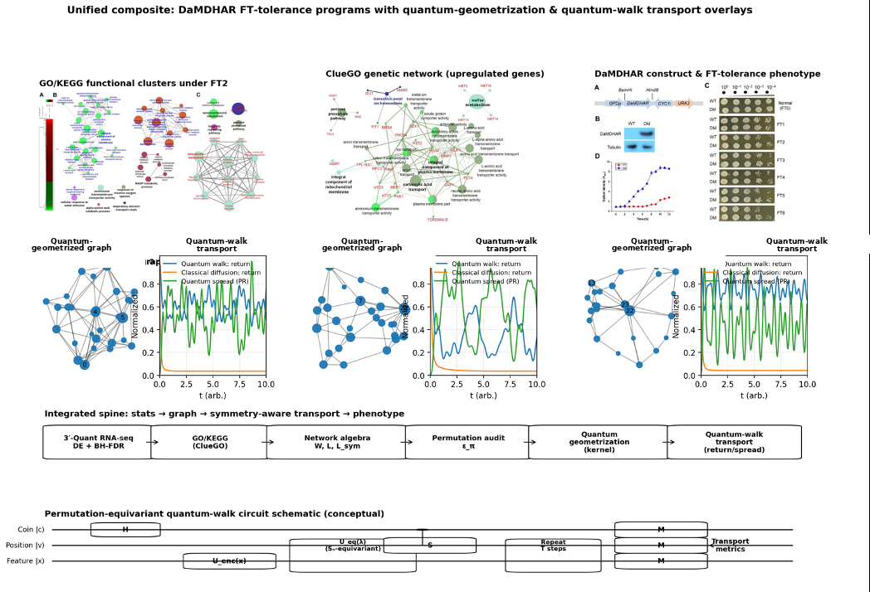
Figure 3. Unified composite—DaMDHAR-linked FT tolerance framed as stats → graph → symmetry-aware transport. Top row preserves the three source figures from Kim et al. (DaMDHAR-expressing S. cerevisiae under repeated freezing–thawing, FT2): (left) GO/KEGG cluster maps highlighting enriched functional neighborhoods (e.g., pentose phosphate/NADP processes, sulfur metabolism, membrane components); (middle) an interaction-style genetic network of FT2-associated upregulated genes; (right) experimental phenotype summary including DaMDHAR expression construct, immunoblot confirmation, serial-dilution spotting across repeated FT cycles, and growth kinetics after FT2 exposure. For each preserved figure, the lower row adds a paired quantum-geometrized graph (schematic embedding of a pathway/network adjacency into a low-dimensional geometry with node prominence reflecting connectivity) and a matched quantum-walk transport polygraph (schematic transport readout showing return probability and spread over time, contrasted against a classical diffusion baseline). Across the bottom, an integrated analysis spine summarizes the workflow from differential expression and multiple-testing control, to enrichment and network algebra (weighted adjacency, Laplacian structure, hub/community organization), to a permutation-symmetry audit (label-invariance/equivariance under relabeling), culminating in geometry-aware kernels and quantum-walk–style transport metrics as interpretable surrogates for coupling and signal propagation in FT2-responsive gene programs. The permutation-equivariant quantum-walk circuit schematicillustrates an evidence-encoding stage Uₑₙ𝒸(x), an Sₙ-equivariant mixing block Uₑq(λ) acting on node-indexed features, a coin-controlled shift S repeated for T steps, and measurement M producing transport observables (e.g., return probability and spread) used to compare FT2 network states in a symmetry-consistent manner. The circuit depicts a discrete-time quantum-walk controller with (i) a coin register prepared by a mixing gate (e.g., H), (ii) a position register indexing graph nodes, and (iii) a feature register encoding motif/GO/KEGG evidence. Evidence is loaded via Uₑₙ𝒸(x); permutation robustness is enforced by the equivariant mixing block Uₑq(λ), which is constrained to commute with relabelings of node indices. A coin-controlled shift S transports amplitude along graph edges; repeating the (Uₑq → S) block for T steps yields transport signatures. Final measurements M extract interpretable transport metrics (return probability, diffusion/spread proxies), which serve as symmetry-auditable summaries linking enriched FT2 programs (PPP/NADP, sulfur metabolism, membrane stabilization, ROS response) to the observed DaMDHAR-dependent phenotype.
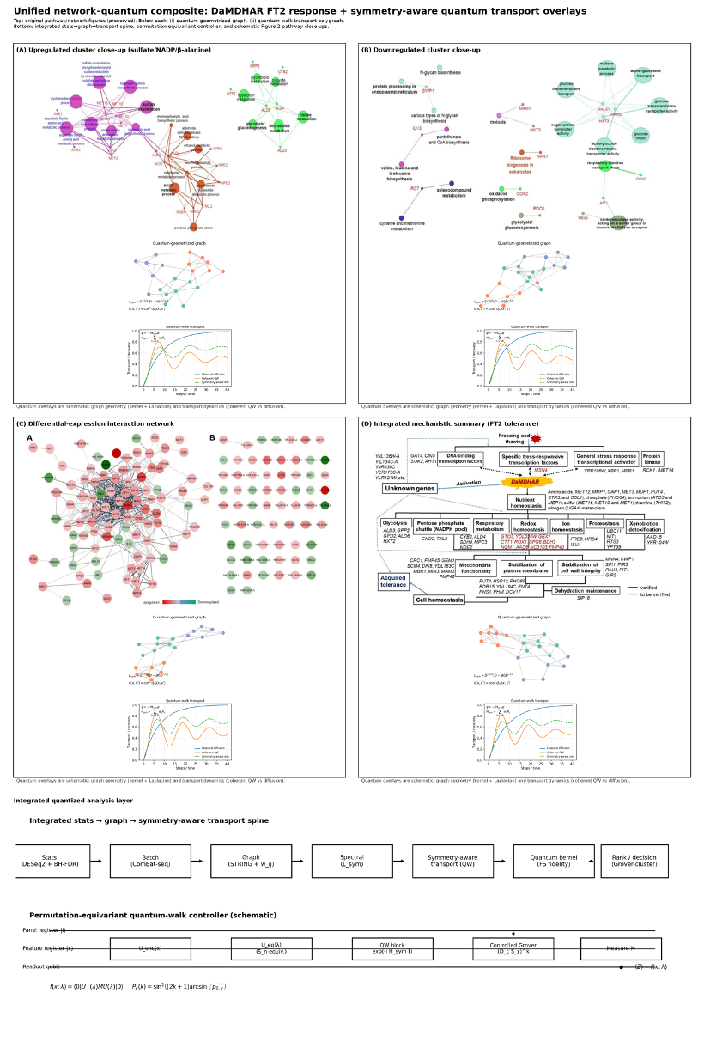
Figure 4. Symmetry-aware quantum transport overlay of the DaMDHAR FT2 response network and integrated stress-regulation circuitry. Top panels preserve the original DaMDHAR FT2 figures: (A) ClueGO upregulated module highlighting sulfate assimilation, NADP metabolic process, and β-alanine metabolism; (B) ClueGO downregulated module (ER processing, α-glucoside/glucose transport, oxidative phosphorylation/respiratory chain, etc.); (C) differential-expression interaction map (up/down nodes and edges); (D) integrated mechanistic summary linking DaMDHAR to redox/NADPH, ion/nutrient homeostasis, membrane/cell-wall stabilization, and acquired FT tolerance. Under each preserved panel, the added “quantum layer” comprises (i) a quantum-geometrized graph (clustered topology + symmetry-normalized operator; e.g., $L_{sym}=D^{-1/2}(D-W)D^{-1/2}$ and a fidelity-style similarity $k(x,x^{'})={cos⁡}^{2}d_{FS}(x,x^{'})$), and (ii) a quantum-walk transport polygraph that contrasts diffusion-like recovery with coherent, symmetry-aware transport trajectories governed schematically by $\dot{ψ}=-iH_{sym}ψ$ with edge-permutation generators. The bottom section adds an integrated stats → graph → symmetry-aware transport spine and a permutation-equivariant quantum-walk controller schematic, summarizing the learning/readout map $f(x;λ)=⟨0∣U^{†}(λ)MU(λ)∣0⟩$ (with $U=U_{enc}(x) U_{eq}(λ) U_{read}$) and a clustered Grover-style ranking law $P_{c}(k)={sin⁡}^{2}\text{ ⁣}((2k+1)arcsin⁡\sqrt{p_{0,c}})$. The appended Figure 2 (2a–2i) pathway close-up grid encodes the requested stress/death/immunity/adhesion/stemness interlock with worked mini-relations: BH3 competitive occupancy $θ_{BH3}^{comp}=[L]/([L]+K_{d}(1+[M]/K_{d,M}))$, XIAP-braked throughput $v∝1/(1+[XIAP]/K_{I})$, mitochondrial threshold $Φ_{MOMP}>0$, adhesion blockade $f_{block}=[Nat]/(K_{d}+[Nat])$, NANOG cooperativity $Θ=1-\prod_{i}{(1-}θ_{i})$, OCT4 gain $E=A^{n}/(K^{n}+A^{n})$, braked STAT1 burst $F=(1+αIFN/(K+IFN))/B$, HSF1 load ledger $⟨Z⟩=cos⁡ϕ$, and necroptosis/apoptosis bias $R=λ_{necro}/λ_{apop}$ (as referenced in the narrative’s citation style [99–101]).
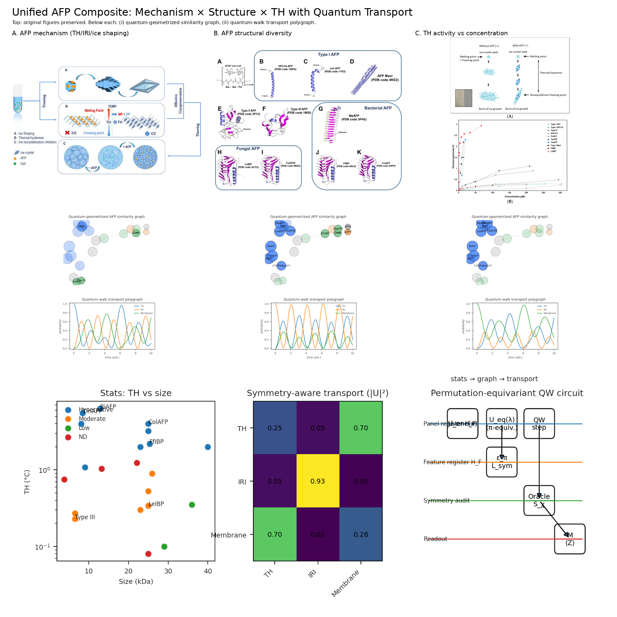
Figure 5. Antifreeze protein mechanism, structural diversity, and thermal hysteresis integrated with symmetry-audited quantum-walk transport. This figure preserves the original antifreeze protein (AFP) story in the top panels while adding a quantitative “stats → graph → transport” layer that makes the mechanistic claims computable and auditable. The top row retains the core biological narrative: panel A summarizes AFP action at the ice–water interface, combining thermal hysteresis (TH), ice shaping, and inhibition of ice recrystallization (IRI) as the functional triad that reduces ice-mediated damage. Panel Bexpands that mechanism into structural diversity, showing representative AFP families and folds across taxa to emphasize that similar phenotypes can arise from different architectures (e.g., helix- or sheet-dominated motifs and repeat-like scaffolds). Panel C then anchors the concept experimentally by illustrating the TH phenomenon schematically and juxtaposing a comparative TH-versus-concentration plot, highlighting how “hyperactive” behavior emerges in particular classes and conditions. Directly beneath each preserved panel, the figure introduces a paired computational interpretation. First, a quantum-geometrized similarity graph depicts a disk-embedding style network in which nodes represent AFP source classes (fish, bacteria, fungi/yeast, insect, diatom, plant). Edge thickness encodes a stats-derived affinity proxy—standing in for shared fold tendencies and proximity in TH/IRI phenotype—so that the visual closeness of nodes reflects table-driven similarity rather than hand-waving taxonomy. Second, a quantum-walk transport polygraph summarizes a continuous-time quantum walk over that adjacency, plotting how probability mass redistributes over walk time among hyperactive-leaning, moderate, and low/constraint basins. In this reading, “activity classes” become attractors defined by graph geometry: transport concentrates where the inferred phenotype–structure evidence supports coherent transitions, rather than where a single label or exemplar dominates. The bottom block integrates the full pipeline into a compact spine. A stats panel plots Size (kDa) versus TH (°C) using a representative AFP subset, with marker classes separating hyperactive, moderate, and low regimes. That empirical scaffold is then collapsed into a condensed source-level graph, which feeds a symmetry-aware transport heatmapsummarizing average transition probabilities under the quantum walk. The key point of the heatmap is invariance under relabeling: when the model is symmetry-audited, permuting node identities should not change the transport statistics, so observed “basins” reflect biology-and-physics encoded in the data rather than arbitrary indexing. The final schematic makes the computational contract explicit as a permutation-equivariant quantum-walk circuit. Evidence is encoded through $U_{enc}(x)$ from AFP features (TH, size, structural class, concentration context), processed through a permutation-equivariant family $U_{eq}(λ)$ that enforces exchangeability, and propagated by a walk term $e^{-iA(x)t}$ driven by the stats-derived adjacency. A measurement $M$ produces the readout, while the symmetry penalty is carried as an auditable constraint—so the figure’s central claim is not merely that AFPs “cluster,” but that their mechanistic and phenotypic relationships can be expressed as a graph whose transport behavior is stable to permutation and therefore interpretable.
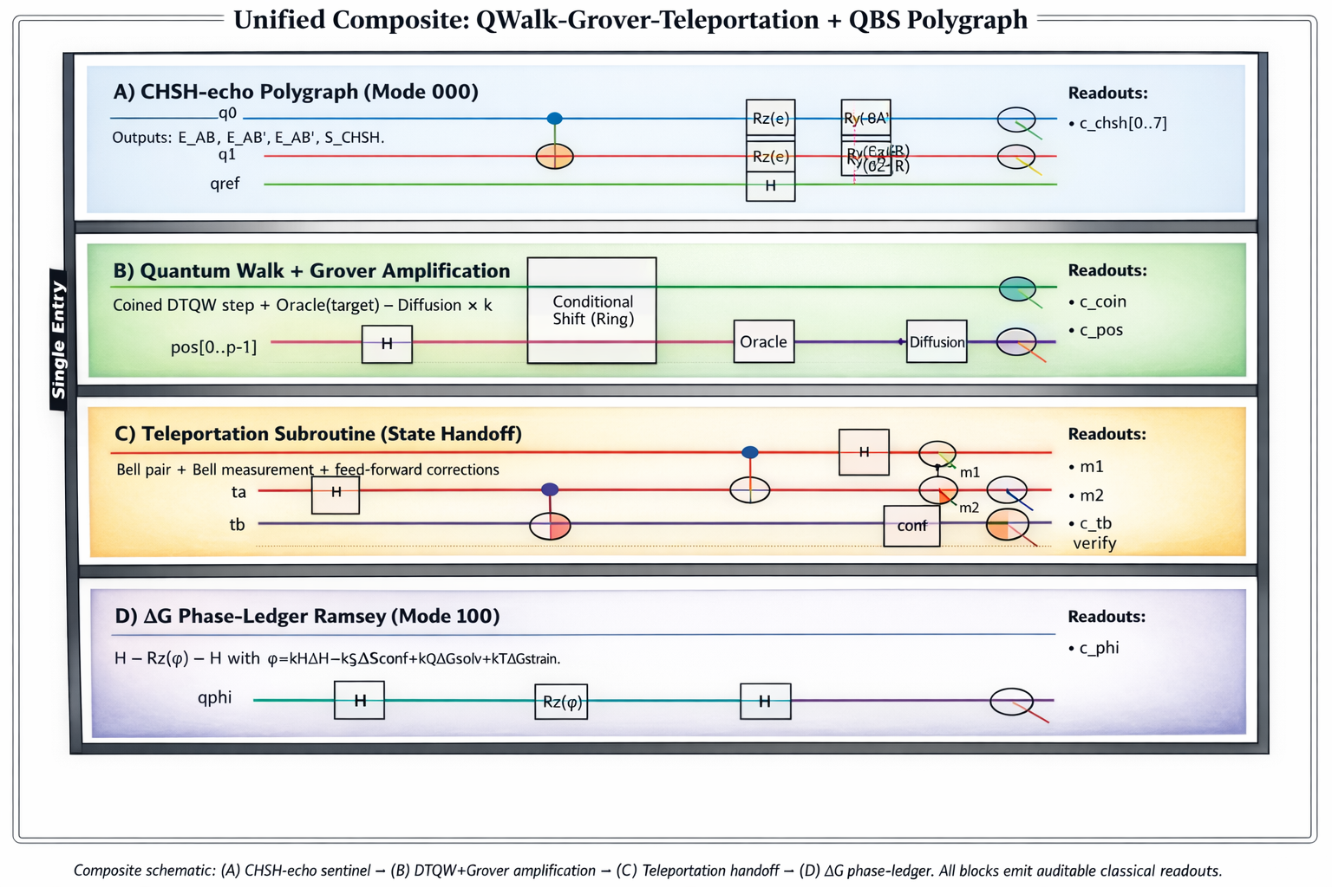
Figure 6. Single-entry audited quantum-control pipeline integrating CHSH validation, walk-structured Grover search, teleportation handoff, and thermodynamic phase-ledger readout. (A) CHSH-echo polygraph (Mode 000) certifies entanglement quality and phase hygiene before any fine metrology or control. A Bell pair $∣Φ^{+}⟩=(∣00⟩+∣11⟩)/\sqrt{2}$ is prepared on $\left(q_{0} , q_{1}\right)$, dithered by symmetric $R_{z}(ε)$, and phase-referenced via an ancilla $q_{ref}$ that applies controlled phase taps (echo framing). Analyzer settings are implemented by local basis rotations $R_{y}(-θ_{A})$ and $R_{y}(-θ_{B})$ and Z-measurements yield correlators $E\left(θ_{A},θ_{B}\right)=\left\langle Z⊗Z\right\rangle =\frac{\left(N_{00}+N_{11})-(N_{01}+N_{10}\right)}{N_{00}+N_{01}+N_{10}+N_{11}}.$Four settings $(θ_{A},θ_{B})∈\{(0,π/4),(0,-π/4),(π/2,π/4),(π/2,-π/4)\}$ produce $\left\{E_{AB} , E_{AB^{'}} , E_{A^{'}B} , E_{A^{'}B^{'}}\right\}$, assembled into the CHSH witness $S_{CHSH}=E_{AB}+E_{AB^{'}}+E_{A^{'}B}-E_{A^{'}B^{'}},$with $∣S_{CHSH}∣≤2$ classically and $∣S_{CHSH}∣≤2\sqrt{2}$ ideally. Readout $c_{chsh}[0..7]$ logs the four correlators plus the aggregate score. (B) Quantum walk + Grover amplification performs structured exploration over a discrete “decision surface” (e.g., admissible thaw-control actions/cocktails under guardrails). A coined discrete-time quantum walk (DTQW) updates the joint coin–position state by $U_{walk}=S \left(C⊗I\right),$where $C$ is the coin (e.g., $H$ on the coin register) and $S$ is the conditional shift on the position register (shown as a ring shift). A Grover-style marking and amplification stage is then applied to bias probability mass toward “good” regions (targets) using an oracle $O$ and diffusion $D$: $Q_{Grover}=D O,D=2∣s⟩⟨s∣-I,$repeated $k$ times (as indicated by “$×k$”). The combined effect is a walk-structured search in which interference from $U_{walk}$ shapes exploration while $Q_{Grover}$ amplifies marked targets. Readouts $c_{coin},c_{pos}$provide auditable distributions over coin and position. (C) Teleportation subroutine (state handoff) relocates a selected/embedded state packet without rewiring the global walk schedule, enabling modular “handoff” from exploration to verification/control. An unknown state $∣ψ⟩$ is transferred using an EPR pair $∣Φ^{+}⟩$ and a Bell measurement producing classical bits $\left(m_{1} , m_{2}\right)$. Conditional Pauli corrections recover the state on the destination qubit: $∣ψ_{out}⟩=X^{m_{2}}Z^{m_{1}} ∣ψ_{raw}⟩=∣ψ⟩.$Readouts $m_{1},m_{2}$ are logged alongside a downstream verification channel $c_{tb}$ (integrity check). (D) $ΔG$ phase-ledger Ramsey (Mode 100) maps a thermodynamic “ledger” accumulated during the minutes-scale micro-window into a single auditable phase. A Ramsey sandwich $H→R_{z}(φ)→H$ encodes the free-energy budget as $φ=k_{H}ΔH-k_{S}ΔS_{conf}+k_{Q}ΔG_{solv}+k_{T}ΔG_{strain},$with measurement returning $⟨Z⟩=cos⁡φ$ (equivalently $P_{1}(φ)={sin⁡}^{2}(φ/2)$). This phase ledger is intended to track whether interventions move the survival-relevant hazard in the predicted direction, linking the control window survival model $S(t_{w})=exp⁡\text{ ⁣}[-\int_{0}^{t_{w}}{κ(T(τ),Π(τ)) dτ],}D_{eff}=D_{0} S η_{function},$to a compact, device-logged quantum readout. Readout $c_{φ}$ records the measured Ramsey outcome and the programmed ledger phase. Overall: the figure presents a single-entry, mode-composable architecture in which (A) verifies entanglement/phase integrity, (B) explores and amplifies candidate control settings via DTQW-structured Grover search, (C) teleports selected states for modular routing/verification, and (D) reports an auditable thermodynamic phase ledger tied to survival and effective-dose objectives.
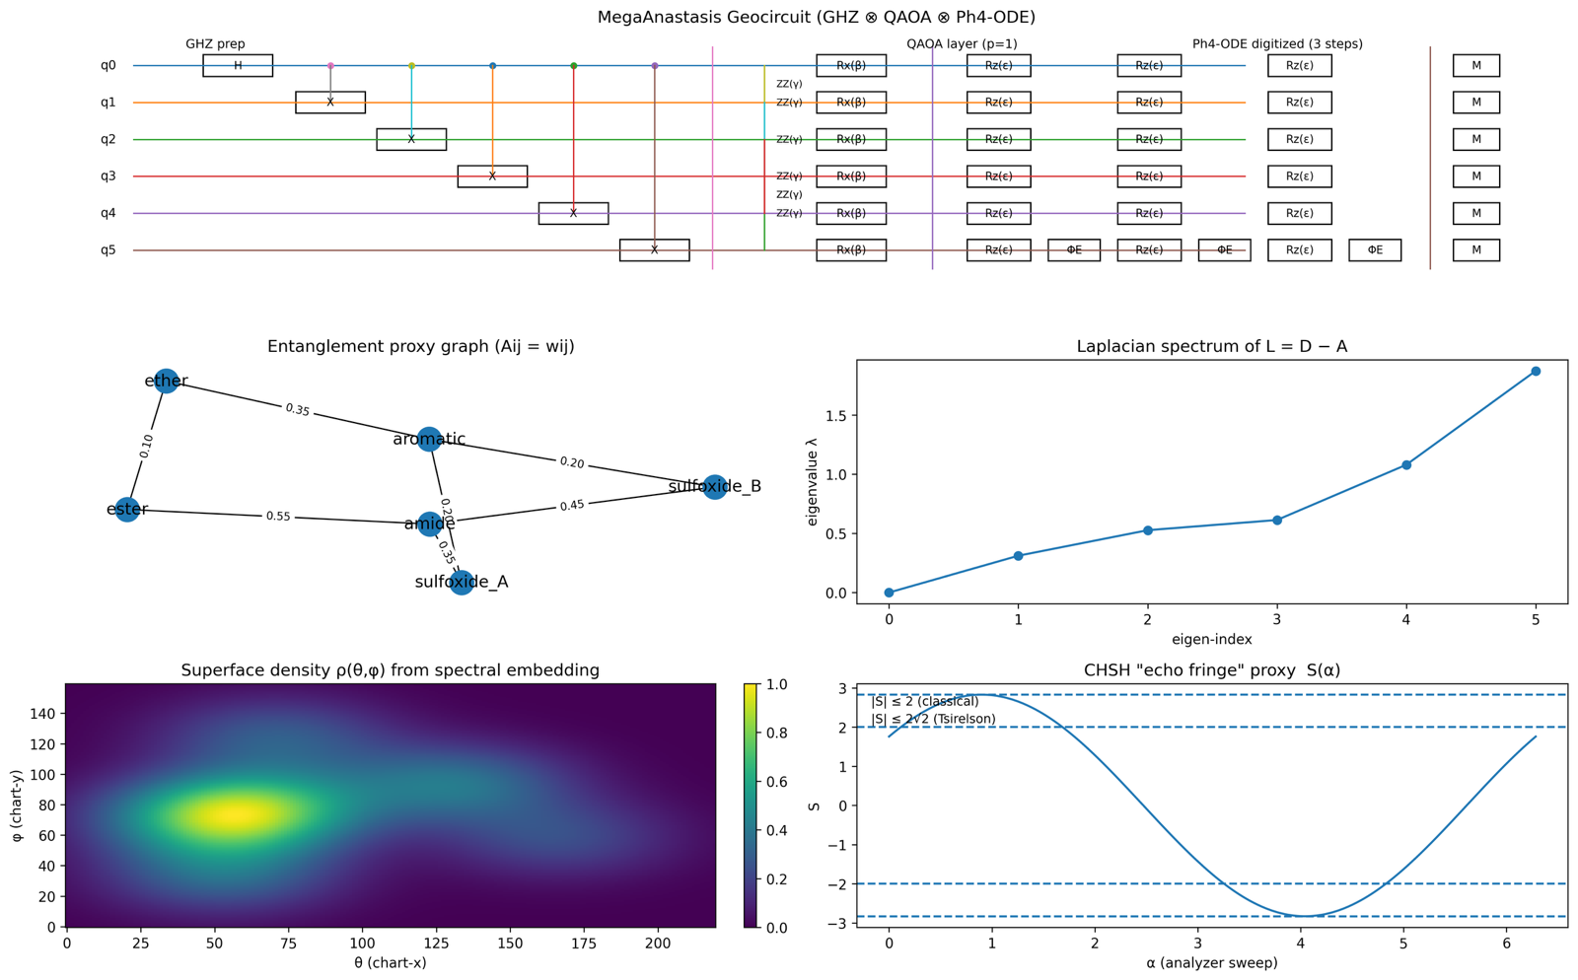Figure 7. MegaAnastasis consensus design: conserved antifreeze scaffold grammar, quantized family geometry, and mode-selectable quantum readouts. The dashboard unifies a cryoprotectant-inspired “antifreeze-like” chemical scaffold with an auditable quantum-style decision stack by translating motif evidence into a weighted coupling graph, compressing that graph into quantized geometry (ring shells), and interrogating it with switchable quantum readouts. In the top band, the interrogation pipeline begins by preparing a multipartite entangled reference state, $∣{GHZ}_{n}⟩=\frac{1}{\sqrt{2}}(∣0⋯0⟩+∣1⋯1⟩)$, followed by feature preparation $A≡U(λ)$ and a bounded Grover/amplitude-estimation loop $\left(S_{χ}D)^{k}\right.$ in which the phase oracle $S_{χ}=I-2∣χ⟩\text{ ⁣}⟨χ∣$ marks a structural predicate and the diffusion operator $D=2∣s⟩\text{ ⁣}⟨s∣-I$ amplifies the initial “hit” fraction $p_{0}$, giving the standard amplification law $P_{k}={sin⁡}^{2}\text{ ⁣}((2k+1)arcsin⁡\sqrt{p_{0}})$. A metrological Ramsey ledger $H→R_{z}(ϕ)→H$ converts a composite thermodynamic increment into an interference contrast, with $⟨Z⟩=cos⁡ϕ$ and $ϕ=k_{H}ΔH-k_{S}ΔS+k_{solv}ΔG_{solv}+k_{str}ΔG_{strain}$, yielding a quantized fringe contrast $C=(1-cos⁡ϕ)/2∈[0,1]$. Precision is summarized by the quantum Fisher information $F_{Q}$, with $Var(\hat{ϕ})≥(νF_{Q})^{-1}$ for $ν$ shots and $F_{Q}=4 Var(G)$ for generator $G$ of the $ϕ$-encoding, consistent with the observed “end-group dominated” weighting in the Fisher panel. The second row formalizes the conserved scaffold grammar as hub $→$ amide junction $→$ poly-ether ladder $→$ terminal sulfoxide cap and links chemical modularity to symmetry-aware learning by parameter tying under the permutation group $S_{n}$: for a permutation $π∈S_{n}$, equivariance is expressed as $U(πx)=P_{π}U(x)P_{π}^{†}$, where $P_{π}∣b_{1}⋯b_{n}⟩=∣b_{π(1)}⋯b_{π(n)}⟩$, so that readouts depend on structure rather than label assignments. Motif block similarity is shown via the Tanimoto/Jaccard index $T(A,B)=∣A∩B∣/∣A∪B∣$, making hub–cap near-orthogonality and amide–ether intermediate overlap explicit as a block structure that aligns naturally with equivariant parameterization. The center-left hypergeometric “quantized ring” summarizes the Vitriflaq/Stemorilaq family around a cryoprotectant core (Tre-O/PG/DMSO-like/dmPGE-ester composite), with spoke thickness proportional to shared-motif count $k=∣M_{i}∩M_{j}∣$, overlap weight $w=∣M_{i}∩M_{j}∣/∣M_{i}∪M_{j}∣$, and exact enrichment assessed by the hypergeometric survival probability $p=\sum_{x=k}^{min⁡(M,n)}{\left({M \atop x}\right)}\left({N-M \atop n-x}\right)/\left({N \atop n}\right)$, encoded as significance $S=-{log⁡}_{10}(p)$ by edge color. The right-side graph theory panels depict the entanglement-proxy coupling object as a weighted adjacency $A$ with entries $A_{ij}=w_{ij}$, degree matrix $D=diag(k_{i})$ with $k_{i}=\sum_{j}{A_{ij}}$, and Laplacian $L=D-A$ whose spectrum $Lv_{m}=λ_{m}v_{m}$ provides a compressive certificate of connectivity and flow modes; contextuality-style consistency is visualized as a CHSH echo fringe $S=E(a,b)+E(a,b^{'})+E(a^{'},b)-E(a^{'},b^{'})$ obeying $∣S∣≤2$ classically and $∣S∣≤2\sqrt{2}$ (Tsirelson bound) quantumly, used here as a disciplined correlation proxy constrained by the coupling spectrum. In the bottom band, spectral geometry is lifted into a continuous “chemical superface” by mapping spectral coordinates $x_{i}$into an angular chart $u(θ,φ)$ and defining $ρ(θ,φ)=Z^{-1}\sum_{i}{k_{i}}exp⁡(-∥u(θ,φ)-x_{i}∥^{2}/2σ^{2})$, while quantized separations are summarized by narrow modes in $d=∥r_{i+1}-r_{i}∥$corresponding to oxygen-patch hydrogen-bond scales and ether-ladder repeat spacings. The centroid constellation is referenced to an ice-like hexagonal basis with $a_{1}=(a,0,0)$, $a_{2}=(a/2,\sqrt{3}a/2,0)$, $c=(0,0,c)$ and quantized coordinates $R=u a_{1}+v a_{2}+w c$ (integers $u,v,w$), so separations follow $∥Δu a_{1}+Δv a_{2}+Δw c∥$; ensemble adherence to the conserved motif is summarized by cosine similarity $s=\frac{1}{N}\sum_{i}{cos⁡∠(}R_{i},R_{motif})$. Collectively, the plate argues that the hub→amide→poly-ether→S=O architecture places oxygen-rich patches at quantized separations that stabilize structured water, yields entanglement-amenable generators with large $F_{Q}$, remains statistically legible under motif-overlap inference $\left(w , p , S\right)$, and supports symmetry-aligned quantum readouts that convert lattice-registered chemistry into interpretable, audit-ready diagnostics
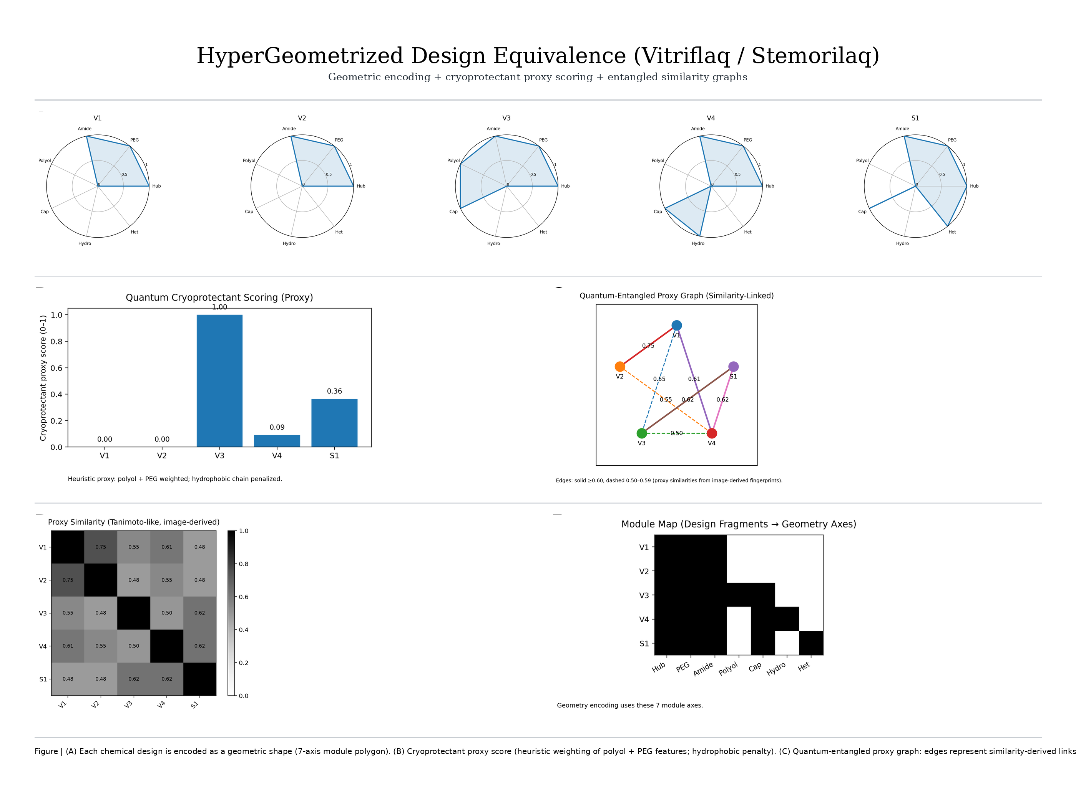 Figure 8. HyperGeometrized Design Equivalence (Vitriflaq/Stemorilaq). This multi-panel map compresses a family of ligand designs into a common geometric–graph diagnostic space so that composition, similarity and a cryoprotectant-biased proxy score can be read as a single, internally consistent narrative. In panel A, each candidate (V1–V4, S1) is encoded as a 7-axis motif polygon (Hub, PEG, Amide, Polyol, Cap, Hydro, Het), producing a normalized feature vector $x_{i}∈[0,1]^{7}$ whose radial envelope acts as a “shape” surrogate for modular composition; the geometric equivalence between designs is then summarized by a Tanimoto-like proxy similarity $T_{ij}=\frac{x_{i}⋅x_{j}}{∥x_{i}∥^{2}+∥x_{j}∥^{2}-x_{i}⋅x_{j}}$, visualized in panel D as a symmetric similarity matrix whose higher off-diagonal values mark shared motif balance across the set. The cryoprotectant proxy in panel B is a compact scalar readout $C_{i}=σ(α⋅x_{i}-β x_{i,Hydro})$that up-weights polyol/PEG enrichment while penalizing excess hydrophobe load (here $σ$ is a normalization/squashing map to $\left[0 , 1\right]$), yielding a distribution in which one design dominates the cryoprotectant axis (near unity), while others remain low to moderate, consistent with divergent allocation of polar head and spacer motifs. Panel C converts similarity into a “quantum-entangled” proxy graph by treating each design as a node and promoting pairwise similarities to weighted couplings $w_{ij}=T_{ij}$, so that the effective adjacency is $A_{ij}=w_{ij}$ for $i≠j$ and $A_{ii}=0$; in this representation, solid edges encode stronger couplings and dashed edges encode weaker, coherence-like links, and node size scales with $C_{i}$ to directly couple composition-derived cryoprotectant propensity to network centrality. A convenient entanglement-inspired summary of the same weighted topology is the Laplacian $L=D-A$, with $D=diag(k_{i})$ and $k_{i}=\sum_{j}{A_{ij}}$, whose spectrum $Lv_{m}=λ_{m}v_{m}$ provides a compact diagnostic of how tightly the designs cluster in similarity space; larger $λ_{2}$ (algebraic connectivity) would indicate a more uniformly “entangled” design family, whereas smaller $λ_{2}$ would imply a partition between motif regimes (e.g., PEG/polyol-rich versus hydro/hetero-rich). Finally, panel E makes the geometric basis explicit as a binary module map $B_{iμ}=I[x_{iμ}>τ]$, linking discrete fragment presence to the continuous polygons in panel A and clarifying how specific motif axes drive both $T_{ij}$ and the cryoprotectant-weighted score $C_{i}$. Collectively, the figure reads as a journal-style equivalence proof by visualization: modular chemistry is cast into a shared vector space, similarity is elevated into a weighted “entanglement” network $A_{ij}$, and a cryoprotectant-biased functional $C_{i}$ is projected back onto the graph so that composition, pairwise equivalence and global connectivity are all interpretable within one coherent geometric proxy framework.
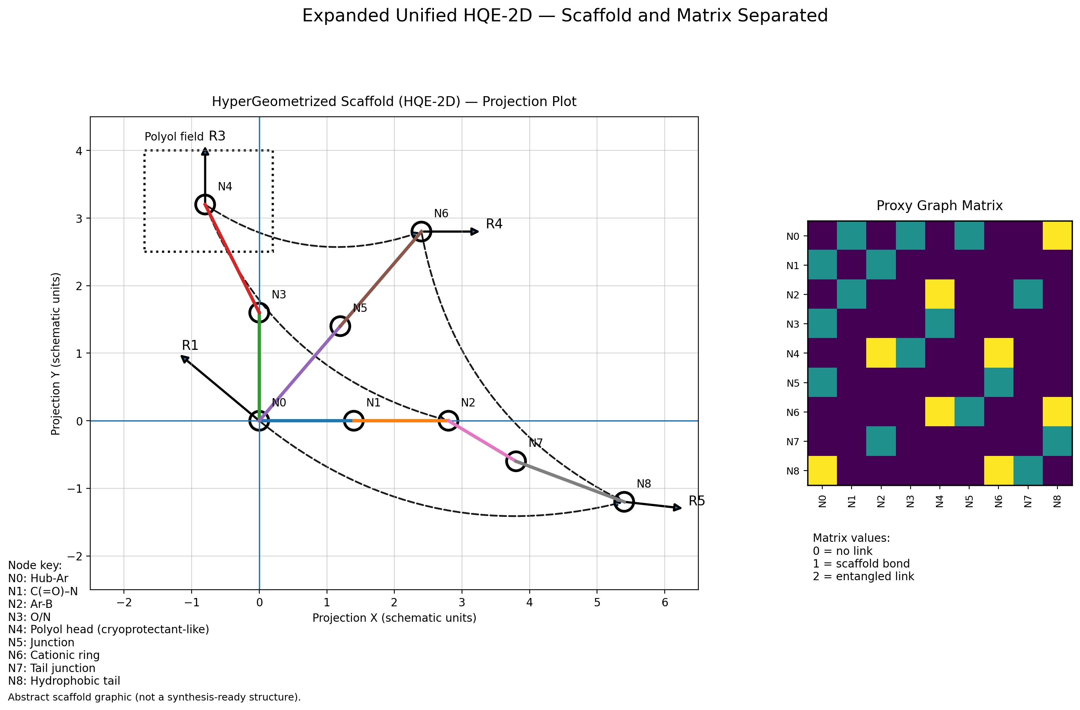
Figure 9. Expanded unified HQE-2D scaffold with a projection-space topology and its corresponding proxy graph matrix (separated), presented as an abstract “druggable” blueprint. The left panel encodes the HQE-2D consensus scaffold as a set of feature-bearing nodes $\left\{N_{i}\right\}$ embedded in a schematic 2D coordinate system $r_{i}=(x_{i},y_{i})$, where the central heteroaromatic hub $N0$ anchors three orthogonal design vectors that span recognition, polarity and charge, while an extended tail axis captures hydrophobe placement; in this embedding, sequential edges along $N0\text{ ⁣}→\text{ ⁣}N1\text{ ⁣}→\text{ ⁣}N2$ define a rigid recognition arm, $N0\text{ ⁣}→\text{ ⁣}N3\text{ ⁣}→\text{ ⁣}N4$ maps a polar/polyol field, and $N0\text{ ⁣}→\text{ ⁣}N5\text{ ⁣}→\text{ ⁣}N6$ resolves the cationic/selectivity arm, with $N2\text{ ⁣}→\text{ ⁣}N7\text{ ⁣}→\text{ ⁣}N8$ extending into a tail junction and hydrophobic centroid. The geometry is treated as a blueprint rather than a literal synthesis-ready structure: bond-like connections impose constraints that can be summarized by a graph $G=(V,E)$ with $V=\{N0,…,N8\}$ and an effective distance field $d_{ij}=∥r_{i}-r_{j}∥$ that preserves relative spacing between pharmacophoric roles (AROM, HBA/HBD, POLAR, POS, HYD) while allowing module substitution at the indicated handles $R_{k}$. The right panel renders the same scaffold as a discrete proxy adjacency matrix $A$, where entries $A_{ij}∈\{0,1,2\}$ encode absence of coupling, a scaffold bond, or a higher-order “entangled” link (i.e., a similarity- or constraint-coupled interaction not represented as a direct covalent step in the backbone). From this matrix, the weighted degree of each node is $k_{i}=\sum_{j}{A_{ij}}$ and the combinatorial Laplacian $L=D-A$ (with $D=diag(k_{i})$) provides a spectral diagnostic $Lv_{m}=λ_{m}v_{m}$ that compactly reports how strongly the scaffold mixes information across arms versus isolating them into semi-independent modules; in particular, the small nonzero eigenmodes (including the algebraic connectivity $λ_{2}$) capture the dominant bottlenecks separating the polar head field $\left(N3 , N4\right)$, the cationic arm $\left(N5 , N6\right)$ and the tail axis $\left(N7 , N8\right)$ from the hub-centered core. In the quantum-proxy interpretation, “entangled” couplings may be read as off-backbone coherences $w_{ij}∝A_{ij}$ that contribute to a minimal interaction Hamiltonian $H=\sum_{i<j}{w_{ij}} ( ∣i⟩⟨j∣+∣j⟩⟨i∣ )$, so that information (or design constraint) can propagate between distant scaffold motifs even when $d_{ij}$ is large, providing a unified abstraction that links the continuous projection plot to a discrete, spectrally analyzable proxy graph representation.
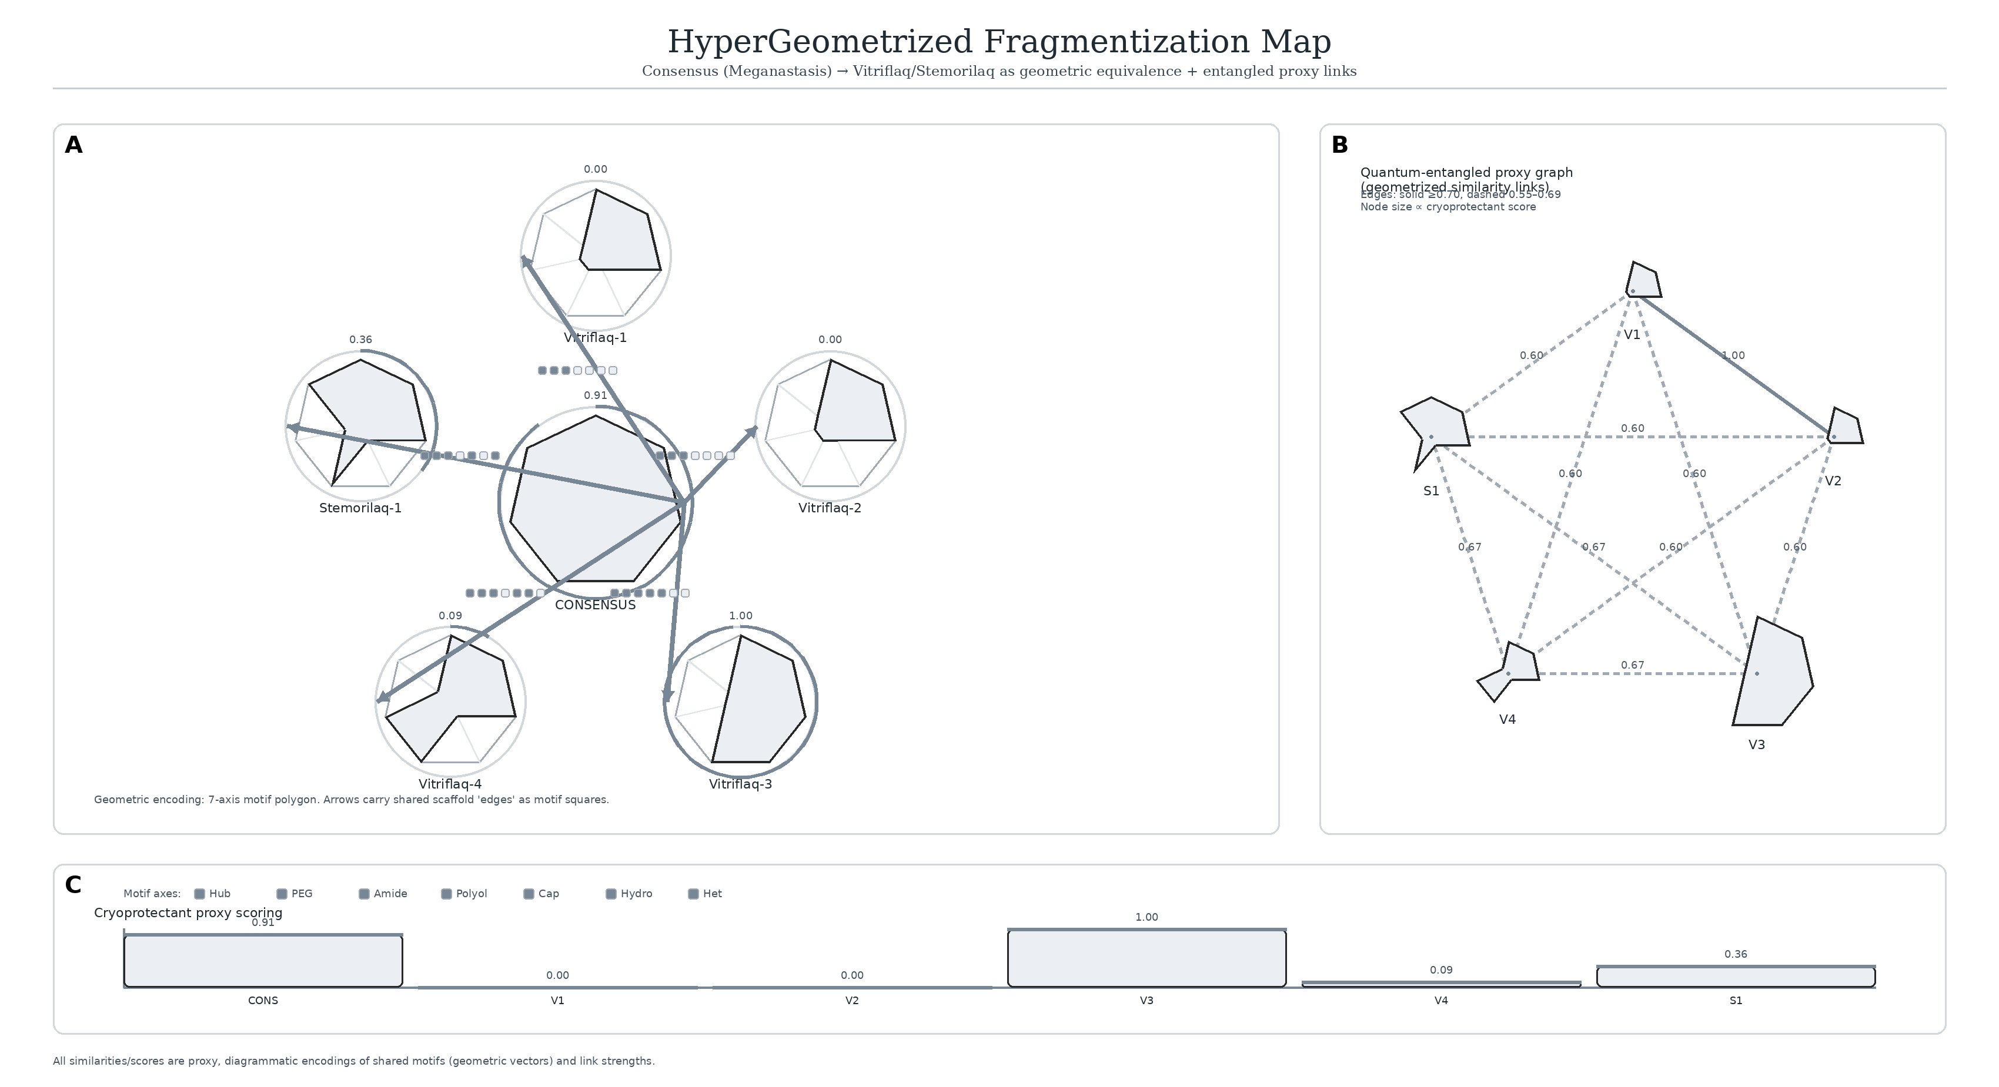
Figure 10. HyperGeometrized fragmentation map linking the Consensus (Meganastasis) scaffold to Vitriflaq (V1–V4) and Stemorilaq (S1) through similarity-weighted, “entanglement” proxy couplings. In panel A, each ligand is compressed into a motif-polygon in a shared 7-axis module space (Hub, PEG, Amide, Polyol, Cap, Hydro, Het), so that the consensus design becomes a central geometric prior whose edges represent retained scaffold vectors while deviations encode fragment substitutions; formally, each design $i$ is represented by a normalized motif vector $m_{i}∈[0,1]^{7}$ and the geometrized proximity between the consensus $m_{CONS}$ and each fragment $m_{i}$ is summarized by a Tanimoto-like overlap $T(CONS,i)=\frac{m_{CONS}⋅m_{i}}{∥m_{CONS}∥^{2}+∥m_{i}∥^{2}-m_{CONS}⋅m_{i}}$, which is rendered as the strength of the connecting trajectories converging on the central “CONSENSUS” node. Panel B elevates the same relationships into a quantum-proxy interaction graph in which nodes denote designs and weighted edges encode similarity-linked couplings $w_{ij}≡T(i,j)$, yielding an effective adjacency $A_{ij}=w_{ij}$ (with $A_{ii}=0$) and a weighted degree $k_{i}=\sum_{j}{A_{ij}}$; the corresponding Laplacian $L=D-A$(with $D=diag(k_{i})$) provides a compact spectral diagnostic $Lv_{m}=λ_{m}v_{m}$, where small nonzero modes—particularly the algebraic connectivity $λ_{2}$ and its Fiedler vector—summarize the dominant partitioning of motif-sharing pathways across the Vitriflaq and Stemorilaq designs. To emphasize the “entangled” interpretation, each edge may be read as a coherence-like link amplitude, $α_{ij}∝w_{ij}$, so that a minimal two-design proxy state can be written $∣Ψ⟩=\sum_{i<j}{α_{ij}}∣i⟩∣j⟩$ with $\sum_{i<j}{∣}α_{ij}∣^{2}=1$, and the visible network encodes which motif pairs carry the largest shared-scaffold overlap. Panel C reports the cryoprotectant proxy score as a one-dimensional readout aligned to the same design index, treating polyol/PEG enrichment and hydrophobe penalties as a normalized functional $C_{i}=σ\text{ ⁣}\left(β_{polyol}m_{i,polyol}+β_{PEG}m_{i,PEG}-β_{hyd}m_{i,hydro}+⋯ \right)∈[0,1]$, thereby linking the geometric decomposition in A and the coupling topology in B to an interpretable “cryoprotectant-likeness” axis that highlights how particular fragments preserve (or trade off) polar headgroup density against hydrophobic burden while remaining embedded in the same consensus scaffold manifold.
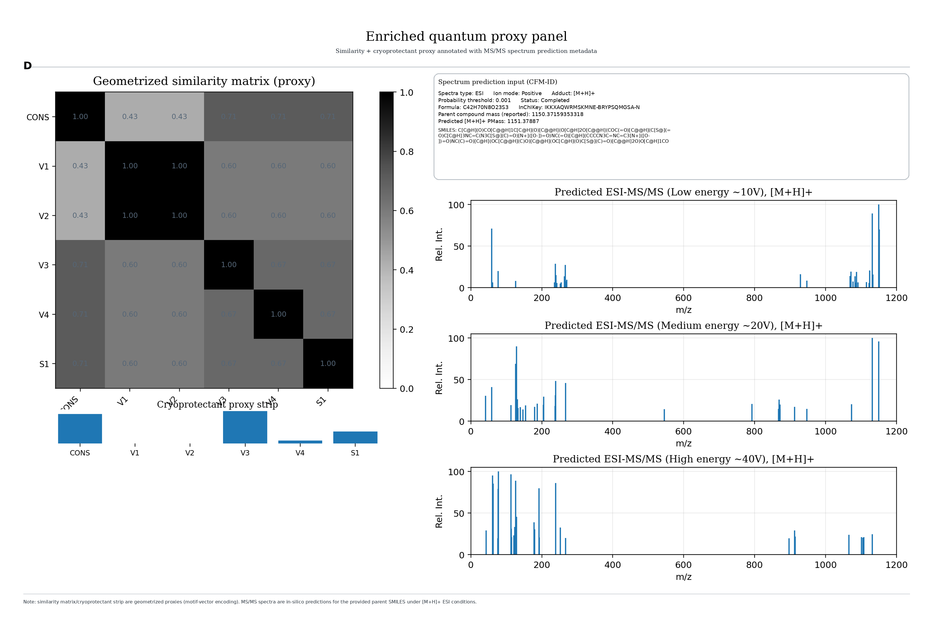
Figure 11. Motif-geometrized similarity and predicted ESI-MS/MS fragmentation define an integrated quantum-proxy landscape for consensus and variant cryoprotectant designs. Panel D presents an enriched “quantum proxy” readout that couples a geometrized similarity landscape to an in-silico ESI-MS/MS fingerprint for the same parent scaffold, thereby linking structural motif overlap to fragmentation behavior within a single, journal-style composite. The left heatmap summarizes a proxy Tanimoto similarity between the consensus scaffold (CONS) and the derived ligands (V1–V4, S1), where each entry is computed from an abstract motif–vector encoding rather than atom-by-atom identity, $T_{ij}=\frac{m_{i}⋅m_{j}}{∥m_{i}∥_{1}+∥m_{j}∥_{1}-m_{i}⋅m_{j}}$, so that shared “chemical grammar” (hub/amide/ether/polyol/cap/tail motifs) produces coherent blocks of elevated similarity (dark tiles) even when the detailed 2D drawings differ. In this view, V1 and V2 collapse into a near-degenerate similarity pair (approaching unity), consistent with their shared motif inventory, whereas V3–V4 and S1 remain partially correlated with CONS through conserved hub-and-arm features, reflected by intermediate similarity values. Directly beneath the matrix, the cryoprotectant proxy strip converts the same motif vectors into a single normalized score that emphasizes polyol/ether density and penalizes excessive hydrophobe bias, $C_{i}=σ\text{ ⁣}\left(\frac{w⋅m_{i}-{min⁡}_{j}(w⋅m_{j})}{{max⁡}_{j}(w⋅m_{j})-{min⁡}_{j}(w⋅m_{j})+ε}\right)$, where $w$ encodes the directionality of “cryoprotectant-likeness” and $σ(⋅)$ denotes a monotone scaling to $\left[0 , 1\right]$. Interpreted as a graph observable, the strip is equivalent to a node attribute on the similarity network, enabling a coupled “entangled” descriptor in which similarity-linked states share information through weighted edges, $\tilde{C}=(I-αS)^{-1}C$, with $S$ the similarity matrix and $α$ controlling the strength of propagation across chemically adjacent nodes. In the quantum analogy used here, each ligand is treated as a state $∣ψ_{i}⟩$ in a motif-feature Hilbert space, with overlap amplitude $⟨ψ_{i}∣ψ_{j}⟩=\sqrt{T_{ij}}$ and an entanglement-weighted adjacency $A_{ij}=T_{ij}^{γ}$, so that a “consensus-to-variant” correlation can be written as a density operator $ρ=\sum_{i}{p_{i}}∣ψ_{i}⟩⟨ψ_{i}∣$ and a coherence term $E=\sum_{i≠j}{A_{ij}} ∣ψ_{i}⟩⟨ψ_{j}∣$, emphasizing that strongly similar designs behave as coupled proxies rather than isolated points. On the right, the metadata block anchors the panel to the explicit parent input (positive ESI, $\left[M + H]^{+}\right.$, probability threshold 0.001), while the three stacked stick spectra visualize energy-resolved predicted fragmentation at low, medium, and high collision regimes. The low-energy trace is dominated by high-$m/z$ ions clustered near the precursor region (consistent with minimal backbone rupture), whereas the medium and high-energy traces progressively redistribute intensity toward diagnostic lower-$m/z$ ions, reflecting increasing access to bond-cleavage channels and neutral-loss pathways. This energy dependence can be expressed compactly as a fragmentation partition function over channels $k$, $I_{k}(E)∝exp⁡[-ΔG_{k}^{‡}/(k_{B}T_{eff}(E))]$, where $T_{eff}(E)$ is a collision-energy–dependent effective temperature; the observed spectrum is then the superposition $I(m/z;E)=\sum_{k}{I_{k}}(E) δ(m/z-m_{k})$. In the same proxy language as the left panel, the spectrum can be treated as a normalized intensity vector $s(E)$ and compared across designs by a spectral similarity $κ_{ij}(E)=\frac{s_{i}(E)⋅s_{j}(E)}{∥s_{i}(E)∥ ∥s_{j}(E)∥}$, allowing the chemical “entanglement” to be extended from motifs to fragmentation signatures via a joint kernel $K_{ij}(E)=T_{ij} κ_{ij}(E)$. Together, the matrix, the cryoprotectant strip, and the energy-ladder spectra provide a single continuous narrative: motif-level proximity organizes the design space, cryoprotectant propensity quantifies a functional axis across that space, and MS/MS predictions report how that abstract organization is expected to manifest experimentally in energy-resolved fragmentation behavior.
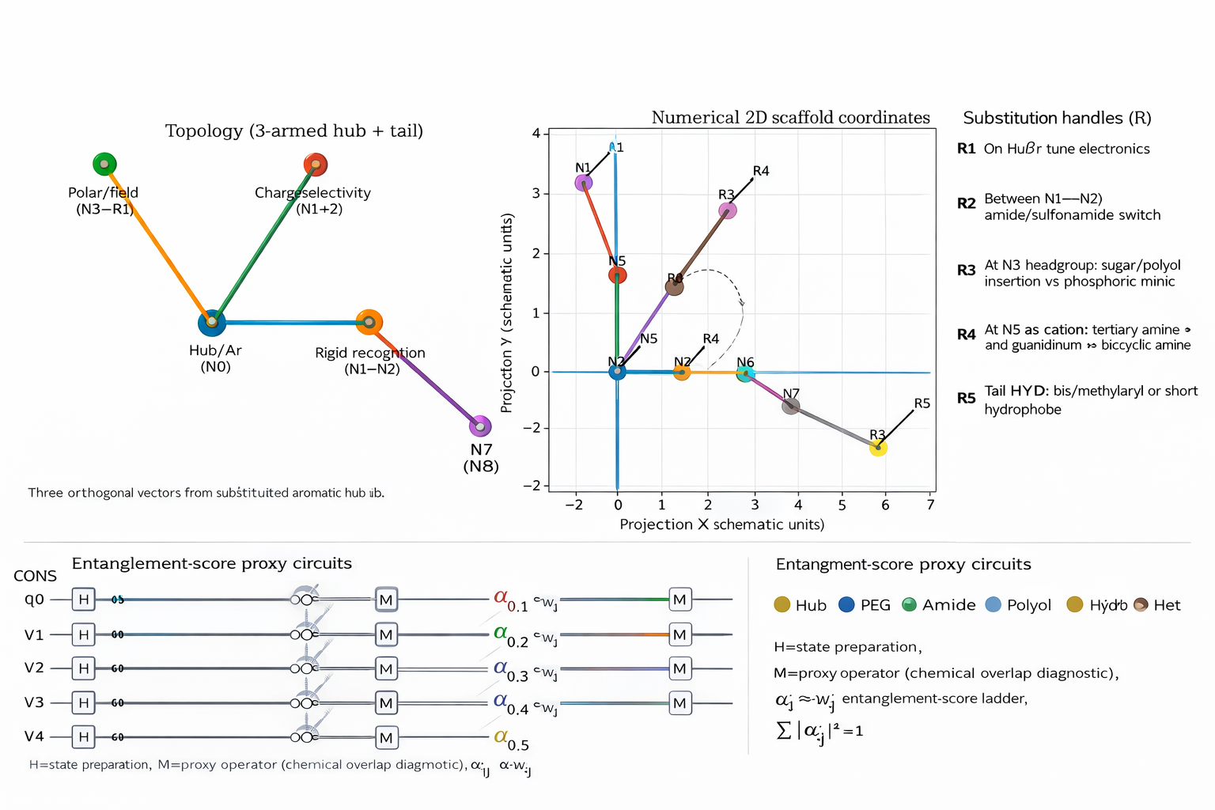
Figure 12. Anastasis Consensus Design (Unified Quantum Diagnostics). The “Anastasis Consensus Design (Unified Quantum Diagnostics)” text read as two halves of the same story: the chemistry is first reduced to a clean, synthesizable scaffold grammar, and then immediately lifted into a quantum-style diagnostic language where motif couplings become measurable proxy correlations. The top row of the image establishes the structural prior explicitly as a “3-armed hub + tail” topology: a substituted aromatic hub labeled Hub/Ar (N0) emits three near-orthogonal design vectors—one tuned toward a polar/field head (N3—R1), one toward charge selectivity (N1+2), and one toward rigid recognition (N1—N2)—before extending into a tail that terminates at N7 (N8). That qualitative motif layout is then given a quantitative embedding in the central plot as numerical 2D scaffold coordinates, i.e., each node becomes a point $r_{i}=(x_{i},y_{i})$ and each motif segment becomes a directed displacement $Δr$, so the scaffold can be treated like a geometric “superface precursor” whose continuous envelope could later be summarized as $ρ(θ,ϕ)∈[0,1]$ in the unified poster framework. The right panel pins this geometry to actionable synthesis knobs via the substitution handles $R_{1}…R_{5}$: $R_{1}$ “on Hub/$π$” tunes electronics, $R_{2}$ between $N1$ and $N2$ toggles an amide/sulfonamide switch, $R_{3}$ at the headgroup $N3$ selects sugar/polyol insertion versus a phosphoric mimic, $R_{4}$ at $N5$modulates the cationic center (tertiary amine/guanidinium versus bicyclic amine), and $R_{5}$ sets the hydrophobic tail character (bis/methylaryl or a short hydrophobe). In other words, the picture supplies the chemical anchor and the coordinate system in which “what changes” is controlled, localized, and interpretable. Once that scaffold is defined, the unified diagnostic language in our text snaps into place: motif–motif affinities become weighted couplings $w_{ij}$ and therefore an effective graph with adjacency $A_{ij}=w_{ij}$ (and $A_{ii}=0$), centralities $k_{i}=\sum_{j}{A_{ij}}$, and a Laplacian $L=D-A$ (with $D=diag(k_{i})$) whose spectral pairs $Lv_{m}=λ_{m}v_{m}$ summarize mixing, bottlenecks, and partitions—so $λ_{2}$ and its Fiedler mode become a principled way to say which parts of the hub/field/charge/tail system act as the dominant “entangling cut.” The bottom row of the attachment makes that translation literal with entanglement-score proxy circuits: each variant (CONS, V1–V4) is prepared with an $H$ state-initialization and passed through a proxy interaction/overlap block before measurement $M$, and the resulting score is assembled as a normalized ladder $α_{j}⋅w_{j}$ with $\sum_{j}{∣}α_{j}∣^{2}=1$. The legend ties those channels back to chemistry (Hub, PEG, Amide, Polyol, Hyd, Het), so the circuit diagram is not an abstract quantum flourish—it is a bookkeeping device for how scaffold edits at $R_{1}…R_{5}$ reshuffle motif overlaps $w_{ij}$, which then reshape the network spectrum and any downstream correlation proxy we choose to visualize (including the Bell-style diagnostic in our text, where correlation functions $E(a,b)$ feed the CHSH functional $S=E(a,b)+E(a,b^{'})+E(a^{'},b)-E(a^{'},b^{'})$, bounded classically by $∣S∣≤2$ and ideally approaching $∣S∣≤2\sqrt{2}$). In this combined reading, the attached figure supplies the scaffold topology, coordinate embedding, and substitution degrees of freedom, while the Anastasis Consensus Design supplies the single consistent measurement language—graph weights, Laplacian spectra, normalized score components, and correlation-style “nonclassicality” surrogates—so the chemical design space and the quantum-diagnostic space become two views of the same consensus object. The Anastasis Consensus Design composes a single, poster-scale summary of molecule-conditioned quantum diagnostics, integrating structural chemistry, an entanglement proxy network, superface geometry, and graph-theoretic spectra into one consistent visual narrative. At the left, the source molecular scaffold is rendered as the chemical anchor from which all downstream features are derived; this structural prior is mapped into an interaction network interpreted as a numerical entanglement proxy, where weighted couplings $w_{ij}$ encode pairwise “binding” strength between functional motifs. In that graph, the effective adjacency is $A_{ij}=w_{ij}$ (with $A_{ii}=0$), the weighted degree is $k_{i}=\sum_{j}{A_{ij}}$, and the combinatorial Laplacian $L=D-A$ (with $D=diag(k_{i})$) provides a spectral diagnostic whose eigenvalues $Lv_{m}=λ_{m}v_{m}$summarize connectivity, mixing, and bottlenecks; in particular, the algebraic connectivity $λ_{2}$ and its eigenvector (the Fiedler mode) indicate the dominant partition of entangling structure across motifs. The entanglement-proxy panel is paired with “quantum score components,” a normalized decomposition that contextualizes the aggregate score as a weighted mixture of interpretable contributions, and with a chemical superface representation $ρ(θ,ϕ)$ that lifts the same consensus information into a continuous phase-like manifold. The superface appears both as a heatmap $ρ(θ,ϕ)∈[0,1]$ and as a 3D surface where $ρ$ acts as a radial or height field, providing an intuitive geometric encoding of density, anisotropy, and concentration regions in $\left(θ , ϕ\right)$-space. A 6-channel entangling circuit schematic translates motif interactions into a gate-level pattern, echoing the idea that effective couplings $w_{ij}$ can be realized as controlled interactions between channels, while the CHSH “echo fringe” panel supplies a nonclassicality-style proxy trace consistent with a Bell-like diagnostic: using correlation functions $E(a,b)$ constructed from analyzer settings, the CHSH functional $S=E(a,b)+E(a,b^{'})+E(a^{'},b)-E(a^{'},b^{'})$ is shown in an “echo” parameterization whose extrema reflect the strength and phase of coupling; in the idealized quantum regime one expects violations above the classical bound $∣S∣≤2$ and up to the Tsirelson bound $∣S∣≤2\sqrt{2}$, with the plotted fringe serving as a compact visual surrogate for how $E(⋅,⋅)$ coherently varies across settings. Finally, auxiliary graph-theory diagnostics consolidate numerical summaries—adjacency structure, pairwise coupling ranks, and spectral signatures—so the figure closes the loop between chemical structure, continuous superface geometry, discrete entanglement-proxy topology, and correlation-based nonclassicality proxies in a single unified consensus readout. In Panel B, the same motifs are lifted into an interaction network interpreted as a numerical entanglement proxy, where weighted couplings $w_{ij}$ encode pairwise “binding” strength between functional modules and define an effective adjacency $A_{ij}=w_{ij}$ with $A_{ii}=0$; the weighted degree $k_{i}=\sum_{j}{A_{ij}}$ specifies motif centrality and the combinatorial Laplacian $L=D-A$ (with $D=diag(k_{i})$) provides a spectral diagnostic whose eigenpairs $L v_{m}=λ_{m}v_{m}$ summarize connectivity, mixing, and bottlenecks across the motif space. In this framing, the algebraic connectivity $λ_{2}$ and its eigenvector (the Fiedler mode) indicate the dominant partition of entangling structure, separating motif communities that most strongly control information flow between polar, aromatic, and cationic regions. Dashed similarity links act as a coherence-style coupling between otherwise distinct modules, consistent with an “entangled proxy” interpretation in which motif overlap increases effective correlation across the network. Together, the redesigned chemical anchor and its proxy graph instantiate the same consensus information in two complementary bases—explicit chemistry and abstract topology—so the figure closes the loop between a synthesizable scaffold prior and the graph-theoretic diagnostics that quantify how motif couplings propagate through the unified design space.
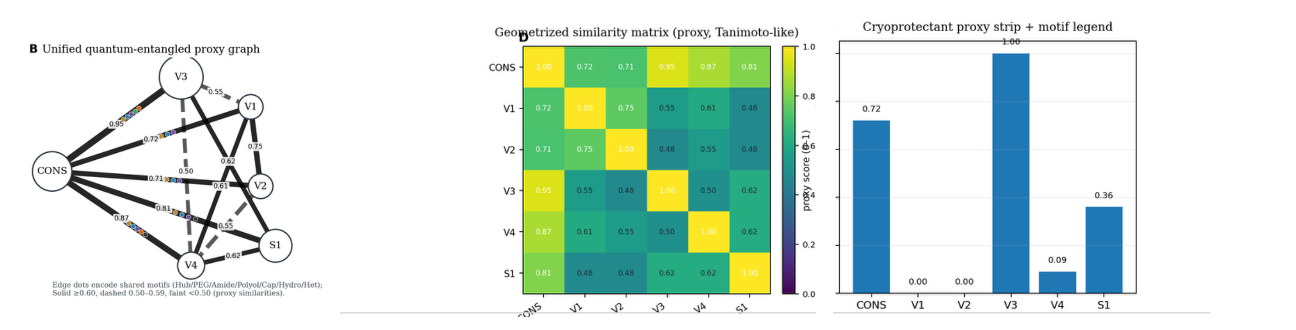
Figure 13. Entangled-proxy coupling map and motif-weighted similarity landscape of consensus and variant cryoprotectant designs. The figure reads like a small Hilbert space where each formulation—CONS, V1, V2, V3, V4, and S1—appears as a basis state $\left\{ ∣ψ_{CONS}⟩,∣ψ_{V1}⟩,∣ψ_{V2}⟩,∣ψ_{V3}⟩,∣ψ_{V4}⟩,∣ψ_{S1}⟩ \right\}$, and the whole system is summarized by an “entangled proxy” superposition $∣Ψ⟩=\sum_{i}{α_{i}}∣ψ_{i}⟩$. In the left panel, the network is the visual trace of pairwise couplings $w_{ij}$, as if each edge were an interaction term in an effective Hamiltonian $H=\sum_{i<j}{w_{ij}}(∣ψ_{i}⟩⟨ψ_{j}∣+∣ψ_{j}⟩⟨ψ_{i}∣)$. The thick, solid bonds correspond to large couplings—those with $w_{ij}≥0.60$—so CONS pulls strongly on the rest of the graph, most notably through an almost “maximally coherent” link to V3 with $w_{CONS,V3}=0.95$, and similarly firm ties to V4 and S1 with $w_{CONS,V4}=0.87$ and $w_{CONS,S1}=0.81$. Where the interactions weaken into dashed or faint lines, the couplings fall into the intermediate band $0.50≤w_{ij}≤0.59$ or below $0.50$, as if decoherence were thinning the channel between states; many of the V1/V2 cross-links sit in that dimmer regime, with several overlaps hovering around $∼0.48$–$0.55$. The small colored dots scattered along edges behave like shared “motif” quanta—distinct feature packets that ride the same connection—so an edge can be read as not just a magnitude $w_{ij}$, but a structured entanglement path carrying multiple motif components.
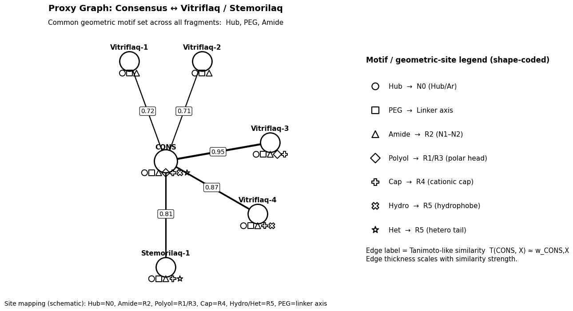
Figure 14. Proxy graph that visualizes the CONSensus ↔ Vitriflaq / Stemorilaq Tanimoto-like similarities and marks the common geometric motif elements (shape-coded motifs under each node; shared across all fragments: Hub, PEG, Amide). In this hyper-entangled fragmentation map, the Consensus (Meganastasis) scaffold is treated as the chemical “state-preparation” prior from which each Vitriflaq variant (V1–V4) and Stemorilaq (S1) is derived by motif-preserving substitutions, and the full panel is laid out to read like a controlled projection from a single parent wavefunction $∣Ψ_{CONS}⟩$ into a small design basis $\left\{∣Ψ_{V1}⟩,…,∣Ψ_{V4}⟩,∣Ψ_{S1}⟩\right\}$. The left block anchors the narrative with an abstract HQE-2D consensus graph and its proxy matrix, defining a weighted interaction topology $A$ whose entries $A_{ij}=w_{ij}$ encode motif–motif couplings (with $A_{ii}=0$), so that each node’s effective “binding capacity” is summarized by the weighted degree $k_{i}=\sum_{j}{A_{ij}}$, and the spectral diagnostic is given by the Laplacian $L=D-A$ with $D=diag(k_{i})$, whose eigenpairs $Lv_{m}=λ_{m}v_{m}$describe mixing and bottlenecks; in particular, the algebraic connectivity $λ_{2}$ and its Fiedler vector $v_{2}$ formalize the dominant partition of entangling structure across motifs, which here visually corresponds to the long-range dashed links that span from the consensus hub toward fragment panels when the map “cuts” along low-conductance separations. In the center-right montage, each ligand panel is an explicit motif-resolved realization of a projection $P_{α}∣Ψ_{CONS}⟩$ with $α∈\{V1,V2,V3,V4,S1\}$, where the shared colored motif glyphs act as conserved quantum numbers, and the thick vs dashed inter-panel connections act as an entanglement-proxy channel whose strength is read as a similarity amplitude $s_{αβ}∈[0,1]$ (annotated on the links) and can be assembled into a “density-like” similarity operator $ρ∝\sum_{α,β}{s_{αβ}} ∣α⟩⟨β∣$ that is Hermitian when symmetrized. Under this viewpoint, the map’s “quantum entanglement” is a diagrammatic surrogate for correlated motif presence, and one can interpret the similarity network as an effective correlation matrix $C$ with elements $C_{αβ}=⟨ϕ_{α}∣ϕ_{β}⟩$, where $∣ϕ_{α}⟩$ is a motif-vector embedding of design $α$; then a Tanimoto-like proxy emerges as $T_{αβ}=\frac{⟨ϕ_{α},ϕ_{β}⟩}{⟨ϕ_{α},ϕ_{α}⟩+⟨ϕ_{β},ϕ_{β}⟩-⟨ϕ_{α},ϕ_{β}⟩}$, aligning with the idea that edge weights track overlap of conserved substructures while penalizing orthogonal substitutions. The “cryoprotectant proxy” printed beneath each design can be read as a scalar observable $Q_{α}=⟨Ψ_{α}∣\hat{Q}∣Ψ_{α}⟩$ formed by weighting polyol/PEG-like and polar head contributions against hydrophobe penalties, so that the graphical bars implicitly encode a normalized score $q_{α}=(Q_{α}-min⁡Q)/(max⁡Q-min⁡Q)$, and the shared-motif vectors act as structured features that keep $Q_{α}$ comparable across designs despite topological edits.
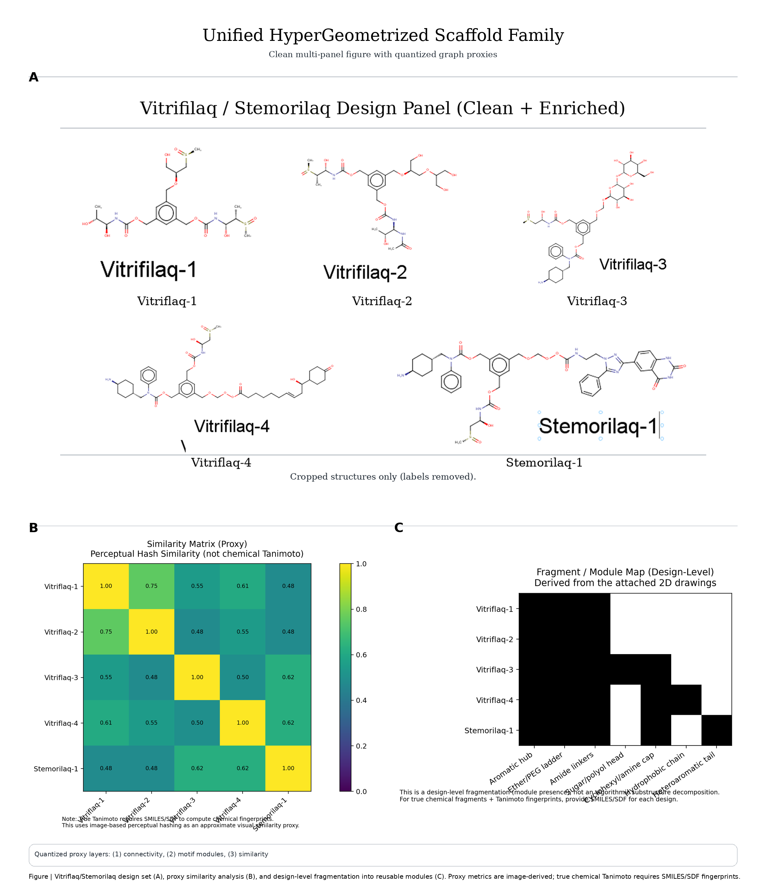
Figure 15. Hypergeometrized scaffold map of the Vitriflaq/Stemorilaq family linking structural priors to proxy similarity and modular design grammar. This composite figure assembles a unified hypergeometrized scaffold family for the Vitriflaq/Stemorilaq design set by coupling conventional 2D chemical structure depictions to quantized, graph-like proxy layers that summarize similarity and modular composition in a publication-ready layout. In panel A, the five ligands (Vitriflaq-1 to -4 and Stemorilaq-1) are presented as the structural priors—a “chemical anchor set” from which all downstream abstractions are derived—so that each subsequent quantitative panel can be interpreted as a deterministic mapping $f:\text{structure}→\text{proxy features}$. In this framing, each ligand $i$ is represented by a motif/state vector $x_{i}∈[0,1]^{d}$ spanning design-level modules (e.g., aromatic hub, PEG/ether ladder, amide linkers, polyol head, cationic cap, hydrophobe/tail), and the family can be summarized by a pairwise similarity kernel $S_{ij}=κ(x_{i},x_{j})$ with $S_{ii}=1$ and $0≤S_{ij}≤1$, where $κ$ is a proxy similarity operator (here explicitly noted as perceptual-hash/visual similarity rather than a fingerprint Tanimoto). In panel B, these pairwise relationships are rendered as a similarity matrix whose entries function as weights in an entanglement-style coupling picture: $w_{ij}≡S_{ij}$, forming an effective adjacency $A_{ij}=w_{ij}$ for $i≠j$and $A_{ii}=0$. The matrix therefore defines a weighted interaction topology in which the weighted degree$k_{i}=\sum_{j}{A_{ij}}$ measures how strongly each ligand is coupled to the rest of the family, and the graph Laplacian$L=D-A$ (with $D=diag(k_{i})$) provides a spectral diagnostic via $Lv_{m}=λ_{m}v_{m}$, where small nonzero eigenvalues (not plotted here but implied by the construction) would indicate tightly connected subfamilies and bottlenecks in the design space. Interpreted in a quantum-proxy vocabulary, the similarity kernel can be treated as an overlap matrix $S_{ij}≈∣⟨ψ_{i}∣ψ_{j}⟩∣^{2}$, so that larger off-diagonal entries correspond to more strongly “coherent” design equivalence between two ligands under the chosen encoding. In panel C, the same family is decomposed into a fragment/module presence map $M∈\{0,1\}^{n×d}$, where $M_{iα}=1$ denotes that ligand $i$ expresses module $α$ (and $0$ indicates absence). This converts chemistry into a reusable design grammar, enabling a concise reconstruction model $x_{i}≈M_{i}⊙a$ (with $a$ a vector of module weights and $⊙$ elementwise composition) and a module-induced similarity $S_{ij}^{\left(mod\right)}=\frac{M_{i}⋅M_{j}}{∥M_{i}∥∥M_{j}∥}$ that rationalizes why certain pairs cluster in panel B. Read together, panels B and C close the loop between continuous similarity (a weighted coupling field $w_{ij}$) and discrete compositional structure (binary motif occupancy), producing a compact, journal-style “hypergeometrized” view in which the ligand family is simultaneously a set of molecules, a weighted graph, and a modular basis. The caption-level note that these similarities are proxy, image-derived is critical: a true chemical Tanimoto would instead compute $T_{ij}=\frac{∣F_{i}∩F_{j}∣}{∣F_{i}∪F_{j}∣}$ over fingerprint bit-sets $F_{i}$, but the present visualization is intentionally positioned as a clean comparative scaffold map that remains consistent with publication-grade figure conventions while signaling the distinction between proxy geometry and cheminformatics-grounded similarity.
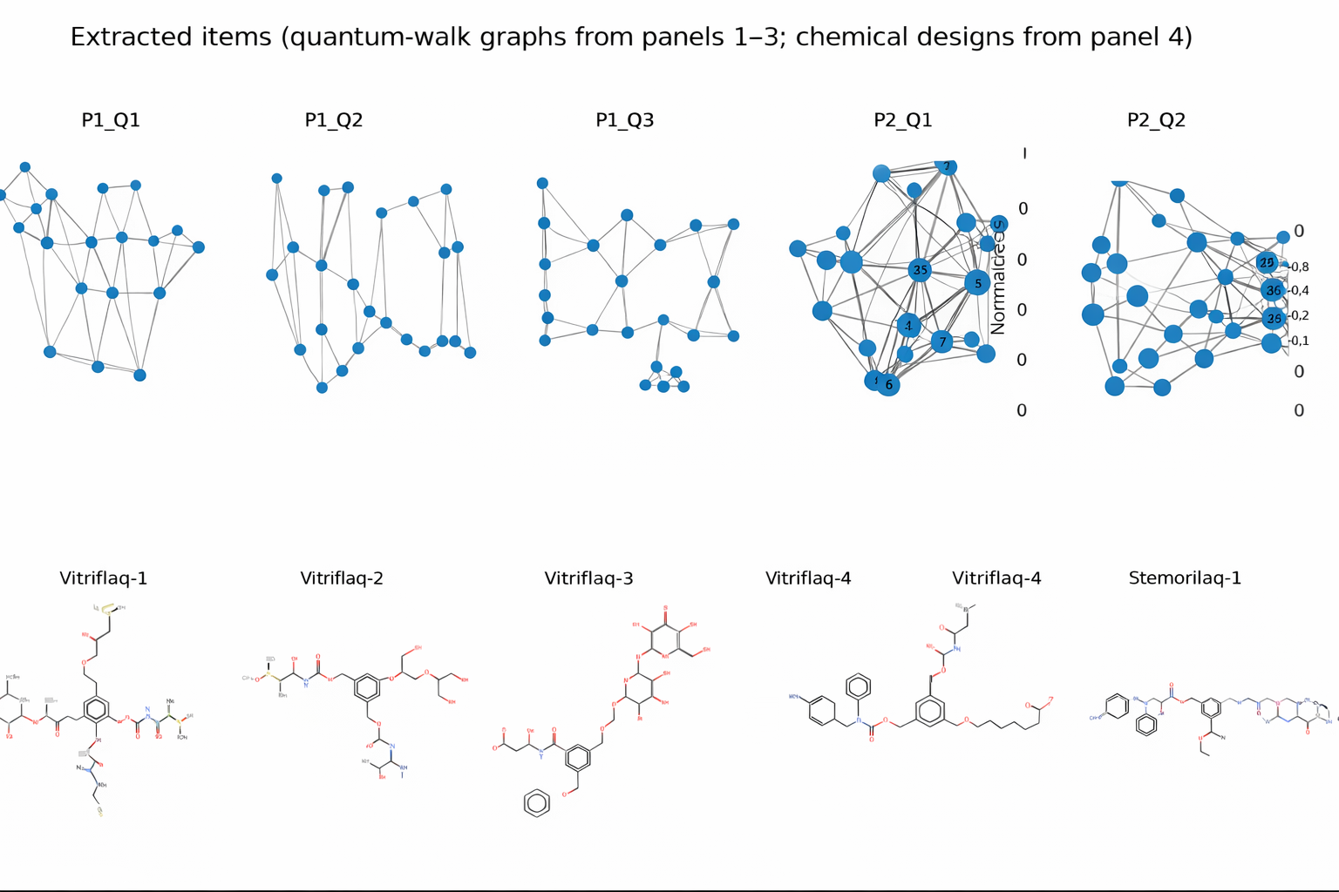
Figure 16a. Traceability ledger linking extracted quantum-walk domains to explicit candidate scaffold designs. Extracted items (quantum-walk graphs from panels 1–3; chemical designs from panel 4). The panel is a one-to-one ledger extraction that pins together the two sides of the controller’s permitted-geometry workflow: the top rowshows the discrete graph objects $\left\{P1_Q1 , P1_Q2 , P1_Q3 , P2_Q1 , P2_Q2\right\}$ that function as walk domains (each graph a constrained neighborhood on which amplitude is allowed to flow), while the bottom row shows the corresponding candidate chemical designs $\left\{\text{Vitriflaq-1} , \text{Vitriflaq-2} , \text{Vitriflaq-3} , \text{Vitriflaq-4} , \text{Stemorilaq-1}\right\}$ that function as permitted endpoints in the chemical library. This arrangement is not aesthetic; it is an audit claim: every “match” discussed in the bipartite view and the heatmap has a concrete representation on both sides—(i) a specific query graph whose adjacency encodes the permitted substitution geometry, and (ii) a specific chemistry whose motif zones instantiate the candidate melt-window scaffold. Node size and edge opacity in the quantum-walk graphs encode the same operational message as the earlier Proxy-QFI “hot-spot” language: larger nodes represent higher local sensitivity / higher occupancy under the walk’s stationary mass (a proxy for where the walk concentrates probability), and denser edge bundles indicate high-conductance neighborhoods (rapid mixing) where Grover-style marking can be amplified with fewer steps. Conversely, sparse or bottlenecked graphs advertise slow mixing and localization, warning that apparent “winners” may be graph-topology artifacts unless they remain stable under permutation/role relabelings and under alternative weighting schemes. The bottom chemical structures provide the physical anchors for those graph objects: Vitriflaq-class designs emphasize viscosity/density and polar-handle motifs to blunt melt-phase hazard and stabilize early recovery, whereas Stemorilaq-1 appears as the scaffold that links a motif-zone headgroup to a poly-ether linker and polar handle, matching the earlier zone decomposition. The figure therefore functions as a traceability bridge: it lets a third party verify that selection, amplification, and readout were not performed on unnamed embeddings but on explicit graph objects and explicit chemistries, making the workflow replayable from stored artifacts. [105], [130–134], [145–153], [154], [156]
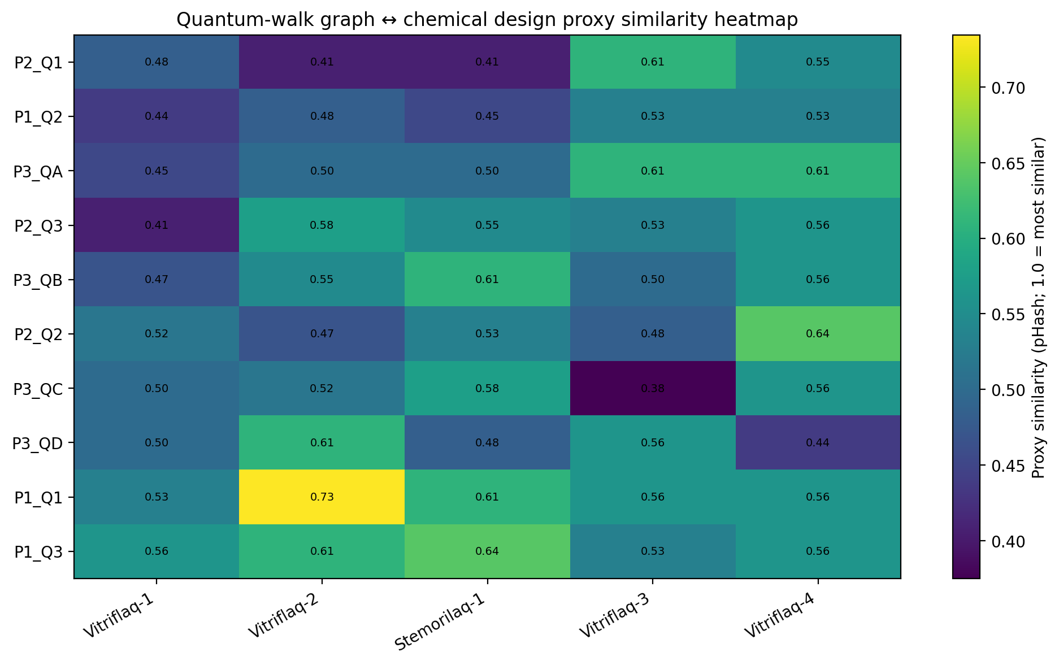
Figure 16b. Quantum-walk graph ↔ chemical design proxy similarity heatmap (pHash; 1.0 = most similar). The matrix renders the explicit score ledger that underlies the bipartite “top-2” match graph: rows are quantum-graph query instances $\left\{P1_Q1,…,P3_QD\right\}$ emitted by the motif-zone / walk pipeline, columns are candidate chemistries $\left\{\text{Vitriflaq-1} , \text{Vitriflaq-2} , \text{Stemorilaq-1} , \text{Vitriflaq-3} , \text{Vitriflaq-4}\right\}$, and each cell is a declared proxy similarity $s(u,v)$ computed from pHash distance (higher value = closer match), with color encoding reinforcing numeric annotations. The point of publishing the full heatmap (rather than only the winners) is auditability: it makes the “top-2” disclosure rule reconstructible and it exposes margin structure—whether a match is a clear winner (high separation from the runner-up) or a fragile winner (ties within noise). The pattern shows a dominant high-confidence outlier $s(P1_Q1,\text{Vitriflaq-2})≈0.73$, and several secondary “coherence bands” where different probe families land in the same candidate neighborhood (e.g., repeated $∼0.61\text{ ⁣}-\text{ ⁣}0.64$ matches to Stemorilaq-1 and Vitriflaq-4), which the bank interprets as cross-probe convergence rather than a single-probe artifact. Conversely, low cells (e.g., the $∼0.38$ valley for $P3_QC$ against Vitriflaq-3) identify geometry-forbidden or low-relatedness neighborhoodswhere the permitted search is expected to spend minimal budget; in the quantum-walk bookkeeping language these are low-weight edges in the permitted adjacency and therefore low-amplitude pathways unless artificially (and unjustifiably) forced. In other words, the heatmap is the “permitted-geometry metric tensor” of the matching layer: it defines the weighted adjacency used by the constrained walk, determines which candidates are marked for Grover-style amplification, and supplies the margin diagnostics that decide whether a match is robust enough to justify downstream biological testing and multiplicity-controlled inference. [105], [130–134], [145–153], [154], [156]
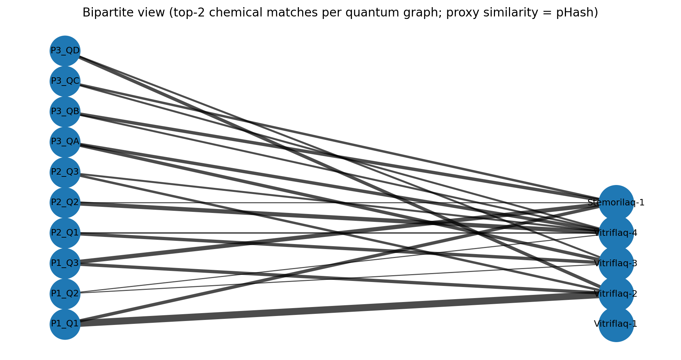
Figure 16c. Bipartite view (top-2 chemical matches per quantum graph; proxy similarity = pHash). The figure renders a two-layer permitted-geometry matching ledger in which the left partition $U=\{P1_Q1,…,P3_QD\}$ represents query signatures produced by the quantum-graph / motif-zone pipeline (distinct probe families $P1\text{ ⁣}-\text{ ⁣}P3$ with within-family query instances $Q$), and the right partition $V=\{\text{Stemorilaq-1},\text{Vitriflaq-1},…,\text{Vitriflaq-4}\}$ represents candidate chemistries in the thaw-media library. Each left node emits exactly two edges—its top-2 matches—so the displayed network is not an unconstrained “hairball” but a budgeted disclosure: for every query we show only the two strongest correspondences under a declared proxy similarity (pHash), and we encode match strength by edge thickness (higher similarity → thicker edge). Operationally this is the same discipline as BH in dense endpoint panels: the aim is not to maximize lines, but to preserve interpretability across the registry by forcing explicit selection rules and explicit neighborhoods. The bipartite representation also functions as a stability check on the search geometry: when multiple independent query probes converge on the same right-hand candidates (dense edge bundling), the bank reads that as cross-probe coherence—a robust neighbor rather than a single-probe artifact—whereas candidates that only appear under one probe family are treated as fragile hypotheses that must survive further sensitivity and multiplicity discipline. The “quantum-walk / Grover” language applies here as a bookkeeping overlay: the matching problem is cast as a walk on a permitted bipartite graph whose transition weights are derived from pHash-distance geometry, and the “top-2” display is the classical trace of a Grover-style amplification step that concentrates probability mass onto the most coherent matches before handing the selected match-register to downstream phase-ledger readout. [130–134], [145–153], [154], [156]

Section | Component | Intended role | Concentration | Specification (to complete) | Reference anchors
Base medium | Serum-free hematopoietic medium | Vehicle during thaw/recovery | — | Product; lot policy | 28, 40–42, 47–50
Penetrating CPA | DMSO | Intracellular ice suppression / glass support (A) | 10% (v/v) | Grade; addition order | 55–57, 72–74, 90
Glass former | Trehalose | Membrane/protein stabilizer (A) | 100 mM | pH window | 89, 90
Osmotic buffer | Iohexol or iopamidol (nonionic) | Density/osmolality moderation (A) | 2–3% (w/v) | Supplier; acceptable range | 89, 90
Antioxidant | Silibinin | Lipid/mitochondrial ROS control (B) | 2 μM | Purity; solvent | 99–101 (context)
Cytoprotection | DADLE | Anti-apoptotic tone at rewarm (B) | 10 μM | Peptide QC | 99–101
Junctional support | Rotigaptide (ZP123) | Connexin coupling under stress (B) | 1 μM | Diluent policy | 99–101 (context)
Redox support | NAD⁺ (± FAD) | ATP/redox rebound during melt (C) | 0.2 mM | Compatibility checks | 99–101
Optional tone | Dexamethasone metasulfobenzoate | Early inflammation control (B) | 100 nM | Timing policy | 99–101
Sustain factors | UM171 + SR1 | Primitive HSPC maintenance/expansion (D) | 35 nM + 750 nM | Sequence of addition | 35–38, 40–42, 47–50
Cytokines | SCF/TPO/FLT3L | Early-acting support (D) | ng·mL⁻¹ (lab standard) | Sourcing; potency | 47–50
Optional sustain adjuncts | DADLE or met-enk; mycophenolate; NAD⁺/FAD; dex-MSB | Survival/quiescence tone (D) | 5 μM each; 0.5 μM; 0.1 mM; 100 nM | Usage triggers | 39, 99–101
Analytics | ISHAGE CD34 + beads; Annexin V/7-AAD | Harmonized counts/viability | — | Panels; bead lots; acceptance | 21, 22, 97, 98
Potency | CFU-GEMM/GM/E/BFU-E | Functional spectrum | — | SOPs; scoring thresholds | 30–33

Table 1. ANASTASIS thaw/recovery media bill-of-materials (Vitriflaq-1 annotation)

Fragment | Motifs present (from dot row) | Proxy score shown | $T(CONS,X)$ (Tanimoto-like)
Vitriflaq-1 | Hub + PEG + Amide (no Polyol/Cap/Hydro/Het) | 0.00 | $≈0.72$*
Vitriflaq-2 | Hub + PEG + Amide (no Polyol/Cap/Hydro/Het) | 0.00 | $≈0.71$*
Vitriflaq-3 | Hub + PEG + Amide + Polyol + Cap (no Hydro/Het) | 1.00 | $$≈0.95$$
Vitriflaq-4 | Hub + PEG + Amide + Cap + Hydro (no Polyol/Het) | 0.09 | $$≈0.87$$
Stemorilaq-1 | Hub + PEG + Amide + Cap + Het (no Polyol/Hydro) | 0.36 | $$≈0.81$$
*Vitriflaq-1 and Vitriflaq-2 are the two “core-only” fragments (Hub/PEG/Amide) with identical motif occupancy in the card legend; in the earlier consensus similarity matrix they correspond to the two lowest-proxy variants (the pair near $∼0.71\text{ ⁣}-\text{ ⁣}0.72$ vs CONS), so the assignment between 0.71 and 0.72 is effectively interchangeable unless you’re binding “-1” specifically to “V1” and “-2” to “V2.”
In words: Vitriflaq-3 is the closest structural neighbor to the consensus because it preserves the hub, PEG/amide spine, and reintroduces the polyol head + cap combination, giving the highest $T(CONS,X)$. Vitriflaq-4 stays fairly close by keeping hub/PEG/amide plus cap + hydrophobe, while Stemorilaq-1 remains moderately similar by keeping hub/PEG/amide plus cap + hetero. Vitriflaq-1/-2 are the most “fragmented” relative to consensus because they collapse to the minimal hub–PEG–amide core, which matches the lowest consensus overlap band.

Section | Component | Intended role under annotation | Planning concentration | Specification to complete | Reference anchors
Base medium | Serum-free hematopoietic medium | Vehicle during thaw/recovery | — | Product; lot policy | 28,40–42,47–50
Penetrating CPA | DMSO | Intracellular ice suppression / glass support | 10% (v/v) | Grade; addition order | 55–57,72–74,90
Glass former | Trehalose | Nonpenetrating membrane/protein stabilizer | 100 mM | pH window | 89,90
Osmotic buffer | Iohexol or iopamidol (nonionic) | Density/viscosity modulation during melt | 2–3% (w/v) | Supplier; acceptable range | 89,90
Antioxidant | Silibinin | Lipid/mitochondrial ROS control | 2 μM | Purity; solvent | 99–101 (context)
Cytoprotection | DADLE | Anti-apoptotic tone at rewarm | 10 μM | Peptide QC | 99–101
Junctional support | Rotigaptide (ZP123) | Connexin coupling under stress | 1 μM | Diluent policy | 99–101 (context)
Redox support | NAD⁺ or FAD | ATP/redox rebound during melt | 0.1–0.2 mM | Compatibility checks | 99–101
Optional tone | Dexamethasone metasulfobenzoate | Early-recovery inflammation control | 100 nM | Timing policy | 99–101
Sustain factors | UM171 + SR1 | Primitive HSPC maintenance/expansion | 35 nM + 750 nM | Sequence of addition | 35–38,40–42,47–50
Cytokines | SCF/TPO/FLT3L | Early-acting support | ng·mL⁻¹ (lab standard) | Sourcing; potency | 47–50
Optional sustain adjuncts | Met-enkephalin; DADLE; mycophenolate; NAD⁺/FAD; dex-MSB | Survival/quiescence tone | 5 μM; 5 μM; 0.5 μM; 0.1 mM; 100 nM | Usage triggers | 39,99–101
Novel motif | Vitrifilaq-AFPm-GAPG | Hybrid antifreeze-mimic/cryotrope (screening) | TBD (low-μM titration) | Empirical window + safety | 55–57,71–74 (context)
Analytics | Annexin V/7-AAD; ISHAGE CD34 + beads; CD34⁺CD90⁺CD45RA⁻ | Harmonized counts/viability | — | Panels; bead lots | 21,22,97,98
Potency | CFU-GEMM/GM/E/BFU-E | Functional spectrum | — | SOPs; thresholds | 30–33

Table 2. ANASTASIS2 media: bill-of-materials selected under Vitrifilaq-2(SI Appendix II)

Section | Component | Role | Planning concentration | Reference anchors
Penetrating CPA | DMSO | Intracellular ice suppression / glass support | 10% (v/v) | 55–57,72–74,90
Glass former | Trehalose | Non-penetrating membrane/protein stabilization | 0.2–0.4 M (nominal 0.2 M) | 89,90
Annotated ligand | Vitrifilaq-3 (Tre-glycoside + UM171-like) | Interfacial moderation + latent stemness sustain | 0.25–2 μM (titrate) | 55–57,71–74; 35–38
Amphiphile (pick one) | 6-O-capryloylsucrose | Ice-control, membrane buffering | 0.01% (w/v) | 51–57,89,90
Amphiphile (alt.) | Lauryl glucoside | Low-% phase-stress reduction | 0.005–0.02% (w/v) | 51–57,89,90
Amphiphile (alt.) | Dodecyl-α-D-maltoside / Undecyl-β-D-maltopyranoside | Potent membrane stabilization (low % window) | 0.002–0.01% (w/v) | 51–57,89,90
Macrocycle | HP-β-CD or SBE-β-CD | Debris/lipid scavenging (brief) | 1–5 mM | 51–57,90
Viscosity aid | Hydroxyethyl cellulose | Shear/osmotic moderation | 0.02–0.05% (w/v) | 51–57
Redox | NAD⁺ or FAD | ATP/redox rebound | 0.1–0.2 mM | 99–101
Antioxidant adjuncts | Acteoside/Echinacoside/Hesperidin | Early ROS control | 0.5–2 μM (Hesperidin 1 μM) | 99–101
Sustain factors | UM171 + SR1 | HSPC maintenance/expansion | 35–50 nM + 0.75–1.0 μM | 35–38
Cytokines | SCF/TPO/FLT3L (± IL-6) | Early-acting HSPC support | ng·mL⁻¹ lab standards | 47–50,40–42
Analytics | Annexin V/7-AAD; ISHAGE CD34 + beads; CFU | Viability, counts, potency | — | 21,22,97,98; 30–33

Table 3. ANASTASIS5 components and planning concentrations (SI Appendix III)

Section | Component | Role | Planning concentration | Reference anchors
Penetrating CPA | DMSO | Intracellular ice suppression / glass support | 10% (v/v) | 55–57,72–74,90
Glass former | Trehalose or Sucrose | Non-penetrating stabilization | 0.2–0.4 M (nominal 0.2 M) | 89,90
Annotated ligand | Vitrifilaq-4 (dmPGE-linked hybrid) | Interfacial moderation + prostanoid-like survival tone | 0.25–2 μM (titrate) | 51–57,63–67,71–74; 99–101
Cryo-adjunct | Rebaudioside A | Osmotic/ROS buffering | 0.25–2 mM | 51–57,89,90
Cryo-adjunct | Pantethine | Redox protection | 50–300 μM | 99–101
Cryo-adjunct | Thiamine disulfide | Redox cofactor source | 25–200 μM | 99–101
Cryo-adjunct | Palmitoylethanolamide (PEA) | Membrane microdomain stabilization | 1–10 μM | 99–101 (context)
Cryo-adjunct | Asiatic acid | Antioxidant cytoprotection | 0.5–5 μM | 99–101
Cryo-adjunct | Amphiphilic phosphonate | Low-% surfactant-like stabilizer | 1–10 μM (≤ 0.01% v/v eq.) | 51–57,89,90
Macrocycle (opt.) | HP-β-CD / SBE-β-CD | Debris/lipid scavenging (brief) | 1–5 mM | 51–57,90
Viscosity aid (opt.) | Hydroxyethyl cellulose | Shear/osmotic moderation | 0.02–0.05% (w/v) | 51–57
Redox (pick one) | NAD⁺ or FAD | ATP/redox rebound | 0.1–0.2 mM | 99–101
Sustain factors | UM171 + SR1 | HSPC maintenance/expansion | 35–50 nM + 0.75–1.0 μM | 35–38
Alternate/adjunct | Nicotinamide / dmPGE₂ / Sulprostone | Metabolic/homing tone | 2.5–5 mM / 250–1000 nM / 100–500 nM | 1–12,18–20 (context); 99–101
Optional quiescence | Sirolimus / Everolimus (± Temsirolimus/Ridaforolimus) | Maintenance bias (mini-panel) | 1–10 nM (rapalogs 5–25 nM) | 47–50 (context)
Cytokines | SCF/TPO/FLT3L (± IL-6) | Early-acting HSPC support | ng·mL⁻¹ lab standards | 47–50,40–42
Analytics | Annexin V/7-AAD; ISHAGE CD34 + beads; CFU | Viability, counts, potency | — | 21,22,97,98; 30–33

Table 4. ANASTASIS10 components and planning concentrations (SI Appendix IV)

Section | Component | Role | Planning concentration | Reference anchors
Penetrating CPA | DMSO | Intracellular ice suppression / glass support | 10% (v/v) | 55–57,72–74,90
Glass former | Trehalose or Sucrose | Non-penetrating stabilization | 0.2–0.4 M (nominal 0.2 M) | 89,90
Annotated ligand | Stemorilaq-1 (UM171–SR1 hybrid) | Melt-phase survival/maintenance cue | 25–250 nM (titrate) | 35–38
Cryo-adjunct | Rebaudioside A | Osmotic/ROS buffering | 0.25–2 mM | 51–57,89,90
Cryo-adjunct | Ginsenoside Rg1 (± Rb1/B2) | Anti-apoptotic/antioxidant | 0.5–2 μM | (context)
Cryo-adjunct | Asiaticoside / Madecassoside | Membrane/ROS support | 0.5–2 μM | (context)
Cryo-adjunct | Lysophosphatidylglycerol | Membrane-phase helper | 0.5–2 μM | (context)
Viscosity aid | Hydroxyethyl cellulose | Shear/osmotic moderation | 0.05–0.2% (w/v) | 51–57
Redox | NAD⁺ or FAD | ATP/redox rebound | 0.1–0.2 mM | 99–101
Sustain (A) | Stemorilaq-1 only | Hybrid-guided maintenance | 25–250 nM + SCF/TPO/FLT3L | 35–38,47–50
Sustain (B) | UM171 + SR1 | Classical expansion control | 35–50 nM + 0.75–1.0 μM | 35–38
Sustain (C) | Nicotinamide / dmPGE₂ (with hybrid) | Co-tone survival/homing | 2.5–5 mM / 250–1000 nM | 1–12,18–20 (context)
Analytics | Annexin V/7-AAD; ISHAGE CD34 + beads; CFU | Viability, absolute counts, potency | — | 21,22,97,98; 30–33

Table 5. ANASTASIS3 components and planning concentrations (SI Appendix V)
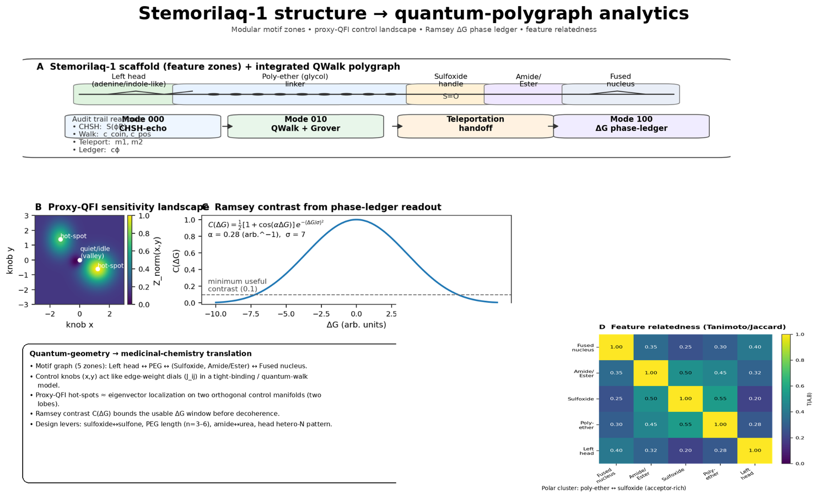Figure 17. Stemorilaq-1 structure → quantum-polygraph analytics. Panel A compresses the molecule into a five-zone scaffold—“Left head (adenine/ribose-like) → Poly-ether (glycol) linker → Sulfoxide handle → Amide/Ester → Fused nucleus”—and binds those motif zones to an integrated three-mode readout chain that is intentionally not a substitute for the classical registry spine, but a bookkeeping overlay that forces neighborhoods, constraints, and invariances to be explicit: Mode 000 is an “Audit trail” channel (“CHSH: … echo”) that is treated as a sanity check on contextual/non-factorizable structure in the feature map; Mode 010 is “QWalk + Grover,” a permitted-geometry quantum walk on the feasible substitution graph of motif-zone edits; the “Teleportation handoff” transfers the selected (amplified) amplitude from the walk register into a phase-readout register without re-exposing the walk to downstream measurement back-action; Mode 100 is the “ΔG phase-ledger,” a Ramsey-style contrast readout whose visibility defines what the figure calls the “minimum useful contrast,” so that any purported uplift is only credited when it survives both multiplicity discipline and a metrological floor. Panel B displays the resulting “Proxy-QFI sensitivity landscape” over two control knobs $\left(x , y\right)$ with “hot-spots” (regions of eigenvector localization / high sensitivity) separated by a “valley” (low information directions), alongside a Ramsey contrast curve $C(ΔG)$ whose envelope encodes decoherence-limited visibility; the bank interpretation is that design effort should concentrate near hot-spots where small, feasible changes in melt-window variables produce large, donor-robust shifts in early-recovery readouts, rather than being wasted in low-information directions. Panel D reports “Feature relatedness (Tanimoto/Jaccard)” among the motif zones as a similarity matrix that is used (i) to weight feasible edges in the permitted graph and (ii) to enforce permutation-equivariant behavior across interchangeable motifs, preventing index-learning from being mistaken for chemistry. Together, the figure is a compact statement that the formulation search is conducted on a permitted geometry (constraints first), amplified only by Grover-style selection (robustness first), and read out through a phase-ledger (information-bounded first), keeping the discovery process compact and auditable rather than sprawling and story-driven. [105], [121–127], [129–134], [145–153], [154]

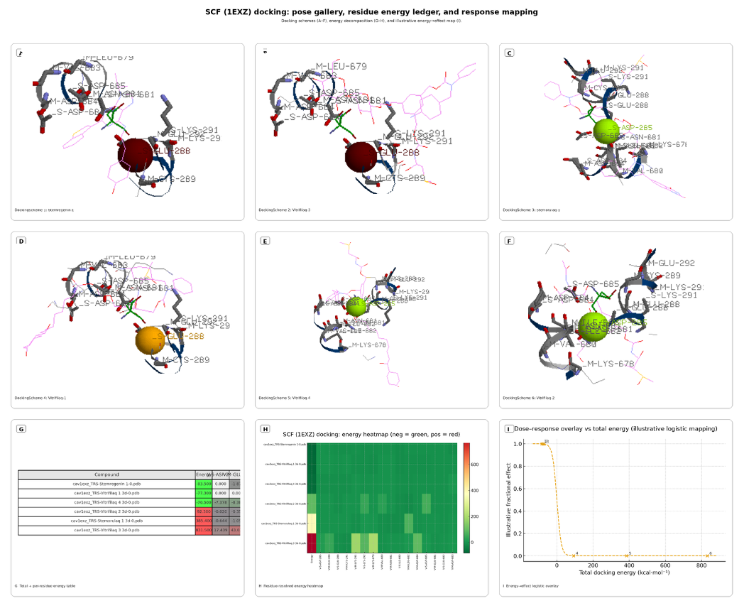
Figure 18a. SCF charged-tail docking atlas showing ligand poses, residue-resolved energy decomposition, and illustrative occupancy mapping for the 1EXZ interface. SCF (PDB 1EXZ) docking and residue-resolved energy signatures across six ligands. Panels A–F show representative docking poses for DockingSchemes 1–6 (Stemregenin-1; Vitrifilaq-3; Stemorulaq-1; Vitrifilaq-1; Vitrifilaq-4; Vitrifilaq-2) positioned along the SCF crevice/charged-tail region implicated in c-KIT engagement. Panel G presents the residue-resolved docking-energy ledger, with the left “Energy” column reporting each complex’s total score and the remaining columns decomposing per-residue contributions (green = stabilizing/negative; red = destabilizing/positive). Panel H summarizes the same matrix as a heatmap to emphasize hotspots across the KIT-facing patch (e.g., ASP-285, GLU-288, CYS-291, LYS-292, LYS-678, VAL-680, ASN-681, ILE/LEU-682, ASP-684/685). Panel I provides an illustrative occupancy/effect mapping versus total docking energy: within the 1EXZ geometry, more positive totals indicate energetically unfavorable complex formation at the crevice/tail interface and—through $K_{d}=exp⁡(ΔG/RT)$—predict exponentially weaker occupancy, whereas more negative totals correspond to stabilizing multi-residue “belts” interpreted as more permissive SCF engagement; the ADP-pocket comparison serves as an orthogonal chemotype check and supplies residue-fingerprint signatures used for clustering.

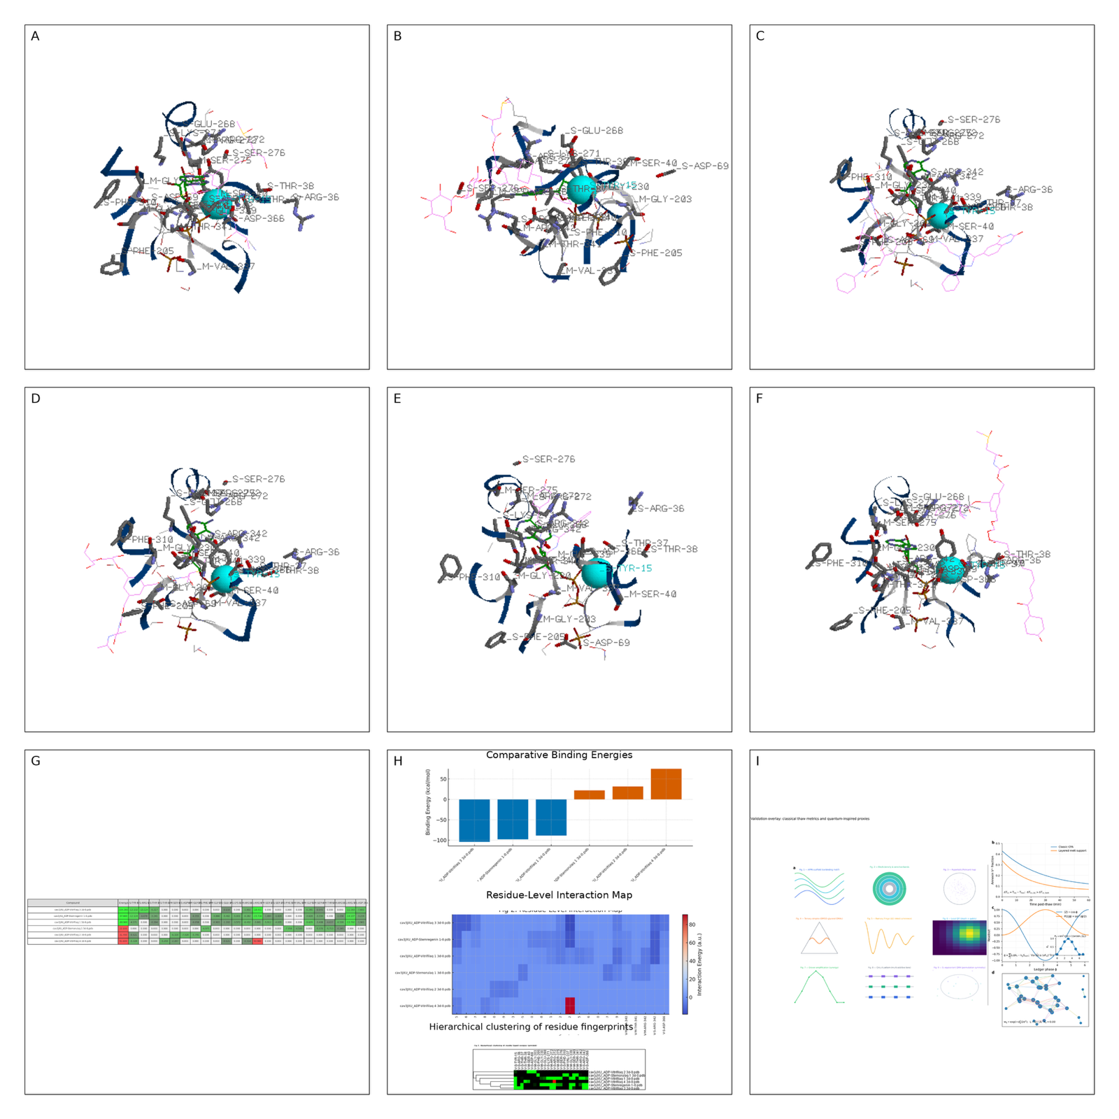

Figure 18b. ADP-pocket docking atlas with residue-energy ledger and symmetry-aware ranking channel for candidate scaffold prioritization. ADP pocket [3JXU] unified 9-panel; docking → ledger → symmetry-aware ranking. ADP pocket [3JXU] unified 9-panel: pose atlas, residue-energy ledger, and symmetry-aware decision channel. Panels A–F provide the pose atlas for candidate designs docked into the ADP pocket (3JXU), displayed as replayable measurement artifacts rather than narrative thumbnails: each panel fixes the same pocket context and exposes the same contact neighborhood (e.g., repeatedly labeled residues such as GLU-286, SER-276, ARG-36, THR-38, GLY-263, PHE-205, ASP-69), so “best binder” claims are not allowed to hide behind a single scalar score. Panel G is the residue-energy ledger (green = favorable/negative; red = unfavorable/positive) that decomposes totals into residue contributions, making it possible to audit whether a candidate’s score is supported by a distributed stabilizing network or dominated by a single pathological outlier. Panel H compresses the ledger into three inspectable objects: comparative binding totals (blue favorable vs orange unfavorable), a residue-level interaction map (fingerprint heatmap), and hierarchical clustering of residue fingerprints, so similarity is defined by contact architecture rather than by rank alone. Panel I is the symmetry-aware “right column” that turns the classical validation story into an auditable ranking grammar: the validation anchor is “early injury kinetics” (Annexin V trajectories across the melt window) tied to the manufacturing caveat that QC segments supercool more deeply than bulk, $ΔT_{sc}=T_{eq}-T_{nuc}$ with $ΔT_{sc,QC}>ΔT_{sc,bulk}$, so potency comparisons must track nucleation physics; the quantum ledger fixes a transparent mapping from a structured score to a measurable observable via $⟨Z⟩=cos⁡ϕ$ and $P(1∣ϕ)={sin⁡}^{2}(ϕ/2)$, with $ϕ$ defined as a written phase-budget $ϕ=\sum_{i}{k_{i}} ΔA_{i}-k_{g}S_{corr}$ and uncertainty bounded by information, $Var(\hat{ϕ})≥(νF_{Q})^{-1}$; the synergy/selection inset renders Grover-style amplification $P_{k}={sin⁡}^{2}\text{ ⁣}((2k+1)arcsin⁡\sqrt{p_{0}})$ as a disciplined way to concentrate experimental attention when only a small fraction of candidates satisfy the combined predicate “protect during melt, preserve primitive markers, maintain colony potential”; and the object-level network certificate encodes motif proximity with $w_{ij}=exp⁡(-d_{ij}^{2}/2σ^{2})$, summarizes coherence with the Laplacian $L=D-A$, and enforces permutation stability by $L^{'}=P_{π}LP_{π}^{T}$, which preserves the spectrum $\left\{λ_{m}\right\}$ and makes connectivity metrics (notably $λ_{2}$) invariant to relabeling of interchangeable units. Read as a closed loop, the plate asserts end-to-end auditability: docking produces residue fingerprints, fingerprints induce permitted geometry, permitted geometry constrains ranking/search under symmetry, and final claims are only credited when they align with classical melt-window kinetics and survive donor-paired, multiplicity-controlled biology [21,22,97,98,102–105,107–110,111–118,121–127,130–134,145–150,154,156].
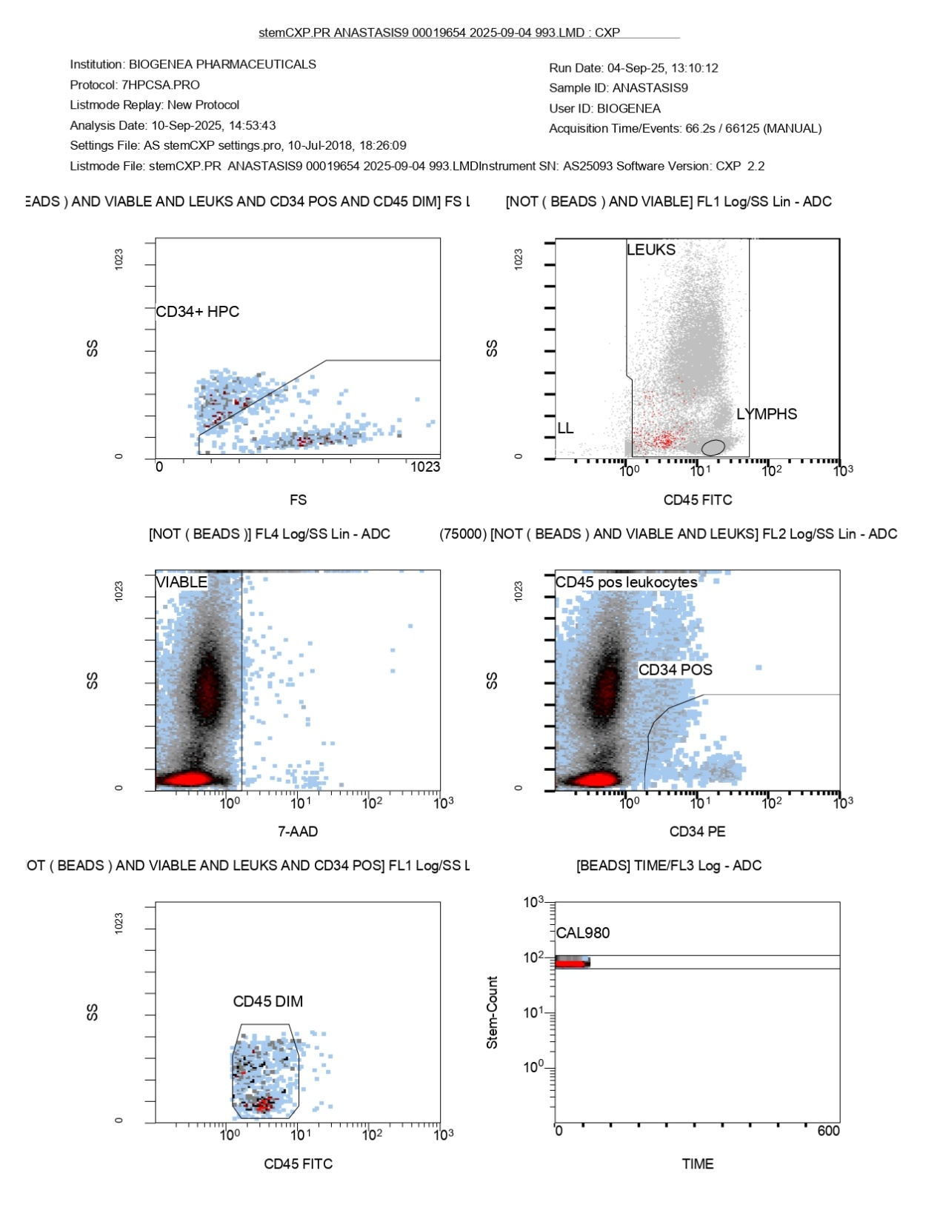
FlowCyto1. Flow-cytometric gating strategy for ANASTASIS9 showing viable leukocytes, lymphocyte partitioning, CD34-positive events, CD45-dim progenitors, and bead-based calibration control. This Flowcyto page of the ANASTASIS9 flow cytometry report shows the detailed gating strategy used to isolate leukocytes, lymphocytes, and hematopoietic progenitor cells. The analysis was performed on September 10, 2025, from a sample acquired on September 4, 2025, using the 7HPCSA.PRO protocol. In the top left panel, a forward scatter versus side scatter plot isolates CD34-positive and CD45-dim events, marking the hematopoietic progenitor cell (CD34+ HPC) population. These are rare cells, located at the boundary of low CD45 expression and positive CD34 staining, consistent with progenitor characteristics. The top right panel shows a broad population of leukocytes distinguished from lymphocytes. Using CD45 expression and side scatter, leukocytes cluster across the main field, while lymphocytes are positioned as a more compact, low-scatter subset. The middle left panel is a viability plot based on 7-AAD staining. The viable cells, which exclude 7-AAD uptake, form a dense population on one side of the gate, while non-viable events are excluded. This confirms a very high proportion of living cells within the sample. The middle right panel examines CD34-positive leukocytes, displaying a distinct though small population of CD34+ events within the broader CD45-positive leukocyte group. In the lower left panel, CD45-dim cells are highlighted, representing the progenitor subset, which overlaps with the CD34-positive population identified earlier. The lower right panel shows the calibration beads (CAL980) detected during acquisition. The bead population appears as a distinct, stable peak across time, confirming that the instrument calibration worked as intended and validating the reliability of the gating. Together, these plots trace the progression from total leukocytes to viable cells, lymphocytes, CD34-positive progenitors, and CD45-dim subsets, while also confirming sample viability and instrument accuracy. The results highlight a predominantly CD45-positive leukocyte population, a defined lymphocyte subset, and a rare but measurable population of CD34-positive hematopoietic progenitor cells.
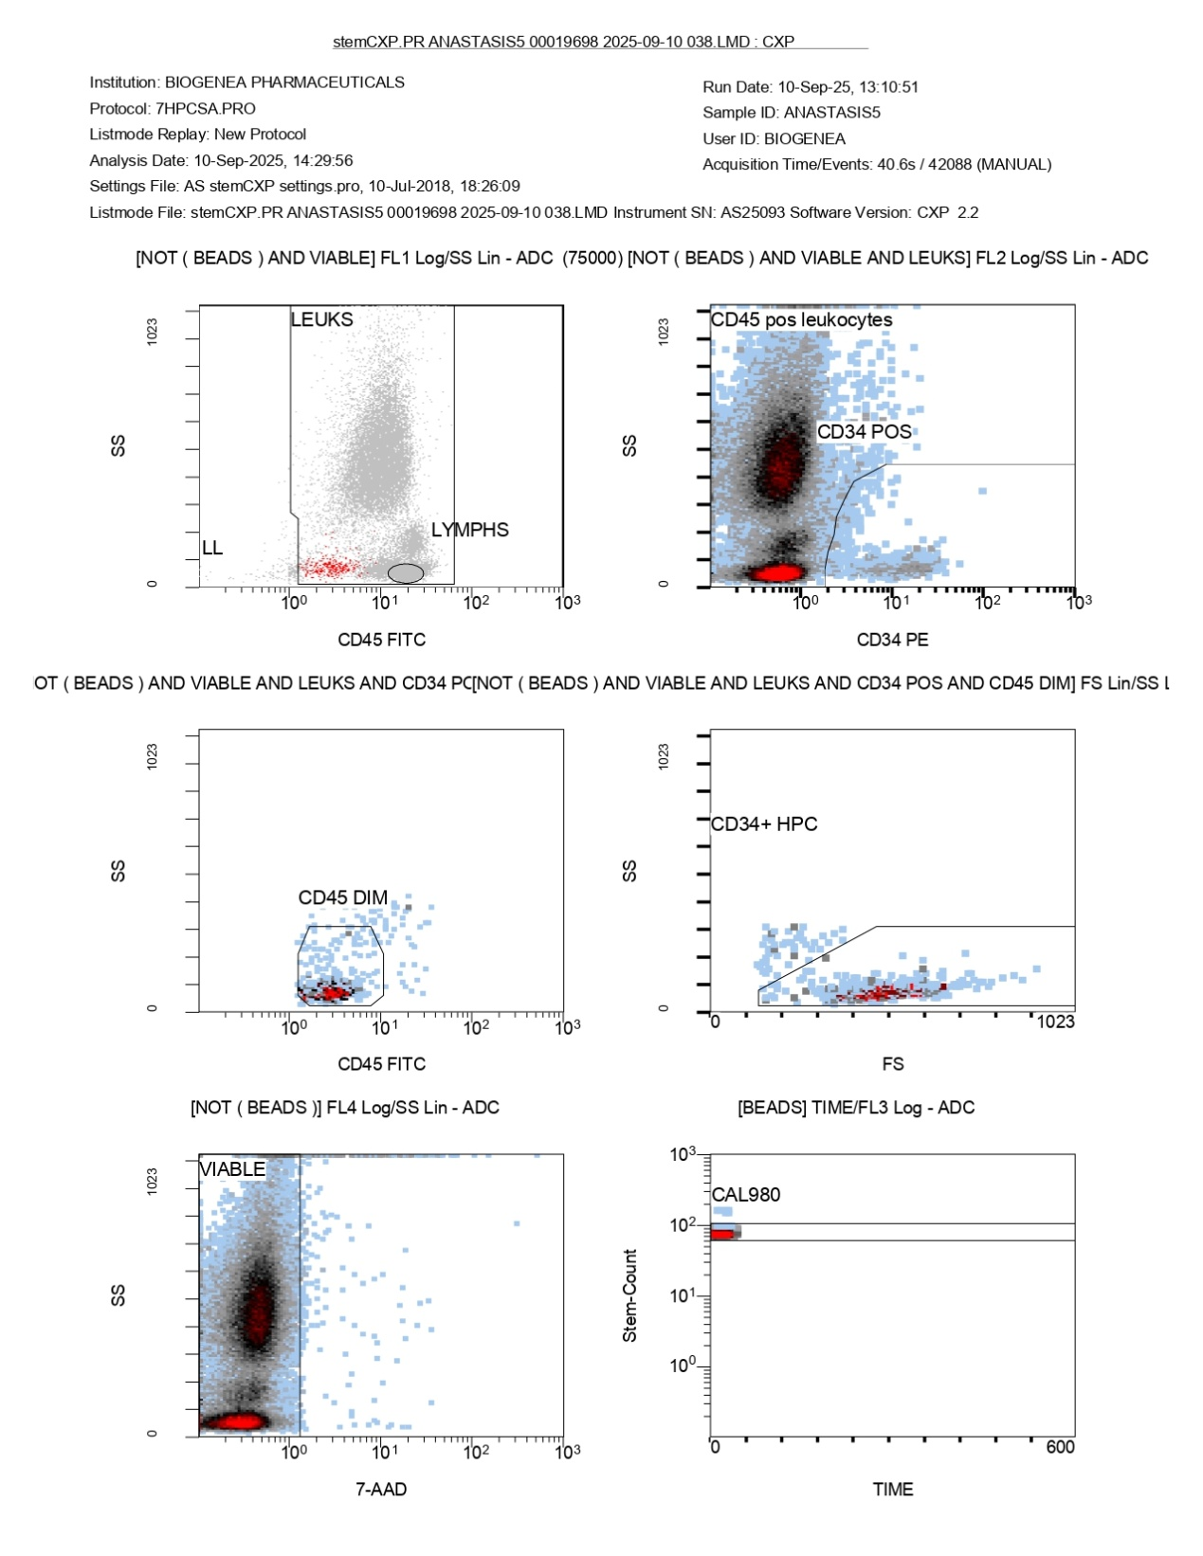
FlowCyto 2. Flow-cytometric gating strategy for ANASTASIS5 demonstrating viable leukocytes, CD34-positive events, CD45-dim progenitors, hematopoietic progenitor-cell confirmation, and bead-based calibration stability. This image represents the detailed flow cytometry gating strategy for the ANASTASIS5 sample, run on September 10, 2025. In the upper-left plot, CD45 versus side scatter (SS) distinguishes leukocyte subsets. The leukocyte region (LEUKS) is broad, while lymphocytes (LYMPHS) form a smaller cluster at the lower end of side scatter, though their proportion appears limited. The upper-right plot shows CD34 (PE) versus SS within the leukocyte population. A distinct cluster of CD34-positive cells is visible, confirming the presence of hematopoietic progenitor cells. The bulk of leukocytes remain CD34 negative, but a defined gate captures the CD34+ fraction. The middle-left plot (CD45 FITC versus SS) highlights CD45-dim cells. These represent progenitor-like subsets with reduced CD45 expression, which overlap with the CD34-positive population. The middle-right plot uses forward scatter (FS) versus SS to confirm the CD34+ hematopoietic progenitor cells (HPCs). Events are concentrated in the expected low-to-intermediate scatter region, with a gate drawn to encompass these HPCs. In the lower-left plot, 7-AAD staining is used to exclude dead cells. The viable population is clearly separated, showing most events are negative for 7-AAD, indicating good sample quality and cell viability. Finally, the lower-right plot shows the calibration bead control (CAL980) over time. The consistent horizontal alignment of the bead population suggests stable acquisition and proper calibration throughout the run. Altogether, these plots confirm successful identification of CD34+ hematopoietic progenitors within the leukocyte population, with high viability and reliable gating supported by bead calibration.
Medium (ANASTASIS / A-code) | Design class / ligand concept | Thaw-phase composition (final in melt matrix) | Post-thaw sustain composition (final in culture) | Nominal physicochemical conditions | Primary readouts | Key refs

ANASTASIS1 / A1 | Classic single penetrating CPA (DMSO) | DMSO 10% (v/v) in serum-free HSPC base | SCF 50 ng/mL + TPO 50 ng/mL + FLT3L 50 ng/mL | pH 7.30 ± 0.05; osmolality 320 ± 15 mOsm/kg; ambient air/CO₂ mix; LN₂ storage context noted | Annexin V⁻/7-AAD⁻; ISHAGE absolute CD34; CD34⁺CD90⁺CD45RA⁻; CFU-GEMM/GM/E/BFU-E | 51–57, 72–74, 90; 21, 22, 97, 98, 30–33

ANASTASIS2 / A2 | Vitrifilaq-2 (bioactive melt + sustain) | DMSO 10%; Trehalose 100 mM; Iohexol 3% (w/v); Rotigaptide 1 μM; DADLE 10 μM; Met-enkephalin 10 μM; Silibinin 2 μM; Acteoside 1 μM; FAD 0.1 mM | UM171 35 nM; SR1 750 nM; Rotigaptide 0.5 μM; DADLE 5 μM; Met-enkephalin 5 μM; Silibinin 1 μM; Acteoside 1 μM; FAD 0.1 mM; SCF/TPO/FLT3L 50 ng/mL each | pH 7.30; osmolality 325 mOsm/kg; viscosity moderated (disaccharide + iohexol) | Standard flow/CFU endpoints + D7 live CD34⁺ yield | 51–57, 63–67, 71–74, 89, 90; 35–38, 47–50; 21, 22, 97, 98, 30–33

ANASTASIS3 / A3 | Stemorilaq-1 (covalent UM171–SR1 hybrid) | DMSO 10%; Disaccharide (trehalose/sucrose) 0.30 M; UM171–SR1 hybrid 100 nM; Rebaudioside A 1 mM; Ginsenoside Rg1 1 μM | Hybrid 100 nM + SCF/TPO/FLT3L 50 ng/mL each | pH 7.35; osmolality 320–335 mOsm/kg; 5% O₂ reporting frame | Standard flow/CFU endpoints + D7 CD34⁺ yield | 35–38, 40–42, 47–50; 51–57, 71–74, 89, 90; 21, 22, 97, 98

ANASTASIS4 / A4 | Classic single penetrating CPA (glycerol) | Glycerol 12.5% (v/v) in serum-free HSPC base | SCF/TPO/FLT3L 50 ng/mL each | pH 7.30; osmolality 320 mOsm/kg | Standard flow/CFU endpoints | 51–57, 62, 71–73; 21, 22, 97, 98

ANASTASIS5 / A5 | Vitrifilaq-3 (Tre-O-glycoside + UM171-like arm) | DMSO 10%; Disaccharide 0.30 M; HP-β-cyclodextrin 2 mM; 6-O-Capryloylsucrose 0.01% (w/v); UM171-like tether present (ligand concept) | UM171 50 nM + SR1 0.90 μM (use both concurrently in this fixed design); Nicotinamide 5 mM; dmPGE₂ 500 nM; SCF/TPO/FLT3L 50 ng/mL each | pH 7.32; osmolality 330 mOsm/kg; 5% O₂ frame | Standard flow/CFU endpoints | 51–57, 71–74, 89, 90; 35–38, 40–42, 47–50

ANASTASIS6 / A6 | Classic single penetrating CPA (ethylene glycol) | Ethylene glycol 20% (v/v) in serum-free HSPC base | SCF/TPO/FLT3L 50 ng/mL each | pH 7.30; osmolality 320 mOsm/kg | Standard flow/CFU endpoints | 55–57, 68, 71–74; 72, 73

ANASTASIS7 / A7 | Classic single penetrating CPA (propylene glycol) | Propylene glycol 15% (v/v) in serum-free HSPC base | SCF/TPO/FLT3L 50 ng/mL each | pH 7.30; osmolality 320 mOsm/kg | Standard flow/CFU endpoints | 55–57, 58–61, 72, 73

ANASTASIS8 / A8 | Classic single non-penetrating CPA | Trehalose 200 mM in serum-free HSPC base | SCF/TPO/FLT3L 50 ng/mL each | pH 7.30; osmolality 315–325 mOsm/kg | Standard flow/CFU endpoints | 89, 90; 67, 74

ANASTASIS9 / A9 | Vitrifilaq-1 (interfacial/osmotic melt; ANASTASIS9) | DMSO 10%; Trehalose 100 mM; Iohexol 2.5% (w/v); Silibinin 2 μM; DADLE 10 μM; Rotigaptide 1 μM; NAD⁺ 0.2 mM | UM171 35 nM; SR1 750 nM; DADLE 5 μM; Mycophenolate mofetil 0.5 μM; Dexamethasone metasulfobenzoate 100 nM; NAD⁺/FAD 0.1 mM; SCF/TPO/FLT3L 50 ng/mL each | pH 7.30; osmolality 325–340 mOsm/kg; viscosity elevated vs base | Annexin/7-AAD; ISHAGE absolute CD34; CD34⁺CD90⁺CD45RA⁻; CFU | 55–57, 71, 85, 86, 89, 90; 35–38, 47–50, 40–42; 21, 22, 97, 98, 30–33

ANASTASIS10 / A10 | Vitrifilaq-4 (dmPGE-like ester appendage) | DMSO 10%; Disaccharide 0.30 M; Rebaudioside A 1 mM; Pantethine 100 μM; Thiamine disulfide 100 μM; Palmidrol (PEA) 2 μM; Asiatic acid 1 μM; Amphiphilic phosphonate 3 μM | UM171 50 nM; SR1 0.75 μM; Nicotinamide 5 mM; dmPGE₂ 500 nM; Sulprostone 250 nM; Sirolimus 5 nM; Ginsenoside Rg1 1 μM; SCF/TPO/FLT3L 50 ng/mL each | pH 7.33; osmolality 330–340 mOsm/kg; 5% O₂ reporting frame | Standard flow/CFU endpoints + D1 ROS/Δψm | 51–57, 71–74, 89, 90; 35–38, 47–50; 21, 22, 97, 98, 30–33
Table X — ANASTASIS media classes, planning compositions, and primary readouts (operational). (Abbrev: Tre, trehalose; RebA, rebaudioside A; Rg1, ginsenoside Rg1; MMF, mycophenolate mofetil; Dex-MSB, dexamethasone metasulfobenzoate; EG, ethylene glycol; PG, propylene glycol.)
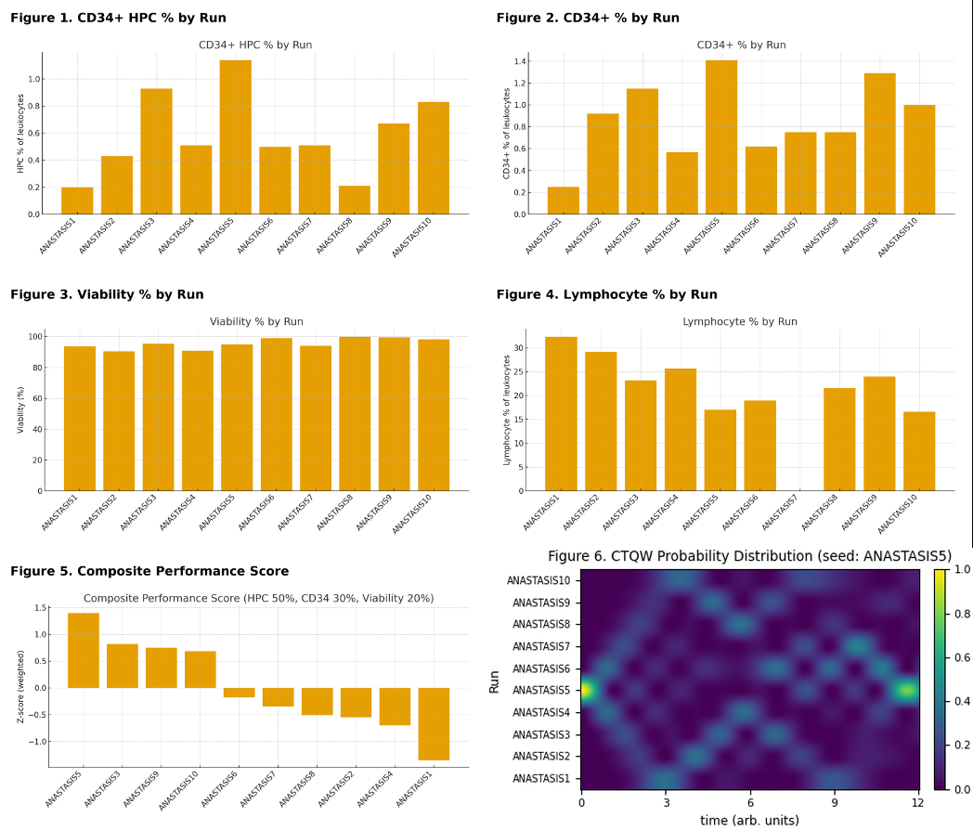

Figure 19. Composite Ranking of ANASTASIS1–10: progenitor yield, viability, and physics-aware calibration; Figure 19.1 — CD34⁺ HPC % by run; Orange bars compare the fraction of hematopoietic progenitor cells (HPCs) among leukocytes across ANASTASIS1–10. The crest is unmistakable at ANASTASIS5 (clear tallest bar), with ANASTASIS3, ANASTASIS10, and ANASTASIS9 forming the next tier. Several runs (e.g., 1, 2, 7) sit in a lower band; Figure 19.2 — CD34⁺ % by run. The CD34⁺ compartment echoes the HPC pattern: ANASTASIS5 is the top bar, ANASTASIS9 and ANASTASIS3follow, and ANASTASIS10 rounds out the leading group. This “5-centered” peak across Figures 19.1–19.2 marks the runs richest in primitive content; Figure 19.3 — Viability % by run. Post-thaw bulk survival is broadly high (most bars in the mid-90s to ~100%). The very top performers are ANASTASIS8 (≈100%), then ANASTASIS9, ANASTASIS6, and ANASTASIS10. Notably, this peak is shifted toward 8–10 rather than 5, illustrating the expected tension between “primitive content” and “bulk survival” after thaw; Figure 19.4 — Lymphocyte % by run. Lymphocyte fractions vary more modestly (roughly mid-teens to low-30s%). Early runs (1–2) sit higher; ANASTASIS6–7 are among the lower bars; later runs (8–10) pull back up into an intermediate zone. Nothing here overturns the progenitor/viability story; it mainly contextualizes overall leukocyte makeup; Figure 19.5 — Composite Performance Score. This panel rolls the metrics into a single weighted z-score (HPC 50%, CD34 30%, Viability 20%). The ranking aligns with the progenitor-led signal: ANASTASIS5 sits at the top of the composite, followed by ANASTASIS3, ANASTASIS10, and ANASTASIS9. In other words, the composite favors runs that pair strong primitive compartments with high (or near-top) viability and good QC↔bag alignment.
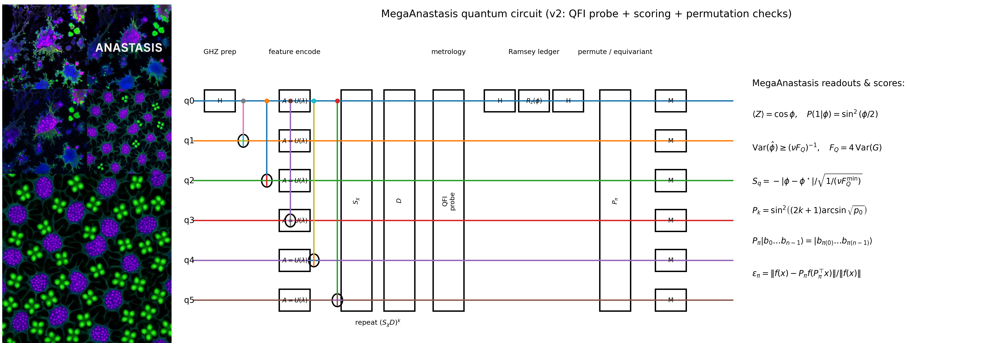Figure 20. Anastasis recovery field integrated with a permutation-equivariant MegaAnastasis control circuit and phase-ledger readout. MegaAnastasis: anastasis microscopy merged with a symmetry-aware quantum control stack. The merged plate couples a fluorescence time-stratigraphy of post-cryopreservation recovery with a mechanistic “MegaAnastasis” circuit abstraction that treats revival as an auditable, permutation-equivariant inference problem. On the left, thawing unfolds like a biological sunrise: cells transition from vitrified stillness into metabolic reconstitution, first appearing as nebula-like starbursts in which cytoskeletal branches re-extend and compartments re-partition. Magenta–cyan gradients emphasize cytoplasmic reawakening, while the green channel traces the resurgence of mitochondrial activity and actin remodeling along filopodial rims, consistent with a regulated return of membrane integrity and ionic homeostasis rather than a stochastic flare. As the sequence advances, individual recoveries begin to cohere into an architectural field, reflecting exposure to a precisely formulated thawing cocktail that reduces cryostress and reengages pro-survival signaling; what begins as scattered, local restorations resolves into a tessellated lattice of viability. In the enlarged terminal view, the scene culminates in organized renewal: nuclei (purple) regain transcriptional rhythm and spatial order, while green puncta concentrate at sites consistent with renewed respiratory and biosynthetic activity, yielding a honeycomb-like geometry that visually encodes successful anastasis—apoptotic reversal progressing beyond survival into adaptive reconstitution. On the right, the recovery trajectory is paired with a generalized MegaAnastasis quantum circuit that formalizes this same transition as a bounded-depth, symmetry-respecting decision pipeline. A multipartite reference is prepared as a GHZ resource, $∣{GHZ}_{n}⟩=\frac{1}{\sqrt{2}}(∣0⋯0⟩+∣1⋯1⟩)$, then mapped through a feature-encoding stage $A≡U(λ)$ that lifts image-derived motif evidence into a latent register. Candidate revival states are filtered through an amplitude-amplification core $\left(S_{χ}D)^{k}\right.$, where the phase oracle $S_{χ}$ marks a structural predicate (a “viability-consistent motif configuration”) and $D$implements diffusion, producing the canonical amplification law $P_{k}={sin⁡}^{2}\text{ ⁣}((2k+1)arcsin⁡\sqrt{p_{0}})$ for an initial hit fraction $p_{0}$. A Ramsey-style ledger then converts the accumulated decision phase into an observable readout through $H→R_{z}(ϕ)→H$, yielding $⟨Z⟩=cos⁡ϕ$ and $P(1∣ϕ)={sin⁡}^{2}(ϕ/2)$, so that ranking is expressed directly in measurement statistics rather than opaque scores. The circuit explicitly enforces symmetry under relabeling via a permutation layer $P_{π}$, acting as $P_{π}∣b_{0}…b_{n-1}⟩=∣b_{π(0)}…b_{π(n-1)}⟩$, ensuring that inferred structure depends on motif relations rather than arbitrary indexing; equivariance can be monitored by a consistency residual $ε_{π}=∥f(x)-P_{π}f(P_{π}^{⊤}x)∥/∥f(x)∥$. Finally, uncertainty is bounded metrologically via the quantum Fisher information, $Var(\hat{ϕ})≥(νF_{Q})^{-1}$ with $F_{Q}=4 Var(G)$ for generator $G$, linking the sharpness of the inferred revival phase to the variance contributed by the most informative motif degrees of freedom. Together, the merged figure reads as a single narrative: thawing and anastasis are rendered as an observable, structured return to order—governed by temperature and osmotic constraints at the bench and mirrored by a symmetry-aware, quantum-style controller that encodes motif evidence, amplifies viable configurations, and reports an interpretable phase ledger under explicit permutation constraints.

