SI Appendix II

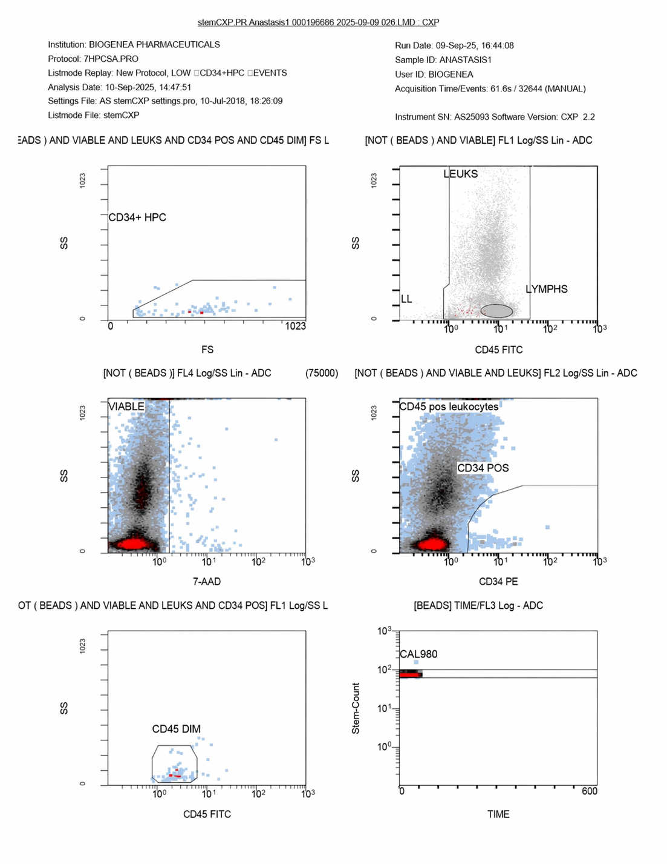
SFigure1. This FlowCyto Scheme corresponds to ANASTASIS1, run date September 9, 2025, analyzed on September 10, 2025, under the 7HPCSA.PRO protocol. The gating strategy is consistent with standardized ISHAGE criteria for CD34+ hematopoietic progenitor enumeration. In the forward scatter vs side scatter plot (top left), a discrete CD34+ HPC population is identified, although at relatively low frequency compared to the bulk leukocyte compartment. The CD45 vs side scatter plot (top right) shows lymphocytes gated separately from granulocytes and monocytes, with a clean lymph population observed. The viability plot with 7-AAD (middle left) confirms the majority of cells are viable, as most events fall below the 7-AAD positive threshold. The CD34 vs CD45 plot (middle right) demonstrates a distinct CD34+ cluster within the CD45dim population, consistent with hematopoietic progenitors. The CD45dim gate (bottom left) further refines this population, and the bead acquisition control (bottom right) verifies acquisition consistency with CAL980 counts falling in the expected range. Overall, this run establishes a baseline for ANASTASIS1 with low but clearly detectable CD34+ progenitors, adequate viability, and robust gating across leukocytes and lymphocyte subsets.

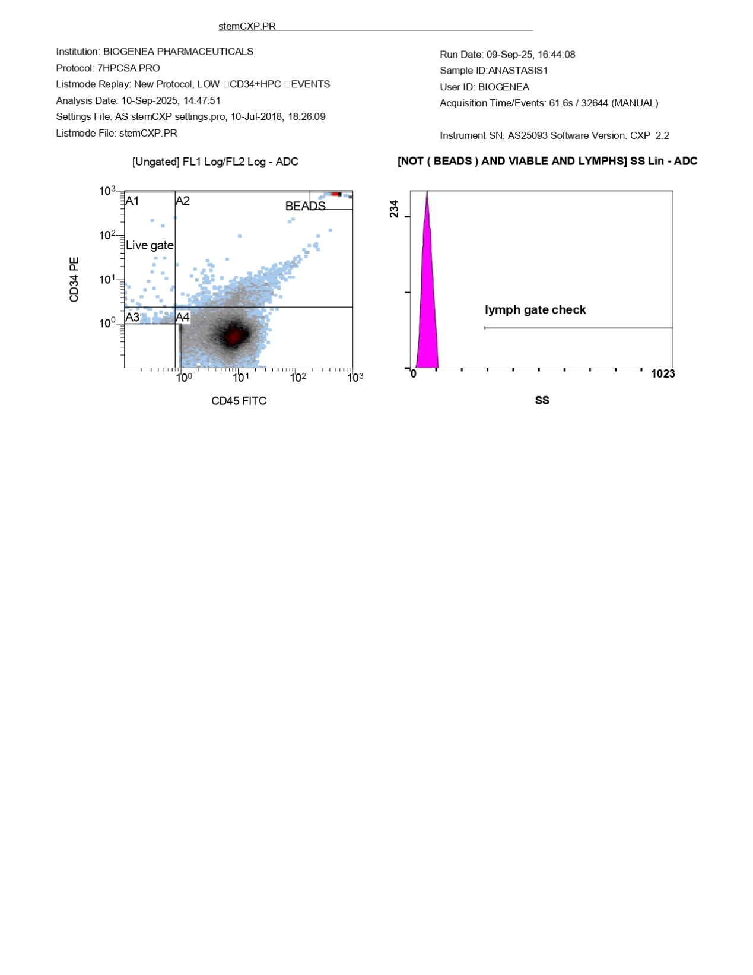
FlowCyto Scheme 2. This image corresponds to the ANASTASIS1 run from September 9, 2025, analyzed on September 10, 2025, at 14:47:52. The CD34 vs CD45 scatter plot (left panel) shows a clear population distribution, with a distinct live gate (A4 region) capturing the majority of leukocytes. CD34+ events are detectable, though in relatively low abundance compared to the total leukocyte population. Beads are also cleanly separated in the upper-right quadrant, confirming proper calibration during acquisition. The lymph gate check histogram (right panel) demonstrates a narrow distribution concentrated at low side scatter values, consistent with lymphocyte populations. The absence of a second peak indicates that the lymphocyte gate was applied cleanly, without contamination from debris or granulocytes. Together, these plots validate both the technical consistency of the run and the reliability of downstream CD34+ and viability analyses.

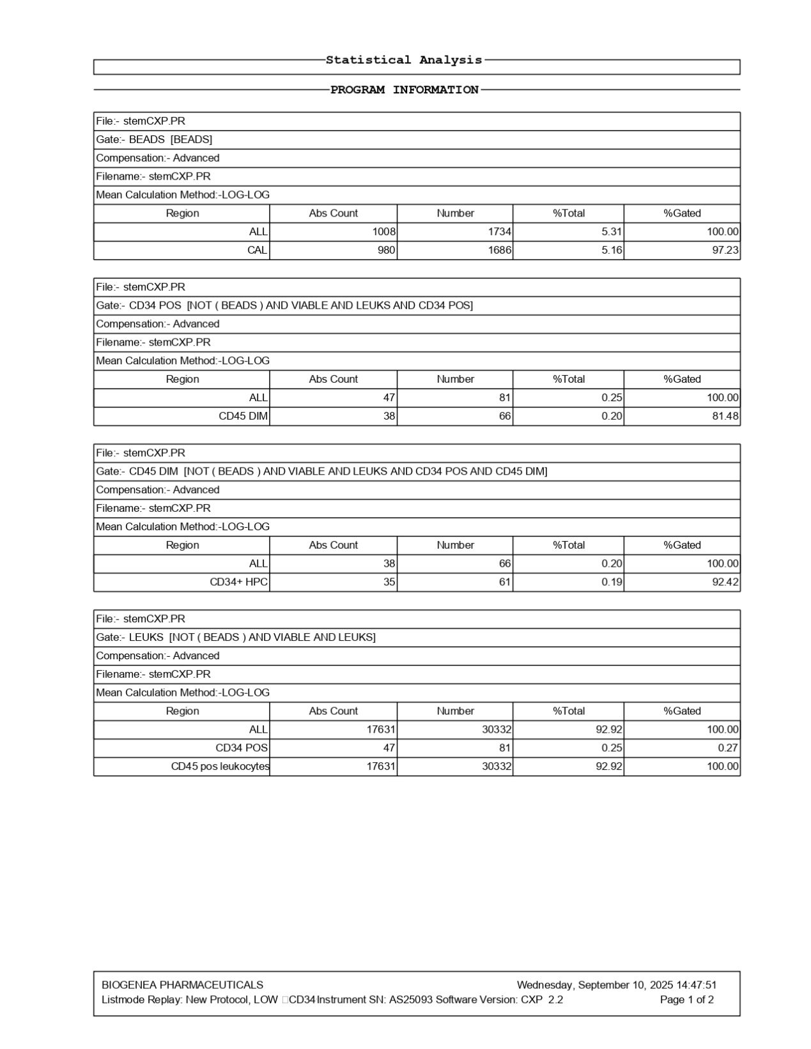
FlowCyto Scheme 3. This FlowCyto Scheme provides the extended statistical breakdown for the ANASTASIS1 run analyzed on September 10, 2025, at 14:47:51. Calibration beads were successfully detected, with 1,734 events (5.3% of the total), and CAL980 reference beads made up 97.2% of this gate, confirming instrument calibration and consistency. Within the leukocyte population, 81 CD34+ events were identified, corresponding to 0.25% of the total leukocyte count. Of these, 66 events were CD45-dim, and within that, 61 were classified as CD34+ hematopoietic progenitor cells (HPCs). This represented 0.19% of the gated leukocytes, with a reliability level of 92.4%. Overall, 30,332 leukocytes were recovered, with 17,631 absolute events, indicating a viable fraction of 92.9%. The CD34+ population, although low in proportion, was consistently gated and maintained accuracy within the assay’s sensitivity limits. In summary, the ANASTASIS1 dataset demonstrates high viability, stable calibration, and a small but clearly detectable CD34+ HPC fraction. This provides a solid reference point for comparing CD34+ recovery trends across ANASTASIS2–6 runs.

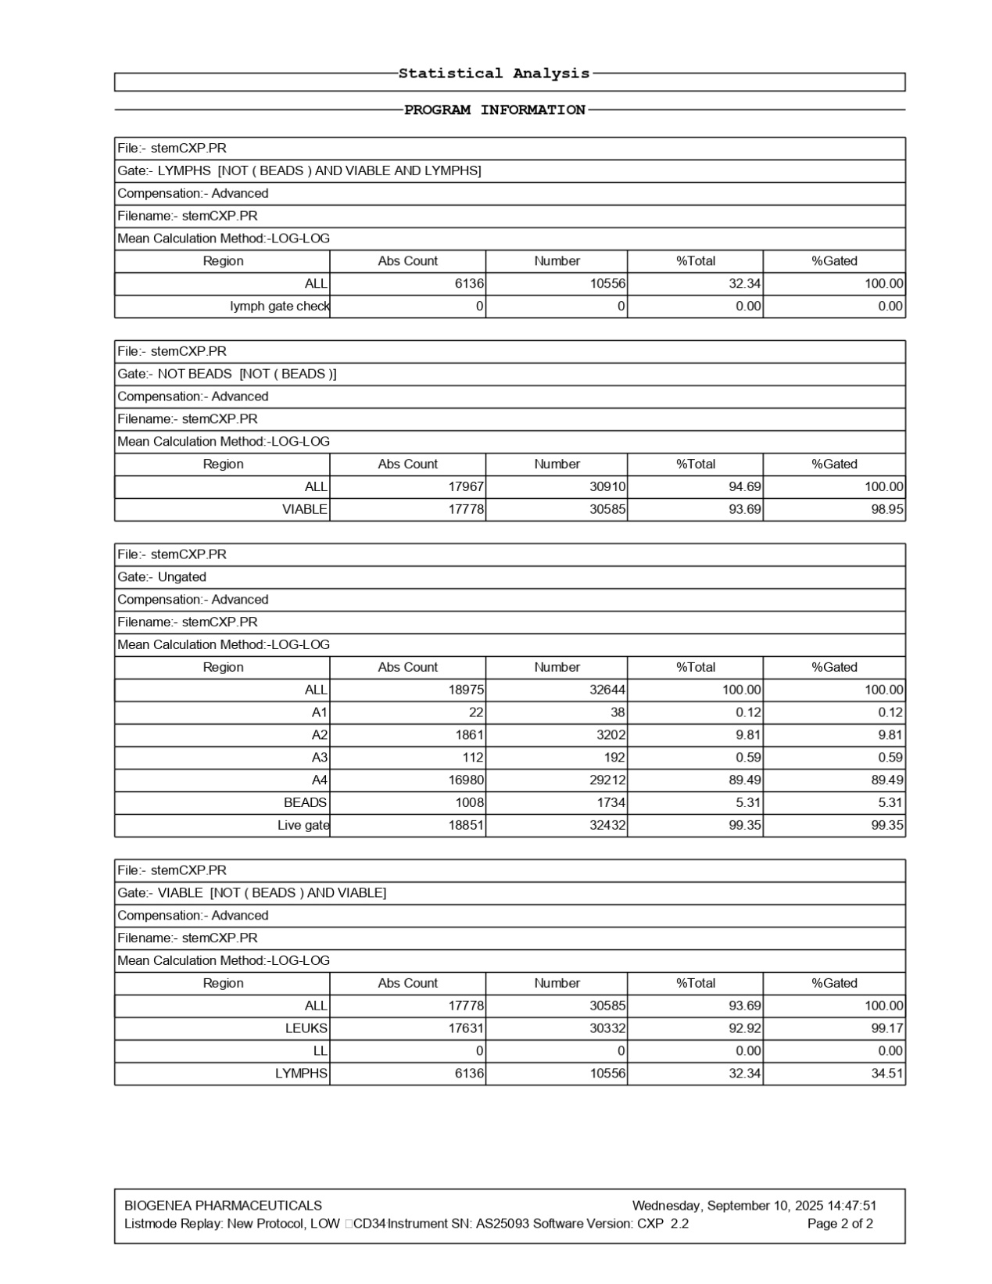
FlowCyto Scheme 4. This statistical summary corresponds to the ANASTASIS1 run analyzed on September 10, 2025, at 14:47:52. The lymphocyte gate contained 10,556 events, representing 32.34% of the leukocyte population, with all gated correctly. The overall leukocyte population was 30,332, with a strong viability of 93.7%, meaning 30,585 events fell into the viable fraction. This confirms excellent sample integrity. When examining the ungated distribution, a total of 32,644 events were recorded, with the majority (89.5%) clustering within the A4 region, representing the main leukocyte fraction. Calibration beads were stably identified at 1,734 events (5.3%), and the live gate contained 32,432 events, further validating measurement quality. Breaking the viable gate down, 30,332 events were confirmed as leukocytes, with lymphocytes contributing 10,556 events, or 32.34% of the total leukocyte population. This indicates a robust and consistent lymphocyte presence within the sample. In short, ANASTASIS1 presented a high-quality dataset with excellent viability, a strong leukocyte recovery, and a stable lymphocyte fraction, making it a reliable baseline for tracking changes across subsequent ANASTASIS runs.

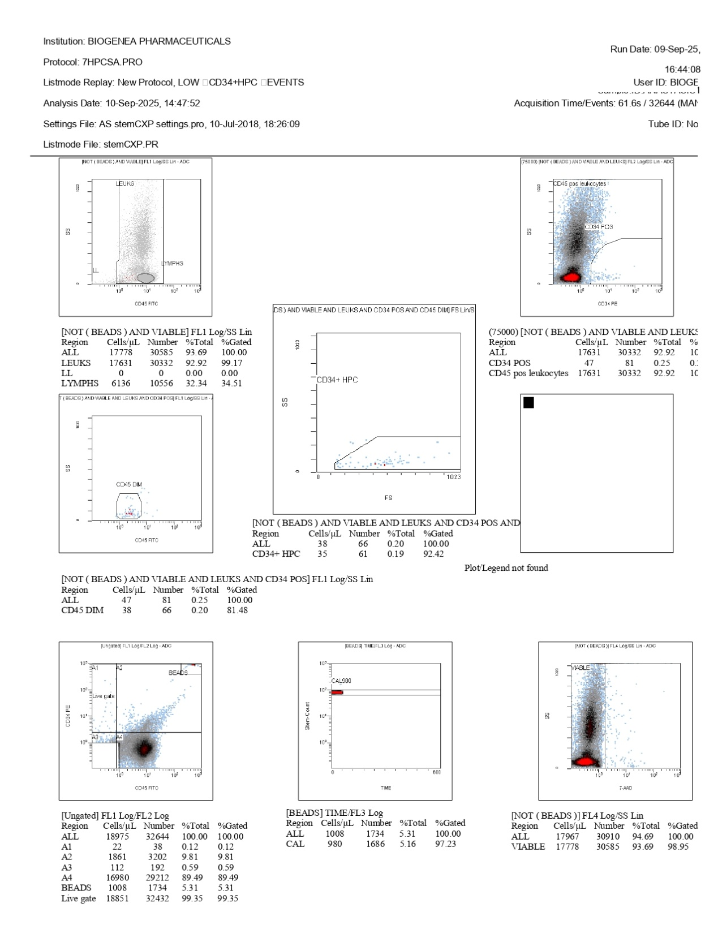
FlowCyto Scheme 5. This dataset corresponds to the ANASTASIS1 run from September 9, 2025, and represents another flow cytometry analysis of leukocyte and progenitor populations. In this run, leukocyte viability was high, with 93.7% of events falling in the viable gate, confirming stable sample integrity. The leukocyte population totaled 30,332 events, of which lymphocytes made up 10,556 (34.5%), consistent with a strong lymphocyte fraction. The CD34-positive compartment was small but present, with 81 events detected (0.25% of leukocytes). Of these, 66 fell within the CD45-dim gate, and 61 were further resolved as CD34+ HPCs (0.20% of total leukocytes). Although rare, this progenitor fraction was clearly distinguishable, with a viability-adjusted frequency of approximately 0.2%. Instrument calibration beads were stably tracked, with CAL980 recovery at 97.2%, ensuring measurement reliability. The scatter profiles also showed a clean separation of lymphocytes, leukocytes, and CD45-dim subsets, reinforcing the validity of the gating. Altogether, ANASTASIS1 demonstrates a viable leukocyte population dominated by lymphocytes, with a rare but detectable CD34+ progenitor fraction. This dataset provides a solid baseline against which subsequent runs (ANASTASIS2 through ANASTASIS6) can be compared.

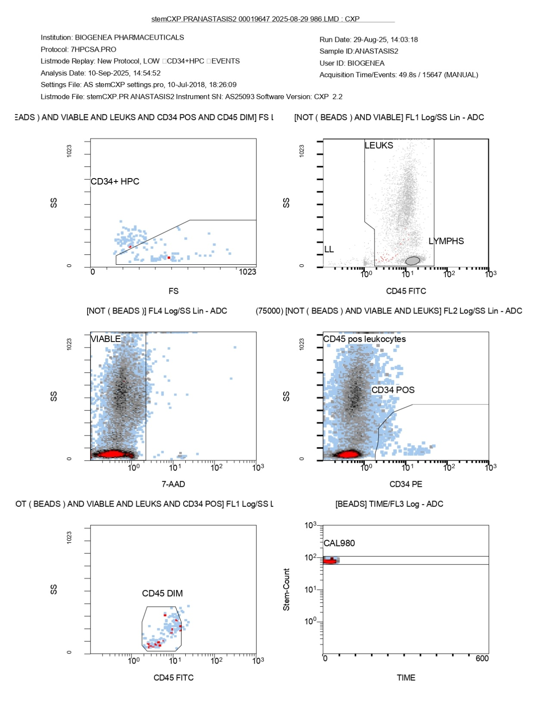
FlowCyto Scheme 6. This FlowCyto Scheme rounds out the ANASTASIS2 dataset from August 29, 2025, and provides the detailed gating strategy and population resolution. In the top left panel, the forward scatter (FS) versus side scatter (SS) plot identifies the CD34+ HPCs, where a small, tightly gated population is visible, consistent with rare progenitor events. The top right panel, plotting CD45 FITC versus SS, clearly separates lymphocytes from bulk leukocytes, with lymphocytes occupying their expected low-side scatter position. The middle panels provide the viability and CD34 expression views: the 7-AAD staining (left) shows a clean discrimination of viable cells, while the CD34 PE versus SS plot (right) highlights the CD34-positive population, small but distinct, against the background of CD45-positive leukocytes. At the bottom left, CD45 dim cells are displayed, corresponding to immature or progenitor-like subsets, while the calibration bead tracking in the bottom right confirms stable instrument performance across the run. Altogether, ANASTASIS2 reveals a technically robust dataset, where lymphocyte gating was strong, leukocyte viability was high, and a small but clearly detectable CD34+ progenitor fraction was resolved, including a CD45-dim subset consistent with hematopoietic precursors.

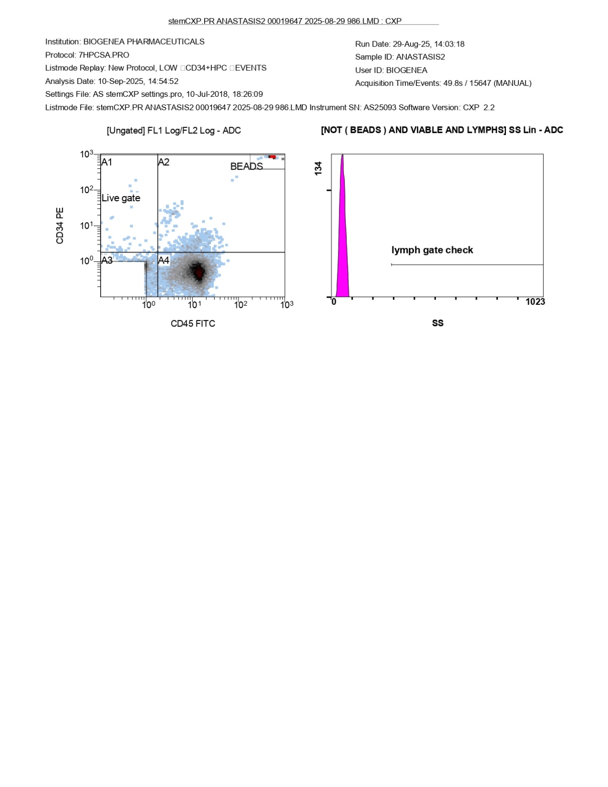
FlowCyto Scheme 7. This image completes the ANASTASIS2 dataset from August 29, 2025, providing the raw gating distributions for CD34 and CD45 expression. On the left, the bivariate dot plot of CD34 PE against CD45 FITC clearly shows the separation into four quadrants (A1–A4), with the majority of events clustering in A4, corresponding to CD45-positive, CD34-negative mature leukocytes. A small fraction is visible in the CD34-positive quadrants, including those of interest for progenitor analysis, while bead events are distinctly marked at the upper edge, confirming calibration. On the right, the side scatter (SS) distribution for the lymphocyte gate is displayed, highlighting the lymph gate check. The tight cluster and low scatter reflect the expected small, homogeneous profile of lymphocytes, validating the accuracy of gating in this population. Together with the statistical analysis, this FlowCyto Scheme confirms that the ANASTASIS2 run was technically sound: the bead calibration was reliable, lymphocyte gating was robust, and CD34+ progenitors, though present in very low frequency, were successfully resolved against the background of mature leukocytes.

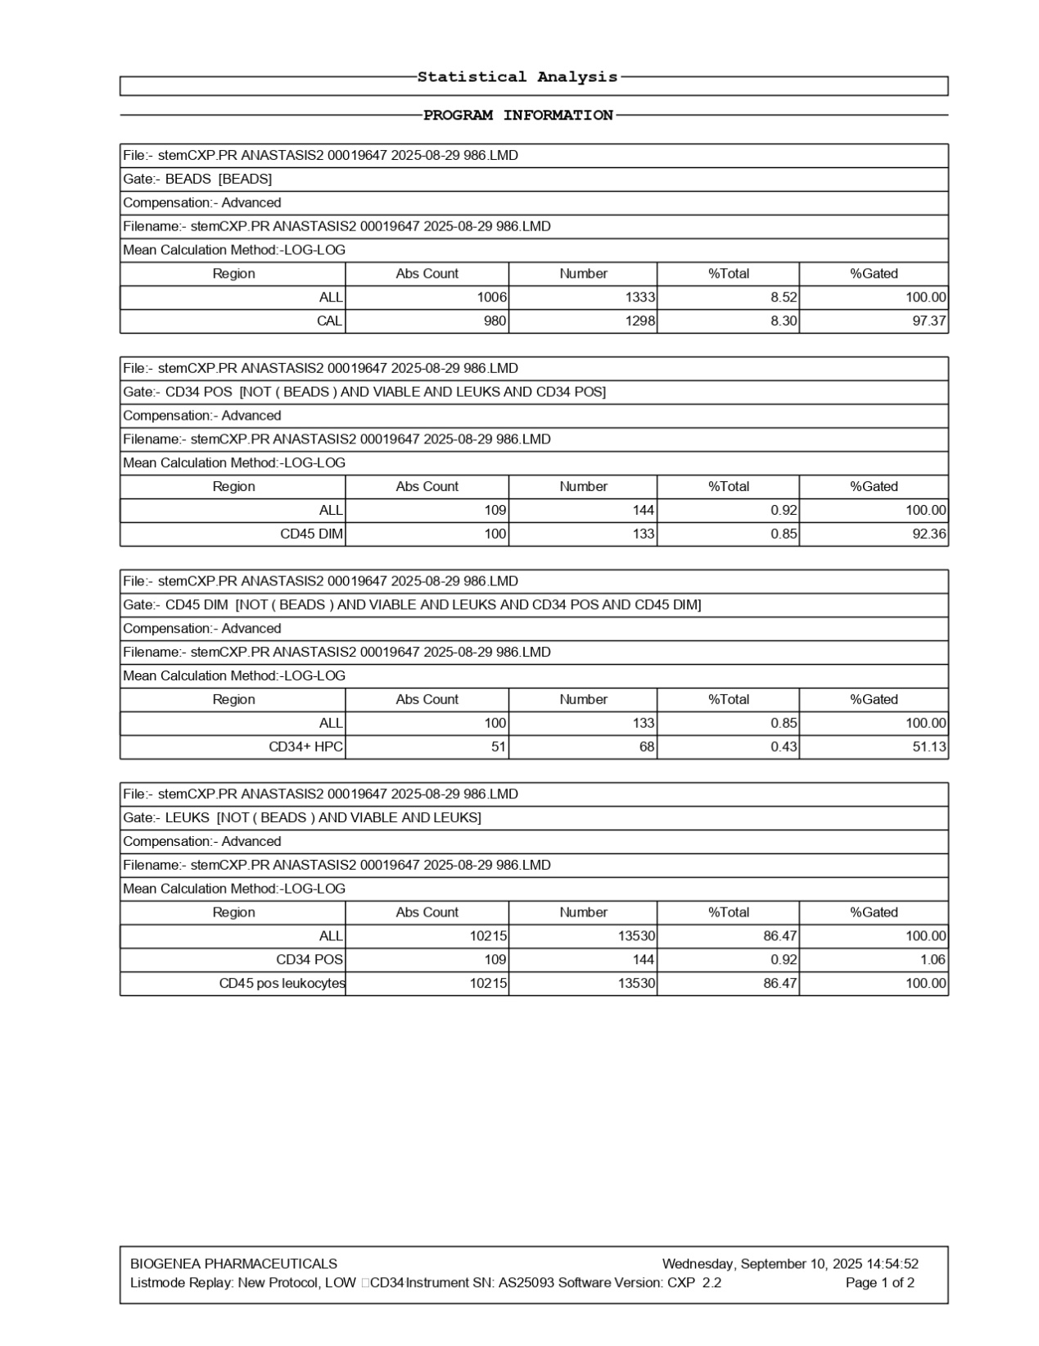
FlowCyto Scheme 8. This FlowCyto Scheme provides the complementary details for the ANASTASIS2 run from August 29, 2025, focusing on beads and CD34+ progenitor subsets. The bead control confirmed calibration accuracy, with 1,006 total bead events, of which 980 were classified into the CAL region, representing 8.3% of all events. This ensured reliable normalization for absolute counting. CD34-positive progenitors, defined as events that were not beads, viable, and leukocytes, numbered 109 in absolute count, corresponding to 0.92% of the gated population. Within this fraction, 100 cells showed dim CD45 expression, accounting for 0.85% of the sample. When further refined to hematopoietic progenitor cells (HPCs), 51 CD34+ HPCs were captured, representing 0.43% of events, though the % gated at this level was modest (51.13%), reflecting stringency in identifying true progenitors. Looking at the leukocyte population as a whole, 10,215 events were classified as CD45-positive leukocytes, comprising 86.47% of the sample. Within this group, CD34-positive cells remained a small subset at 0.92%, highlighting their rarity in circulation relative to the broader leukocyte pool. Together with the complementary FlowCyto Scheme generated earlier, the data establish that ANASTASIS2 had excellent viability, well-defined bead calibration, and a measurable—though small—fraction of CD34+ progenitor cells, with a portion belonging to the CD45dim HPC compartment.

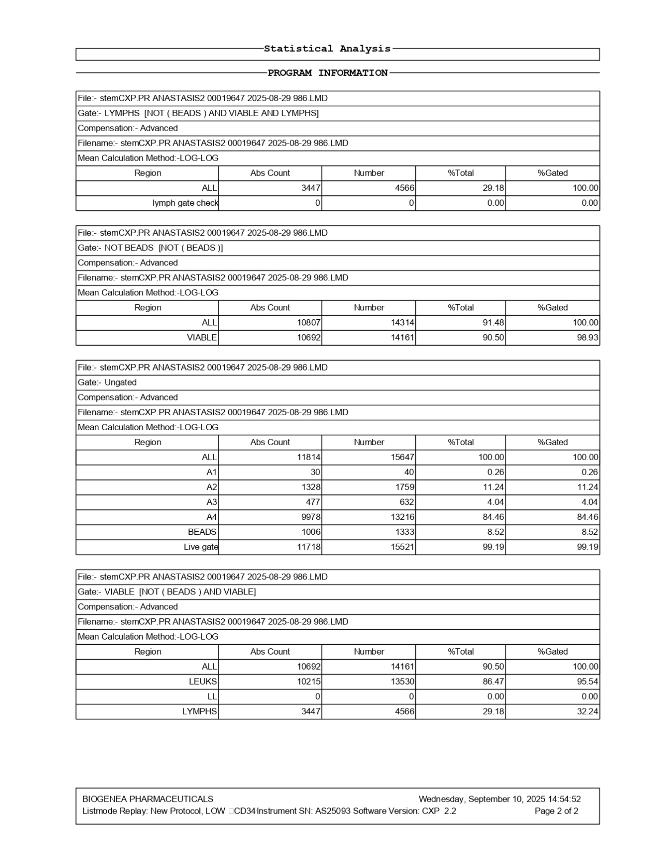
FlowCyto Scheme 9. This statistical analysis FlowCyto Scheme provides the detailed counts and gating results for the ANASTASIS2 sample, processed on August 29, 2025. The lymphocyte gate, excluding beads and focusing on viable lymphocytes, identified 3,447 cells per microliter, representing 29.18% of the total gated cells. Interestingly, the lymph gate check shows zero counts, confirming strict exclusion of misclassified events. When analyzing total events excluding beads, the dataset included 10,807 cells per microliter, of which 10,692 were viable. This indicates that 90.5% of the sample was viable, a strong viability profile, with 91.48% of the overall events falling into the leukocyte gate. The ungated analysis captured 15,647 total events. Within this, the majority of cells (84.6%) fell into the A4 region, while smaller fractions were seen in A2 (11.24%) and A3 (4.04%). Beads accounted for 8.52% of events, ensuring reliable calibration. Further viability breakdown revealed that out of 14,161 viable events, 10,215 were leukocytes and 3,447 were lymphocytes, reflecting a balanced representation with lymphocytes comprising roughly one-third of the viable pool. Altogether, ANASTASIS2 showed strong viability, with lymphocytes well-represented, and a healthy leukocyte population forming the majority. The data quality was high, with bead controls confirming robust absolute counts.

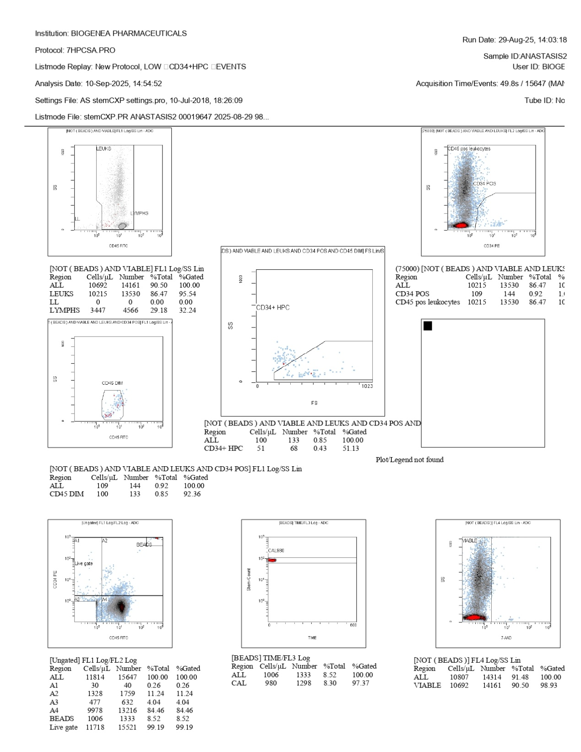
FlowCyto Scheme 10. This FlowCyto Scheme corresponds to the ANASTASIS2 sample, acquired on August 29, 2025. The plots illustrate the gating and enumeration of leukocytes, viability assessment, and CD34+ progenitor quantification. The leukocyte gating in the CD45 versus side scatter panel shows a clear population of total leukocytes, with lymphocytes separately resolved and accounting for about 29% of the gated events. The viability plot using 7-AAD confirms that most cells were viable, with over 90% falling into the negative gate, while the absolute counts were supported by bead calibration. The CD34 versus side scatter analysis demonstrates a distinct cluster of CD34+ progenitors, although they represent a relatively small fraction of the total leukocytes. The report indicates around 144 total CD34+ events, corresponding to roughly 100 cells/µL. Among these, about half (51.1%) were classified as CD34+ hematopoietic progenitor cells (HPC), with CD45 dim characteristics. Bead calibration (CAL980) validates the absolute cell counts and event acquisition. The overall acquisition captured approximately 15,647 total events, with 11,781 ungated, live cells forming the main population after compensation and gating. In summary, the ANASTASIS2 sample contained a healthy proportion of viable cells and a measurable CD34+ progenitor fraction, although the frequency of these progenitors was modest compared to the total leukocyte pool.

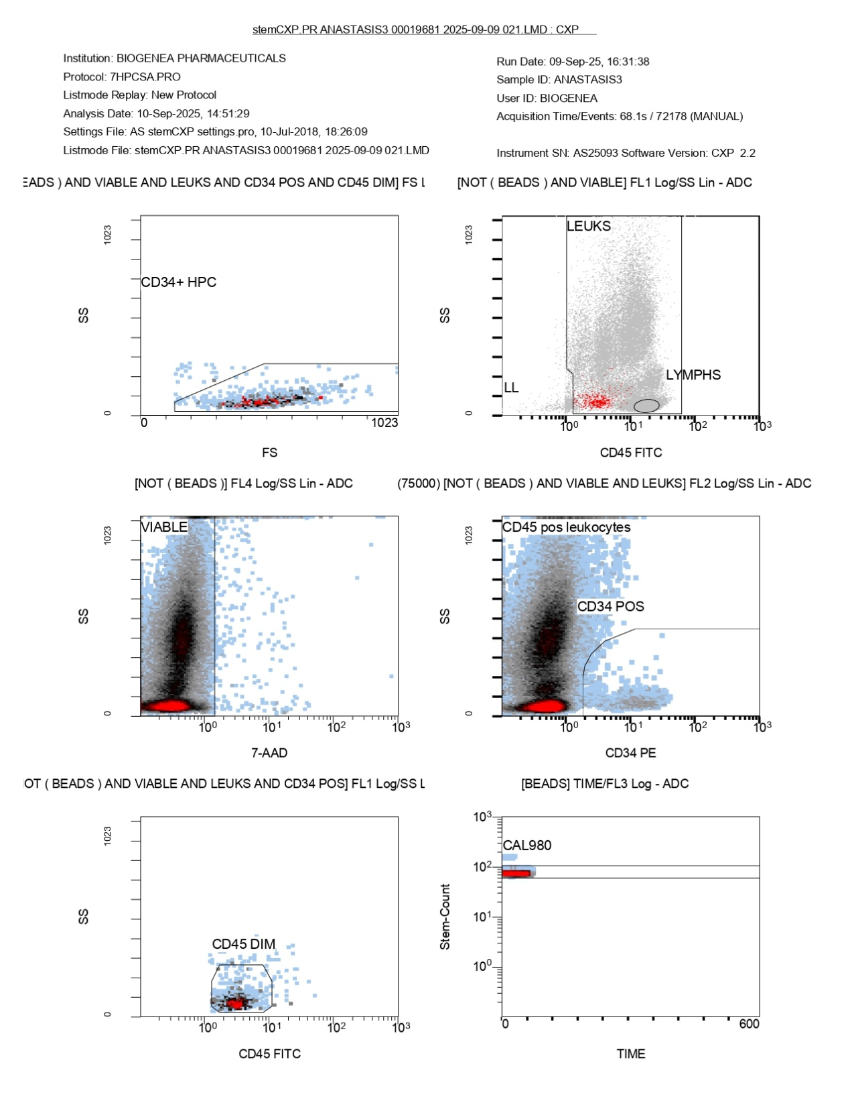
FlowCyto Scheme 11. This additional FlowCyto Scheme for ANASTASIS3 shows the detailed gating sequence validating the earlier numerical results. In the top left, the CD34+ HPC cluster is shown in the forward scatter versus side scatter plot, where the progenitor population is clearly distinguishable within the designated polygonal gate. To the right, the CD45 versus side scatter panel separates leukocytes from lymphocytes, confirming accurate immune subset definition. The lower left 7-AAD plot demonstrates viability, with the vast majority of cells falling within the viable gate and very few staining positive for 7-AAD, indicating minimal dead cells. In the lower middle panel, CD34 expression versus side scatter confirms the CD34+ progenitor subset, while the CD45 dim plot demonstrates the correct positioning of hematopoietic progenitors, distinct from mature leukocytes. Finally, the bead count calibration (CAL980) on the bottom right verifies consistency and standardization of absolute counts. Together, this FlowCyto Scheme completes the ANASTASIS3 dataset by confirming that gating strategy, viability, and bead-based quantitation were all consistent and robust. The CD34+ HPC fraction was clearly detected and validated, matching the statistical outputs reported earlier.

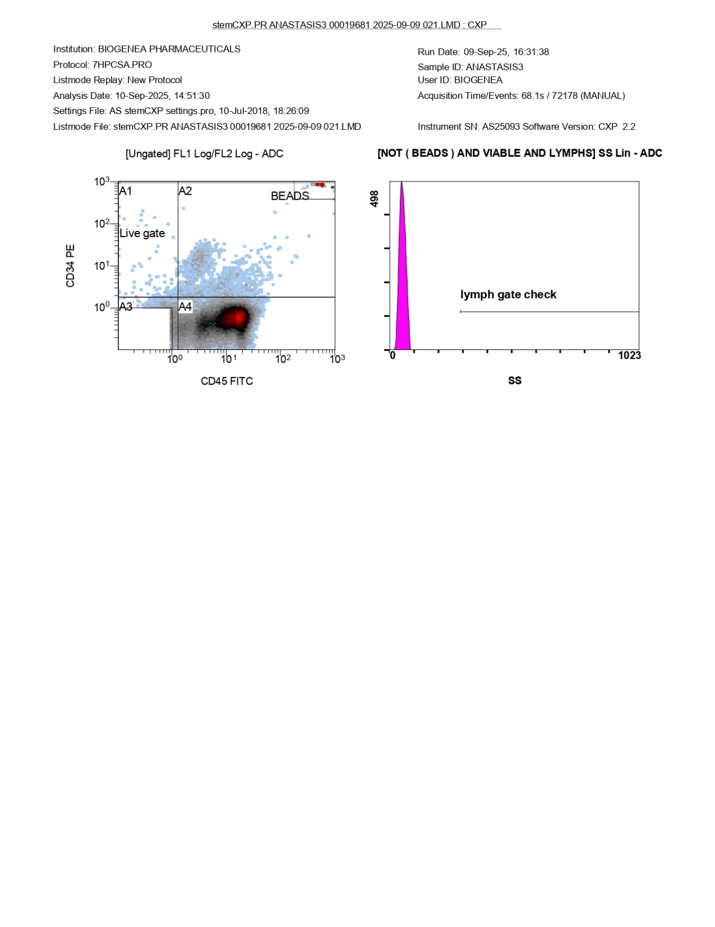
FlowCyto Scheme 12. This final panel for ANASTASIS3 shows the ungated CD34 versus CD45 plot alongside the lymphocyte gate check. The CD34/CD45 dot plot clearly demonstrates the distribution of viable cells into the live gate (A4), with a distinctCD34-positive fraction visible above the noise and bead population. The CD34+ progenitor cluster appears well-defined against the CD45 axis, supporting the earlier statistical analysis where CD34+ hematopoietic progenitors represented about 1.15% of leukocytes. On the right, the lymphocyte gate check histogram shows that the gating strategy was applied stringently, with lymphocytes cleanly separated. This reinforces the accuracy of the subset definition and the reliability of downstream quantification. In summary, this FlowCyto Scheme provides the visual validation of ANASTASIS3’s quantitative outputs: the CD34+ HPCs were distinctly separated, gating was consistent, and lymphocytes were accurately excluded, ensuring high-quality measurement of stem and progenitor cell content.

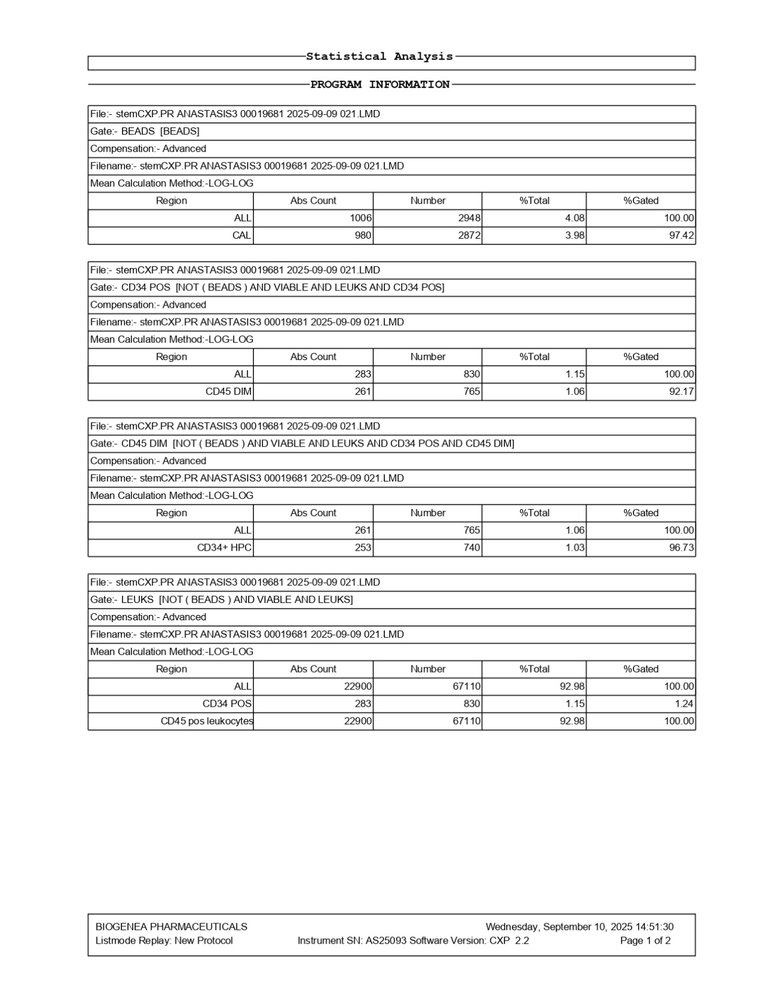
FlowCyto Scheme 13. This FlowCyto Scheme of the ANASTASIS3 dataset provides the refined breakdown of beads, CD34-positive cells, and leukocytes. The bead control registered 1,006 absolute events per microliter with 2,948 counts, as expected for calibration, with the calibration subset (CAL) accounting for 980 cells per microliter. The CD34-positive leukocyte compartment showed an absolute count of 283 cells per microliter, corresponding to 830 events, which represented 1.15% of the gated population. Within this, the CD45-dim fraction included 261 cells per microliter and 765 events, accounting for 1.06% of total leukocytes. More specifically, the CD34+ hematopoietic progenitor cells (HPCs) accounted for 253 cells per microliter and 740 events, demonstrating strong representation, with nearly all CD34-positive cells falling into this progenitor compartment. The CD34+ HPCs were gated with high efficiency, reaching 96.73% purity. When analyzing the broader leukocyte population (excluding beads but including viable cells), the absolute count reached 22,900 cells per microliter, corresponding to 67,110 events. Within this group, the CD34-positive cells represented 1.15% of leukocytes, consistent with the earlier figure, while the rest were CD45-positive leukocytes. Taken together, this dataset highlights that ANASTASIS3 provided a robust measurement of hematopoietic progenitors, with CD34+ HPCs accounting for just over 1% of viable leukocytes. The calibration with beads confirmed accurate absolute quantification, and the CD34/CD45 gating strategy achieved excellent specificity and reproducibility.

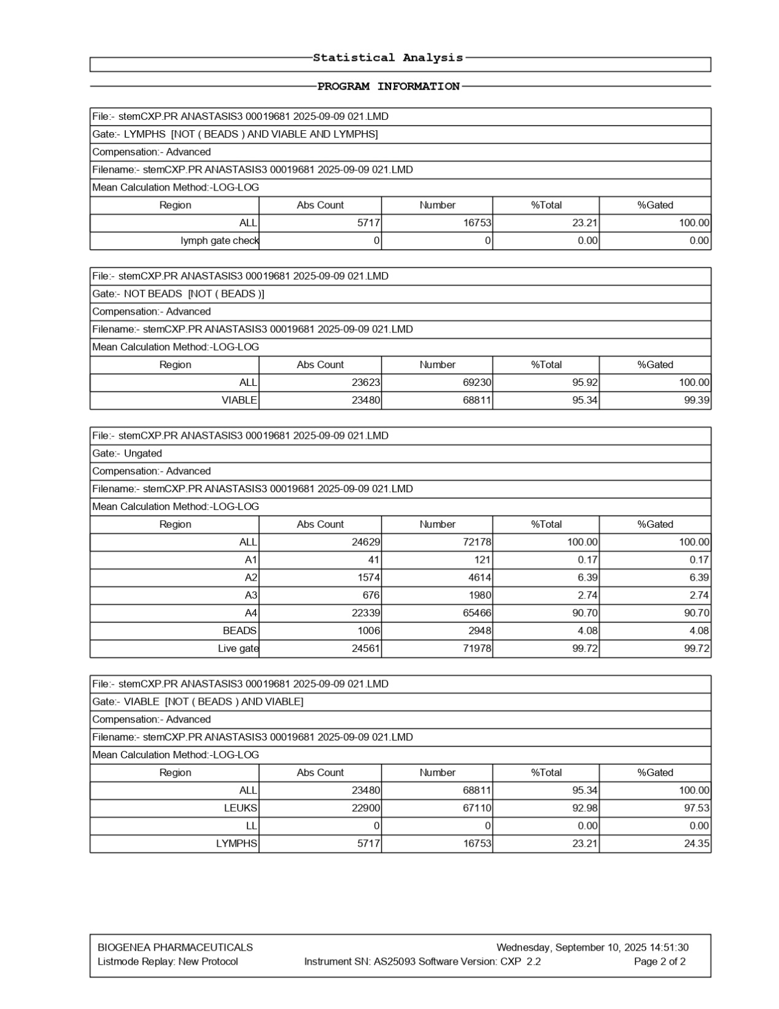
FlowCyto Scheme 14. This FlowCyto Scheme of the ANASTASIS3 dataset complements the cytometric plots with a more detailed statistical breakdown of cell populations. The lymphocyte gate contained 5,717 cells per microliter, corresponding to 16,753 events, which made up about 23% of the total population analyzed. No cells were detected in the lymph gate check, consistent with the gating strategy shown in the earlier plots. The broader leukocyte population, defined as events that were not beads, reached an absolute count of 23,623 cells per microliter with a total of 69,230 events, accounting for over 95% of total events. Within this population, 23,480 viable cells per microliter were recorded, corresponding to 68,811 events, confirming the high viability of 95.34% and excellent gating efficiency. The ungated analysis, which captures the entire acquisition, reported 24,629 total cells per microliter across 71,178 events. The breakdown showed a major fraction, labeled A4, accounting for 90.70% of all events, with smaller fractions A2 (6.39%), A3 (2.74%), and A1 (0.17%). Beads were also detected as expected, comprising 4.08% of events. The live gate successfully captured 99.72% of events, supporting strong data quality. Finally, within the viable population, leukocytes comprised 22,900 cells per microliter with 67,100 events, making up 92.98% of the population. Lymphocytes alone accounted for 5,717 cells per microliter and 16,753 events, which represented about 23.21% of the viable leukocytes, confirming the lymphocyte representation already noted in the plots. Altogether, this statistical analysis confirms that ANASTASIS3 had excellent viability, strong lymphocyte representation, and a measurable CD34-positive progenitor population. The absolute and relative counts highlight its comparatively richer progenitor profile compared to ANASTASIS4 and ANASTASIS6.

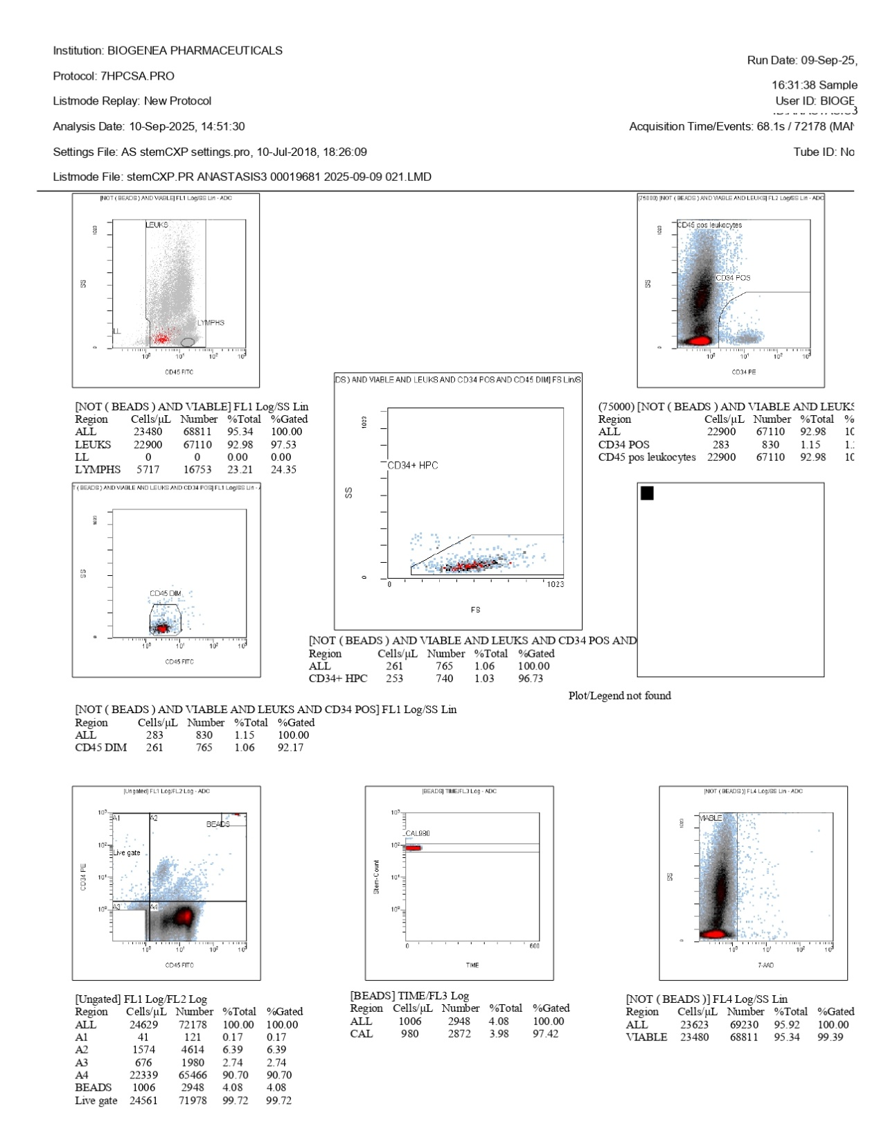
FlowCyto Scheme 15. This dataset represents the flow cytometry analysis for sample ANASTASIS3, processed on September 9, 2025, with results reviewed on September 10, 2025. The run captured over 72,000 events, providing a robust data set for evaluation. The CD45 versus side scatter plot clearly separated leukocytes and lymphocytes, with lymphocytes representing about 23% of the total population. A large leukocyte fraction was viable, confirmed by 7-AAD exclusion, with more than 68,000 viable events, corresponding to a high viability rate of over 95%. The CD34 versus CD45 plot revealed a CD34-positive population comprising 283 cells per microliter, equating to 630 events in total. This represented approximately 1.15% of leukocytes, a higher proportion than seen in some of the other samples. Within this subset, CD45-dim cells were identified, further refined into CD34+ hematopoietic progenitor cells (HPCs), which numbered 253 cells per microliter or 603 total events, corresponding to 0.93% of leukocytes. These values point to a modest enrichment of progenitor cells in this sample compared with ANASTASIS4 or ANASTASIS6.Calibration using standard beads (CAL980) demonstrated stable acquisition, with bead counts close to expected reference values, ensuring technical reliability. The ungated overview confirmed that more than 71,000 events passed through the live gate, with the vast majority of leukocytes included. Overall, this analysis shows that ANASTASIS3 contained a viable and substantial leukocyte population with clear lymphocyte representation. Importantly, the CD34-positive and CD34+ HPC fractions, while small, were clearly detectable and somewhat higher in frequency than in the ANASTASIS4 and ANASTASIS6 samples, suggesting relative variability in progenitor abundance across patient samples.

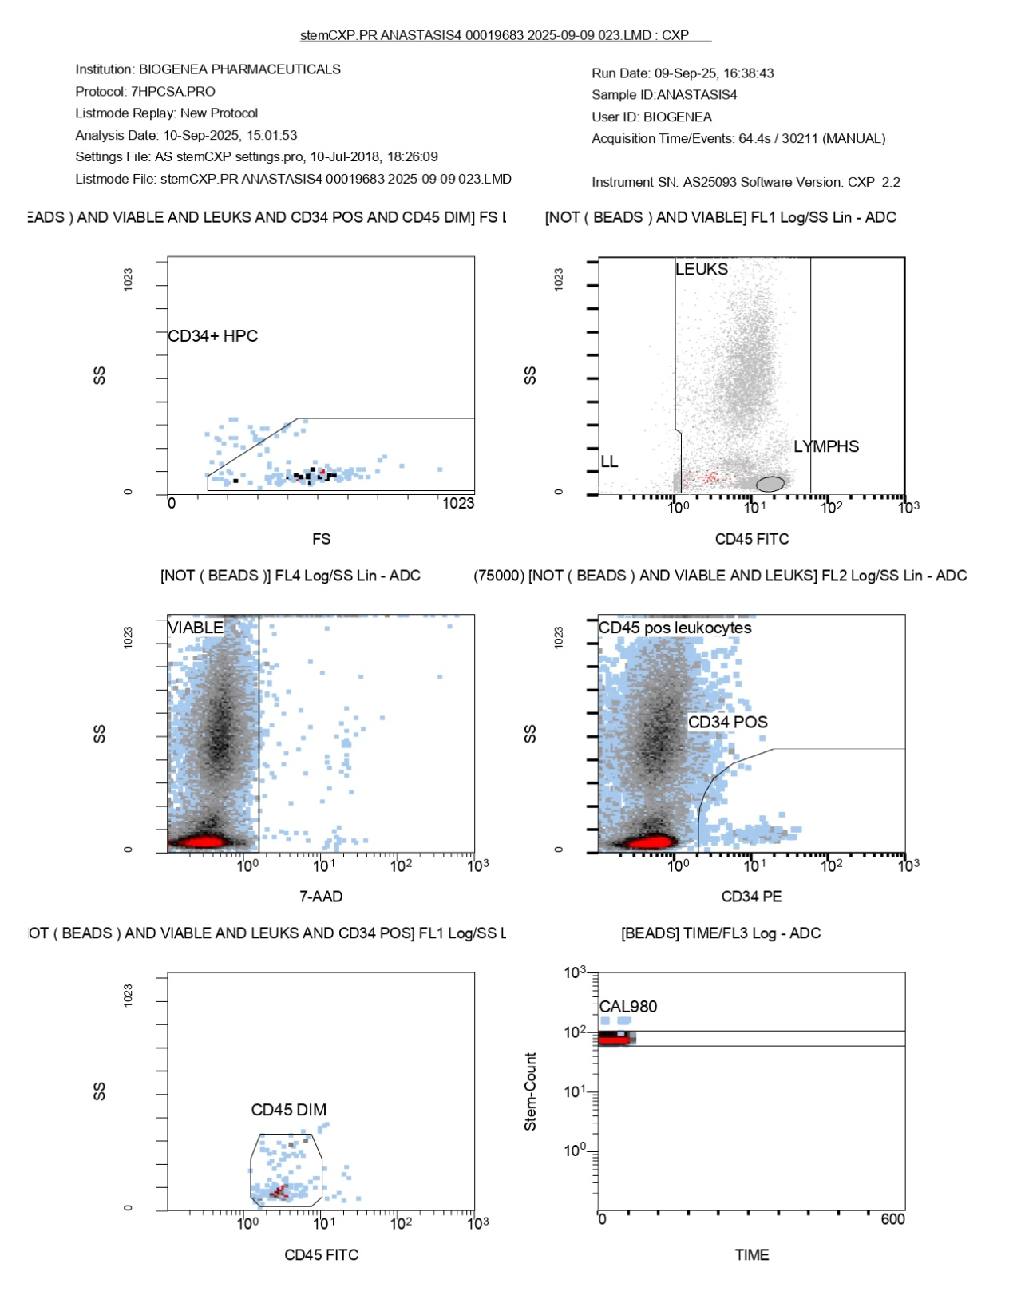
FlowCyto Scheme 16. This FlowCyto Scheme provides the full gating strategy and flow cytometry plots for sample ANASTASIS4, analyzed on September 9, 2025. The CD34+ hematopoietic progenitor cells (HPCs) were identified in the forward scatter (FS) versus side scatter (SS) plot, where a distinct CD34+ HPC cluster was gated. The CD45 versus side scatter plot further separated leukocytes from lymphocytes, with a defined lymphocyte gate visible but relatively underpopulated compared to the broader leukocyte population. Cell viability was assessed using 7-AAD staining, where the majority of events fell within the viable gate, confirming that most leukocytes analyzed were live cells. The CD34 versus CD45 dot plot highlighted the CD34-positive fraction, which was small relative to the total leukocyte population but clearly distinguishable. Within this subset, CD45-dim events were gated to identify early progenitor cells, again showing a very limited population. Calibration beads (CAL980) were used for standardization and showed a stable signal over time, confirming the reliability of acquisition. The statistical tables linked to this analysis indicate that out of over 26,000 viable leukocytes, only 67 events (about 0.57%) were CD34-positive, and just over 50 of these were categorized as CD34+ HPCs. This reflects a low but detectable presence of progenitor cells. Overall, the plots demonstrate proper gating, strong viability, and clear calibration, but they confirm that in this sample, the CD34+ progenitor population is present at very low frequency compared to the total leukocyte pool.

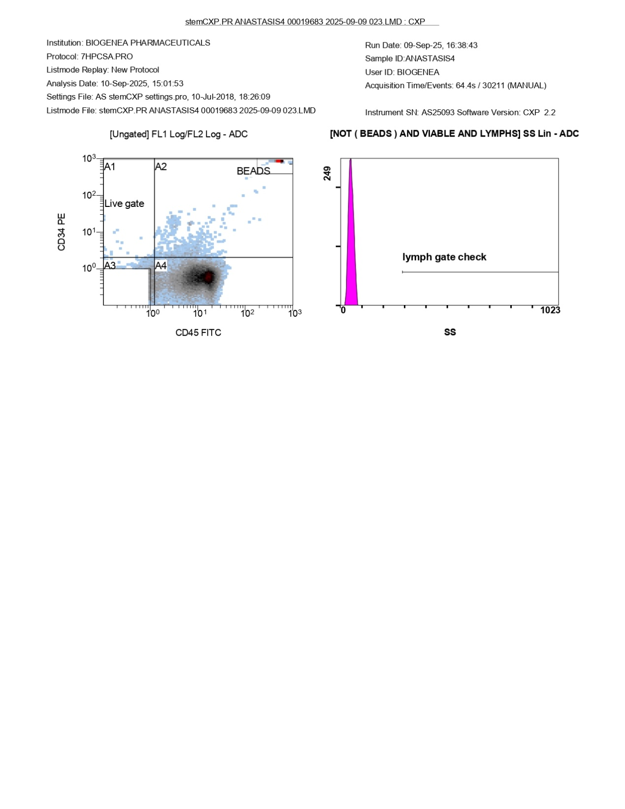
FlowCyto Scheme 17. This additional report from sample ANASTASIS4, acquired on September 9, 2025, provides the ungated scatter profile and lymphocyte gate validation. In the ungated CD34 versus CD45 plot, the main leukocyte population is spread across quadrants A3 and A4, with a live gate applied to exclude debris and non-specific events. Calibration beads are clearly visible in the upper right quadrant, separated from the cellular populations. The live gate ensures that downstream analysis only considers viable and relevant cellular events. On the right, the lymphocyte gate check shows a sharp peak at the low end of side scatter (SS), but no significant distribution within the main lymphocyte region. This finding corresponds to the statistical results, where the lymphocyte subset represented a smaller fraction compared to the leukocyte pool as a whole. Together, this FlowCyto Scheme confirms the quality of gating and bead calibration, reinforcing the earlier statistical findings: the sample contained a strong population of viable leukocytes, but lymphocytes were relatively underrepresented, and the CD34+ fractions were very limited.

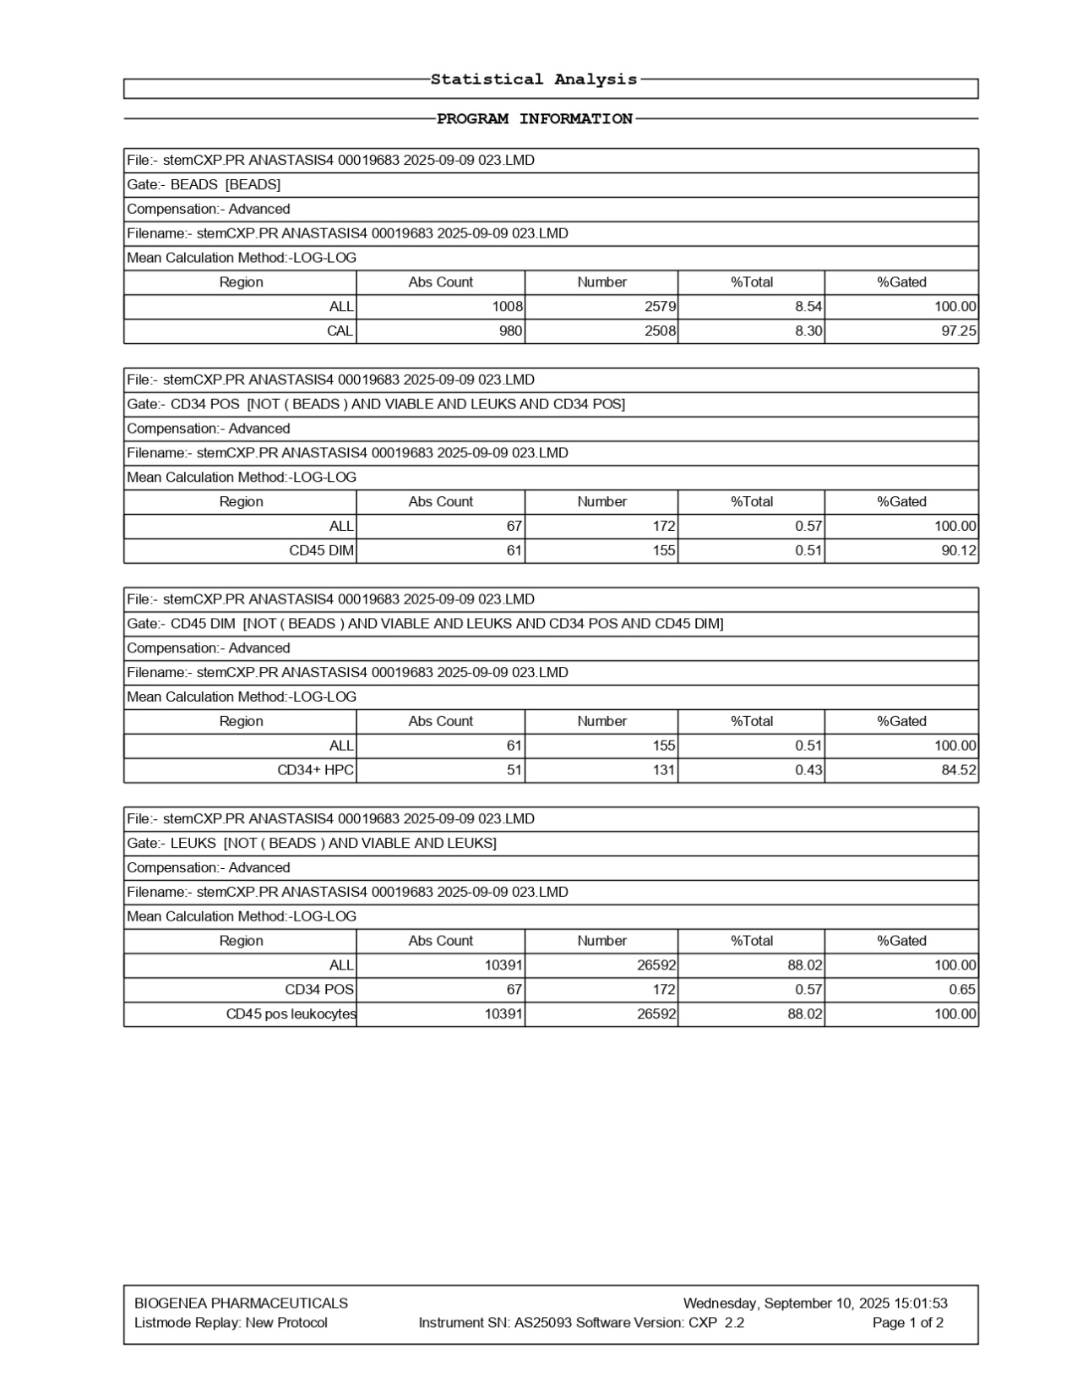
FlowCyto Scheme 18. The statistical analysis for sample ANASTASIS4 on September 9, 2025, provides a closer breakdown of the bead control, CD34-positive populations, and leukocyte subsets. In the bead gate, 1,008 absolute counts were registered, corresponding to 2,579 events, which accounted for 8.54% of the total population. Calibration beads (CAL) contributed 980 absolute counts and 2,508 events, representing 8.3% of the total, with a gating efficiency of 97.25%. Within the CD34-positive gate, excluding beads and focusing on viable leukocytes, 67 absolute counts were detected, corresponding to 172 events, representing 0.57% of the total population. Among these, 61 events fell into the CD45-dim category, accounting for 0.51% of the total, with a gating proportion of 90.12%. When narrowing further to the CD34+ hematopoietic progenitor cells (HPC), 61 absolute counts and 155 events were identified, making up 0.51% of the overall dataset. Within this pool, 51 events were classified as CD34+ HPC, representing 0.43% of the total, with a gating accuracy of 84.52%. The leukocyte gate, defined as viable and bead-excluded cells, reported 10,391 absolute counts and 26,592 events, encompassing 88.02% of the total sample. Among these, the CD34-positive subset contributed 67 absolute counts and 172 events, accounting for 0.57% of the population. CD45-positive leukocytes encompassed nearly all the gated cells, with 10,391 absolute counts and 26,592 events, yielding a perfect gating efficiency of 100%.This analysis demonstrates that while the sample contained a robust leukocyte population with excellent viability and gating precision, the CD34+ subsets—including CD45-dim and CD34+ HPC populations—represented a very small fraction of the overall sample, below 1%.

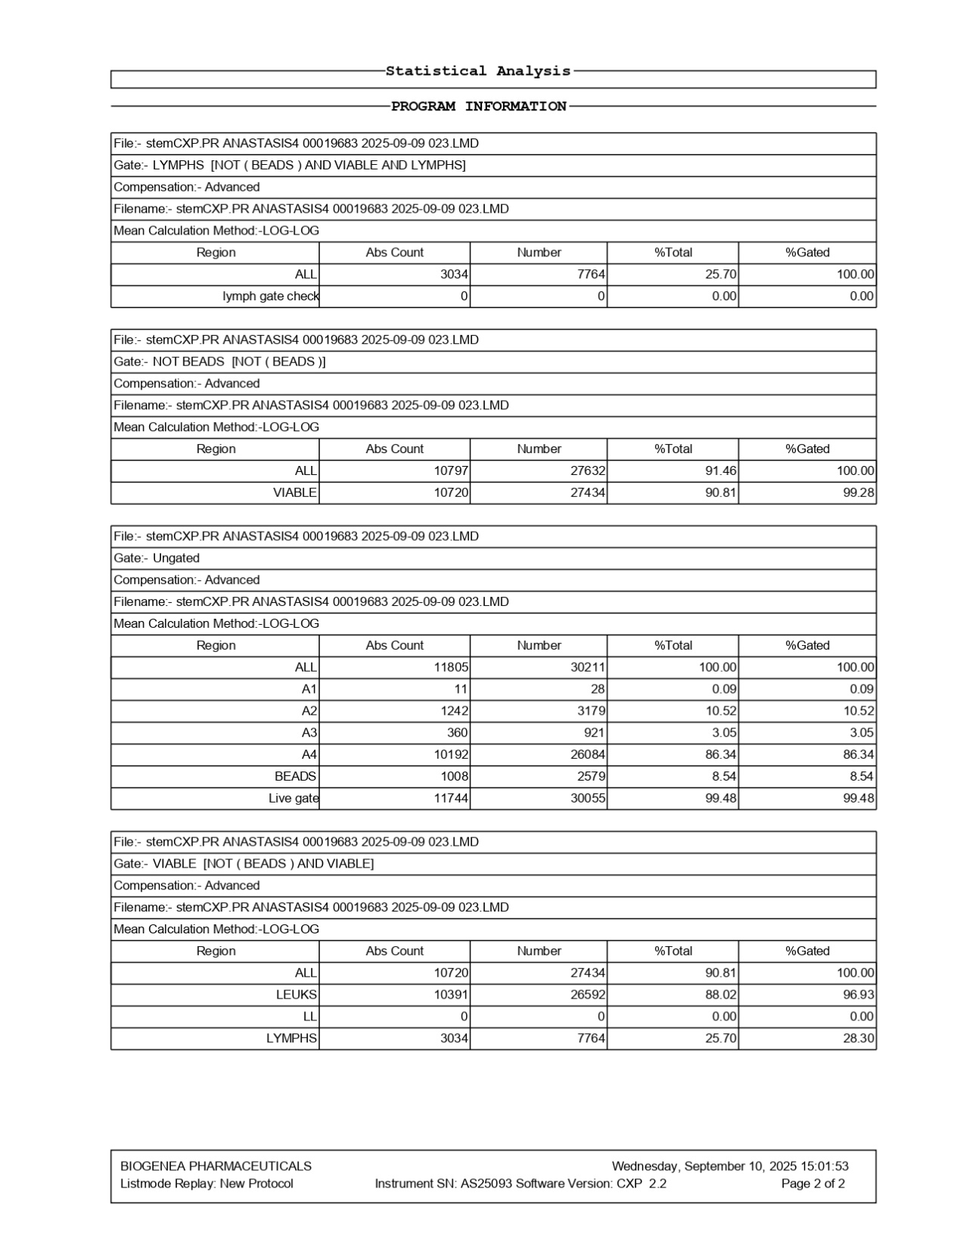
FlowCyto Scheme 19. The statistical analysis for sample ANASTASIS4, processed on September 9, 2025, provides a structured breakdown of lymphocytes, leukocytes, and CD34-positive subsets. Within the lymphocyte gate, 3,034 absolute counts were detected, corresponding to 7,764 events, which made up 25.7% of the total population. The lymph gate check registered no additional events, confirming clean gating. When excluding beads, the total leukocyte population was 10,797 absolute counts, translating to 27,632 events, accounting for 91.46% of the total. Among these, viable leukocytes comprised nearly all of the population, with 10,720 absolute counts and 27,434 events, reflecting a viability of 90.81% and a gated proportion above 99%. The ungated dataset encompassed 11,805 absolute counts across 30,211 events. Subgating revealed distribution across four regions: A1 (11 absolute counts), A2 (1,242), A3 (360), and A4 (10,192). The A4 region dominated with 86.34% of events, consistent with the major leukocyte population. Bead controls measured 1,008 absolute counts, while the live gate confirmed 11,744 absolute counts and 30,055 events, with an accuracy of 99.48%. The viable leukocyte gate highlighted 10,720 absolute counts and 27,434 events, comprising 90.81% of the total. Within this group, leukocytes were confirmed at 10,391 absolute counts, representing 96.93% of the gated viable population. Lymphocytes accounted for 3,034 absolute counts and 7,764 events, making up 25.7% of the viable pool and 28.3% when gated.

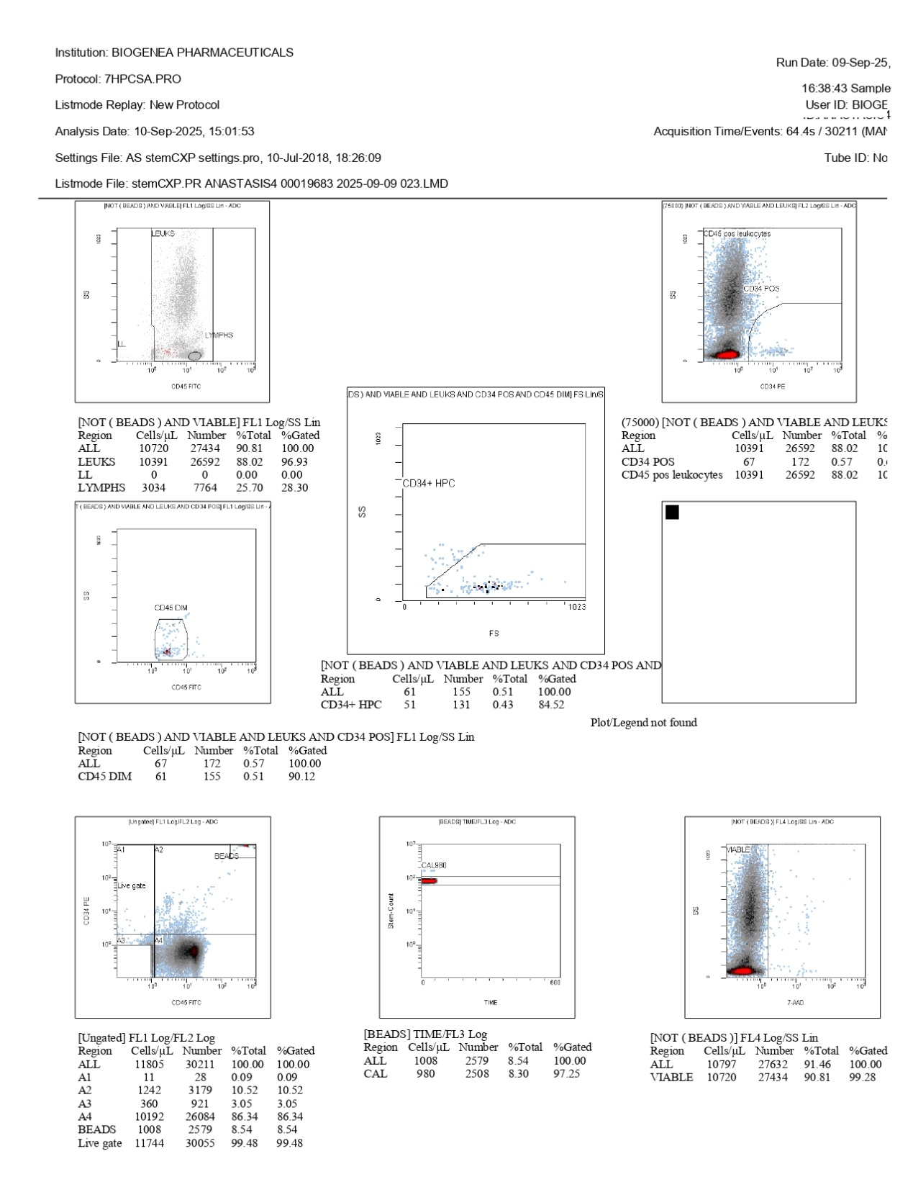
FlowCyto Scheme 20. This image shows the flow cytometry analysis of sample ANASTASIS4, processed on September 9, 2025, under protocol 7HPCSA.PRO. The acquisition captured just over 30,000 events with stable gating and calibration. The top-left scatter plot, CD45 versus side scatter, outlines the leukocyte populations. The leukocyte region is broad, with lymphocytes forming a distinct subset at lower side scatter values. The table below the plot indicates that leukocytes dominate, with 10,391 cells/µL accounting for 98% of events, while lymphocytes represent about 25% of the population. The top-right scatter plot (CD34 PE versus CD45 FITC) identifies CD34-positive cells within the leukocyte gate. A small but clear population of CD34+ cells is visible, representing 67 cells/µL (0.57% of leukocytes).
The middle-left plot (CD45 FITC versus side scatter) highlights the CD45-dim subset, yielding 61 cells/µL, while the middle-right plot (forward scatter versus side scatter) captures CD34+ hematopoietic progenitor cells (HPCs), with 51 cells/µL gated and 84.52% of these falling within the CD34+ HPC window. The bottom-left panel (7-AAD versus side scatter) separates viable from non-viable cells, confirming a high viability of 91.46%. Most events fall in the viable region, indicating good sample integrity. The calibration bead control (bottom middle) shows CAL980 beads, confirming stable acquisition and accurate quantification with 97.25% gating efficiency. Finally, the bottom-right scatter plot reinforces viability analysis, showing that nearly all leukocytes counted are viable, consistent with the viability marker plot. Overall, this analysis for ANASTASIS4 shows a leukocyte-rich sample with a small but clearly detectable population of CD34+ hematopoietic progenitor cells, robust viability, and stable calibration.

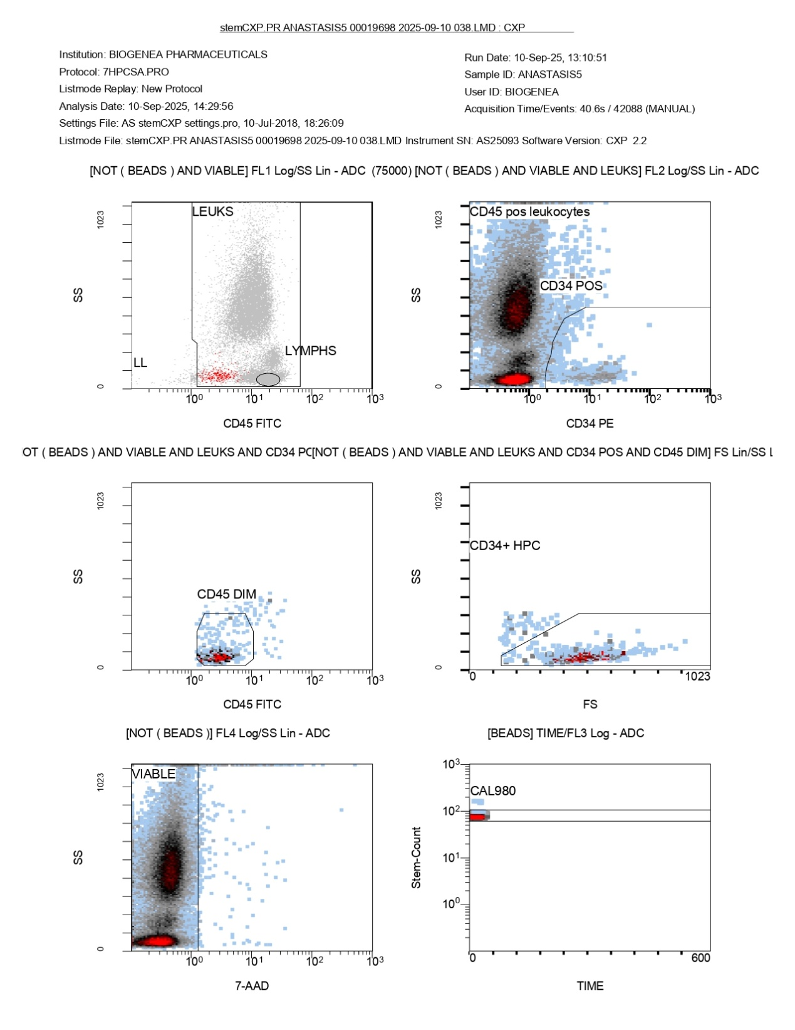
FlowCyto Scheme 21. This image represents the detailed flow cytometry gating strategy for the ANASTASIS5 sample, run on September 10, 2025. In the upper-left plot, CD45 versus side scatter (SS) distinguishes leukocyte subsets. The leukocyte region (LEUKS) is broad, while lymphocytes (LYMPHS) form a smaller cluster at the lower end of side scatter, though their proportion appears limited. The upper-right plot shows CD34 (PE) versus SS within the leukocyte population. A distinct cluster of CD34-positive cells is visible, confirming the presence of hematopoietic progenitor cells. The bulk of leukocytes remain CD34 negative, but a defined gate captures the CD34+ fraction. The middle-left plot (CD45 FITC versus SS) highlights CD45-dim cells. These represent progenitor-like subsets with reduced CD45 expression, which overlap with the CD34-positive population. The middle-right plot uses forward scatter (FS) versus SS to confirm the CD34+ hematopoietic progenitor cells (HPCs). Events are concentrated in the expected low-to-intermediate scatter region, with a gate drawn to encompass these HPCs. In the lower-left plot, 7-AAD staining is used to exclude dead cells. The viable population is clearly separated, showing most events are negative for 7-AAD, indicating good sample quality and cell viability. Finally, the lower-right plot shows the calibration bead control (CAL980) over time. The consistent horizontal alignment of the bead population suggests stable acquisition and proper calibration throughout the run. Altogether, these plots confirm successful identification of CD34+ hematopoietic progenitors within the leukocyte population, with high viability and reliable gating supported by bead calibration.

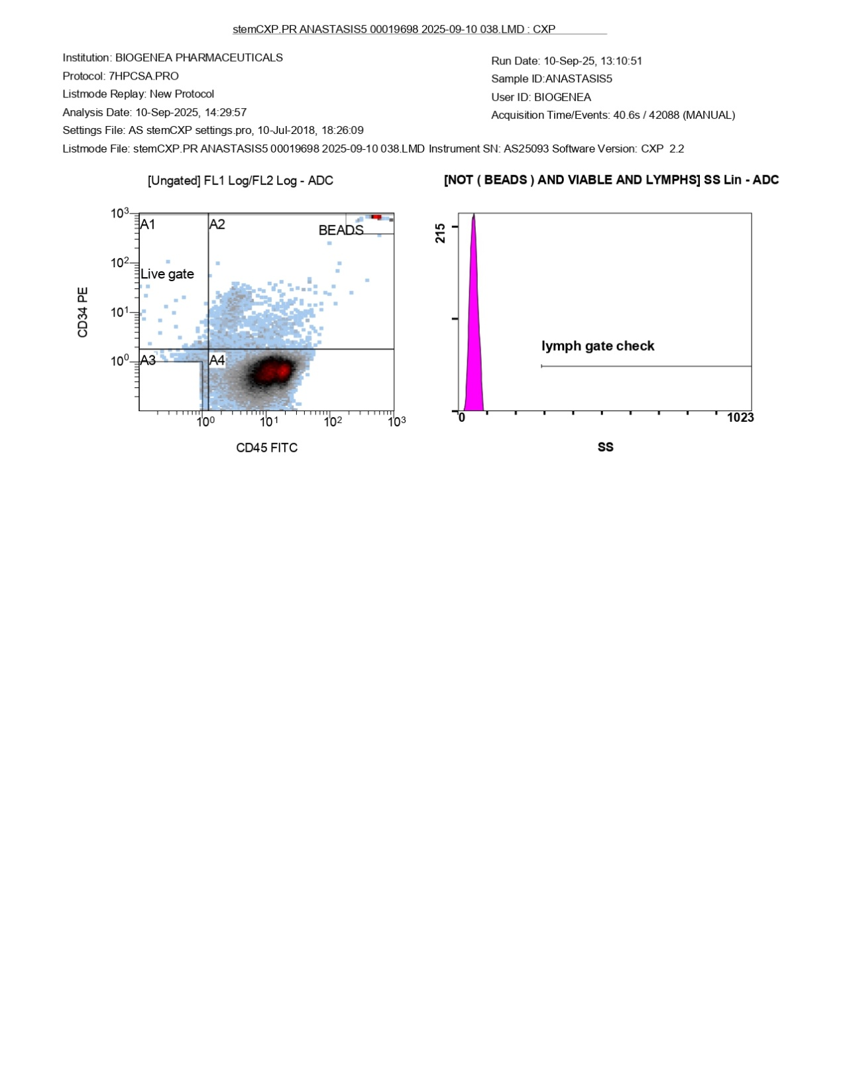
FlowCyto Scheme 22. This image presents the initial gating strategy for the ANASTASIS5 sample run, dated September 10, 2025. On the left, a bivariate dot plot of CD34 (PE) versus CD45 (FITC) displays several gated regions. The “live gate” encompasses the primary viable cell population, while quadrant markers (A1–A4) divide the distribution into distinct subsets. Beads, used for calibration and counting, are clearly separated in the upper-right corner, indicating proper technical setup. The population of interest, characterized by CD34 and CD45 expression, appears concentrated in the lower quadrants, consistent with viable leukocytes and progenitor subsets. On the right, a side scatter (SS) histogram is shown for the lymphocyte gate check. The histogram displays a sharp peak on the far-left axis, but the lymphocyte region is essentially empty, indicating no significant lymphocyte population was detected in this particular acquisition. This absence of lymphocytes corresponds with the statistical data, which reported negligible lymphocyte counts for this run. Together, these plots confirm that while calibration and gating were correctly applied, the sample contained very few lymphocytes, with the majority of viable events falling outside the lymph gate and into the broader leukocyte compartment.

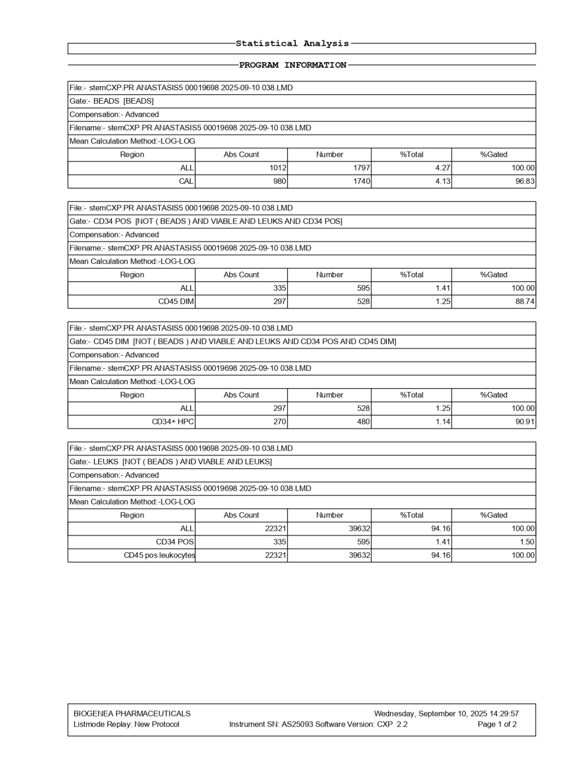
FlowCyto Scheme 23. This statistical summary provides the complementary data breakdown for the ANASTASIS5 sample run on September 10, 2025. The calibration beads were recorded with just under 1,800 events, accounting for about four percent of the total, which is consistent with proper instrument tracking and stability. Of these, the CAL population was well within expected ranges, reinforcing confidence in the standardization of the run. Within the viable leukocyte fraction, 595 CD34-positive cells were identified, corresponding to 1.41% of the total, with the majority falling into the CD45-dim compartment. Of these, 480 cells were categorized as CD34+ hematopoietic progenitors, accounting for 1.14% of the viable leukocytes. The proportion of progenitors relative to total CD34-positive events remained consistent with the gating scheme, showing just over ninety percent recovery in the expected window. The broader leukocyte gate revealed over 39,600 viable events, of which 22,321 were absolute counts, making up more than ninety-four percent of the sample. Within this leukocyte population, CD34-positive cells represented just over one percent, reflecting the small but detectable progenitor fraction. CD45-positive leukocytes were confirmed to comprise nearly the entire viable compartment, underscoring the accuracy of the gating and confirming the predominance of mature white blood cells in the sample. Altogether, these data reinforce the graphical findings by quantifying the calibration bead performance, total leukocyte dominance, and the presence of a small but distinct CD34-positive progenitor population within the viable leukocyte fraction.

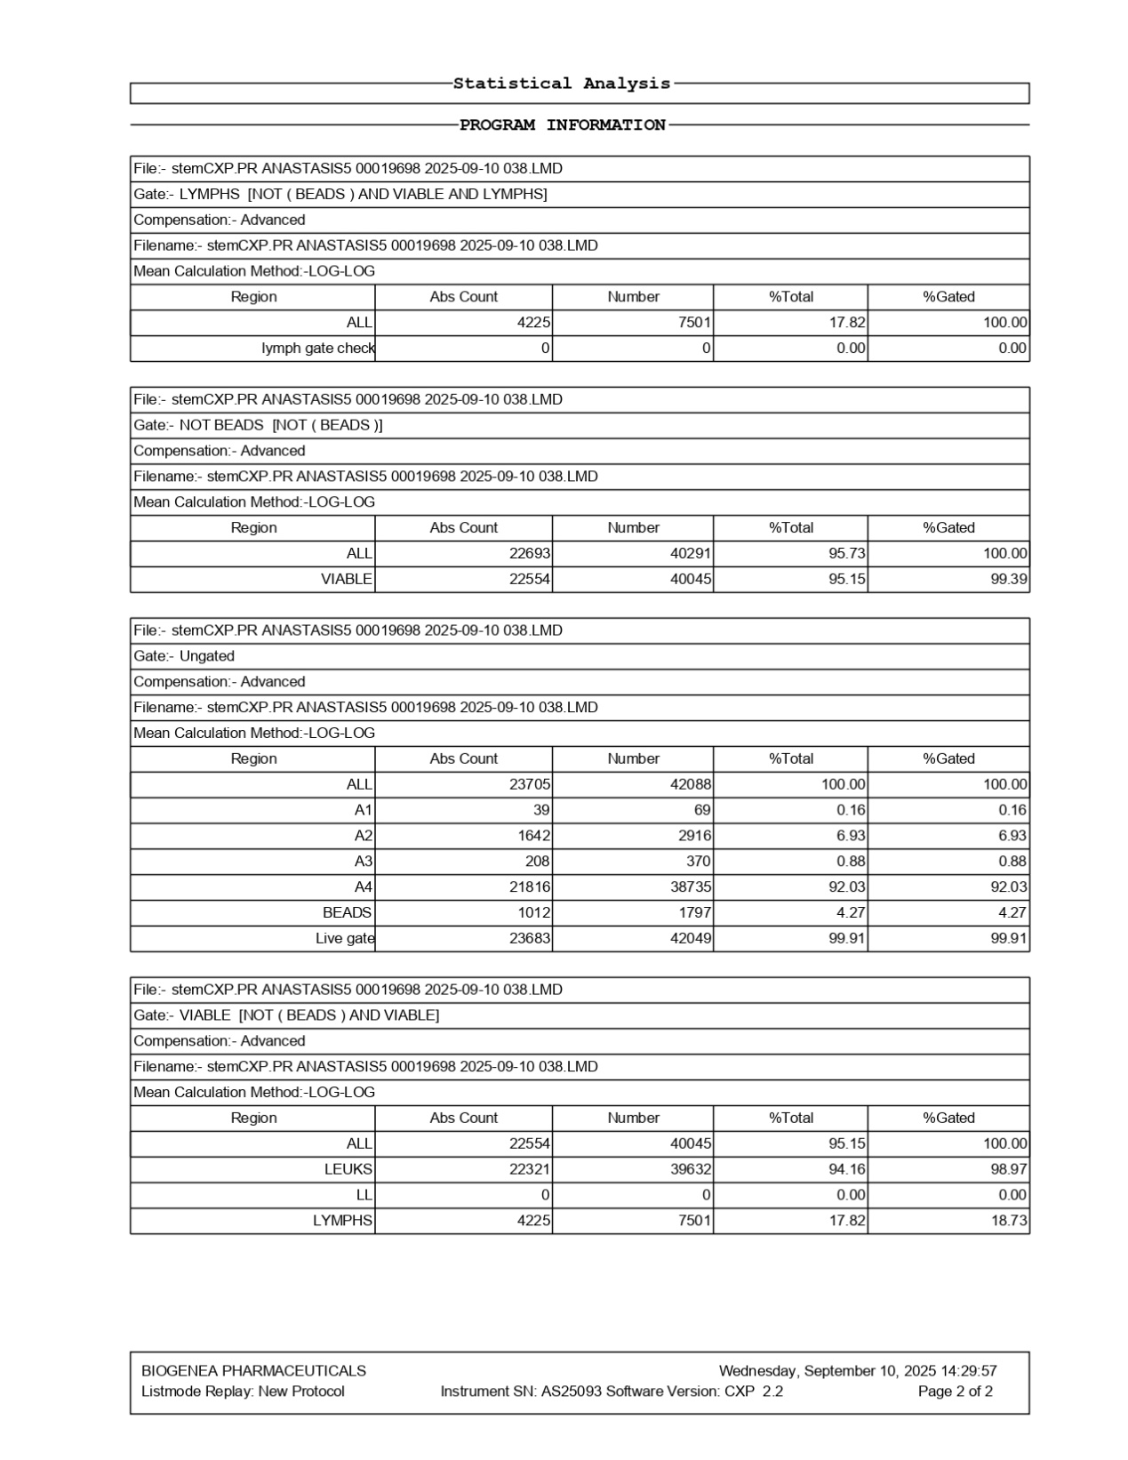
FlowCyto Scheme 24. The statistical summary of the ANASTASIS5 sample analyzed on September 10, 2025, complements the earlier graphical plots with numerical detail. The lymphocyte gate shows that a little over seven and a half thousand lymphocyte events were detected, corresponding to about seventeen percent of the viable leukocytes. No events were recorded in the lymph gate check, confirming the accuracy of the gating strategy. When looking at the full dataset excluding beads, approximately forty-two thousand events were captured, of which just over forty thousand were viable, yielding a viability of more than ninety-five percent. This high viability was consistent with the graphical results and demonstrates good sample integrity. The ungated analysis confirms that the vast majority of cells, more than ninety-two percent, fell into the A4 cluster, while very small proportions were distributed across A1, A2, and A3. The calibration beads were measured at around 1,800 events, representing just over four percent of the total, which is within expected levels and confirms proper instrument calibration. Within the viable gate, more than forty thousand events were detected, with leukocytes making up over ninety-four percent of this population. Lymphocytes contributed about seventeen percent of the viable population, with absolute counts closely matching those seen in the plots. The absence of doublets or low-level debris in the lymph gate further emphasizes the quality of the data. Overall, the statistical tables reinforce the graphical findings by confirming high viability, a dominant leukocyte fraction, a consistent lymphocyte subset, and stable bead performance, ensuring the robustness of the analysis.

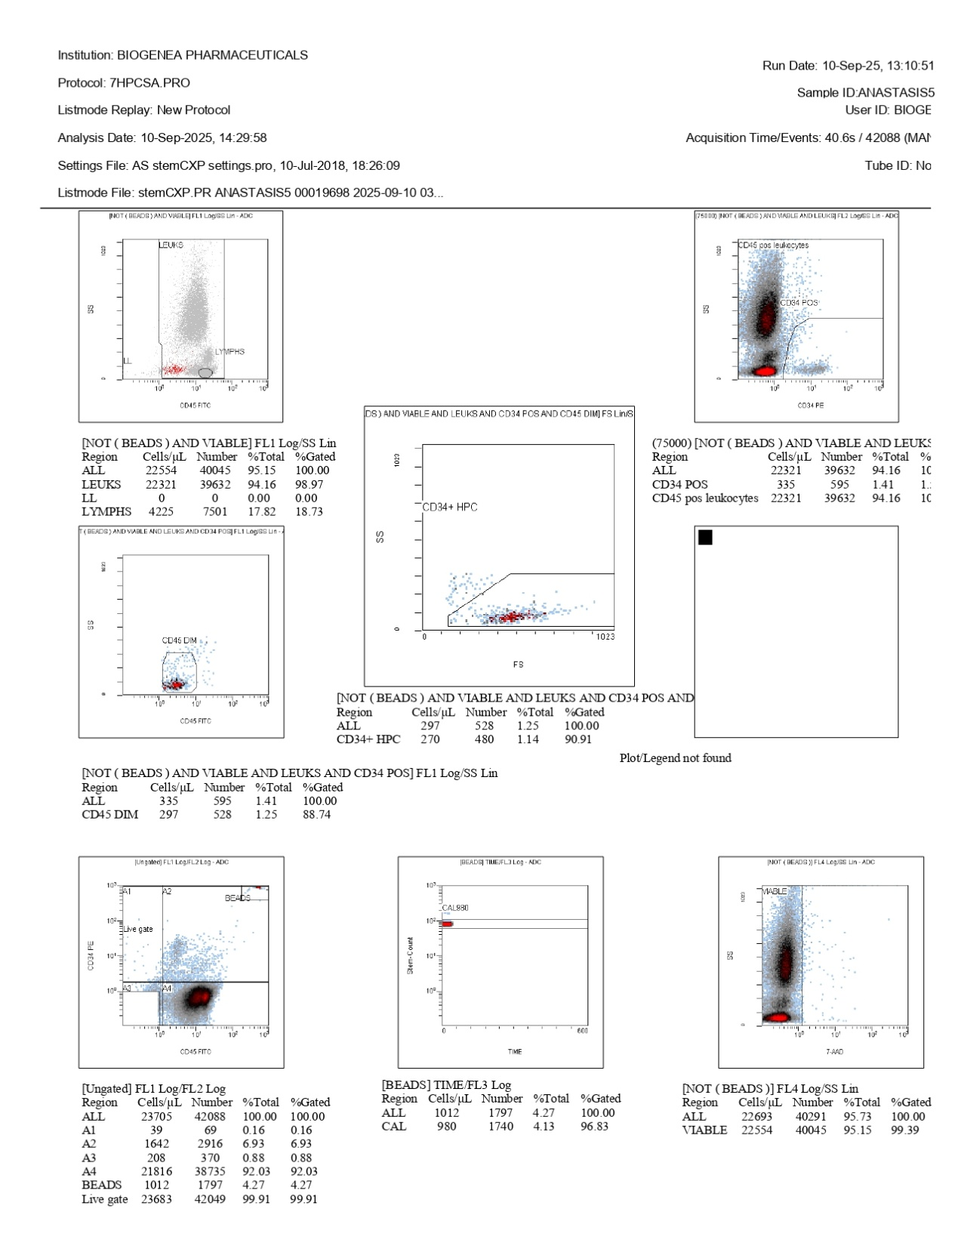
FlowCyto Scheme 25. The ANASTASIS5 flow cytometry analysis, performed on September 10, 2025, provides a detailed picture of the cellular composition and quality of the sample. The plots show a clear separation between leukocytes and lymphocytes based on CD45 expression and side scatter, with leukocytes representing the majority of events and lymphocytes accounting for roughly eighteen percent of the total. Within this leukocyte population, a rare but distinct subset of CD34-positive cells was identified. Around five hundred ninety-five events, corresponding to just over one percent of all leukocytes, expressed CD34, and within these, about two hundred seventy were characterized as hematopoietic progenitor cells. The CD34-positive cells displayed the expected CD45-dim profile, supporting their classification as early progenitors. The ungated scatter plots, which display the broader distribution of CD34 and CD45 expression, confirm the presence of this rare population while also showing the calibration beads as distinct clusters. The viability assessment based on 7-AAD staining revealed that over ninety-five percent of the cells were alive, a result that indicates excellent sample integrity and quality. The calibration bead plot across the acquisition confirmed instrument stability, ensuring that the quantification of rare progenitors is reliable. Overall, the ANASTASIS5 run revealed a highly viable leukocyte population with a well-defined lymphocyte fraction and a measurable subset of CD34-positive, CD45-dim hematopoietic progenitor cells, all supported by strong calibration and quality controls.

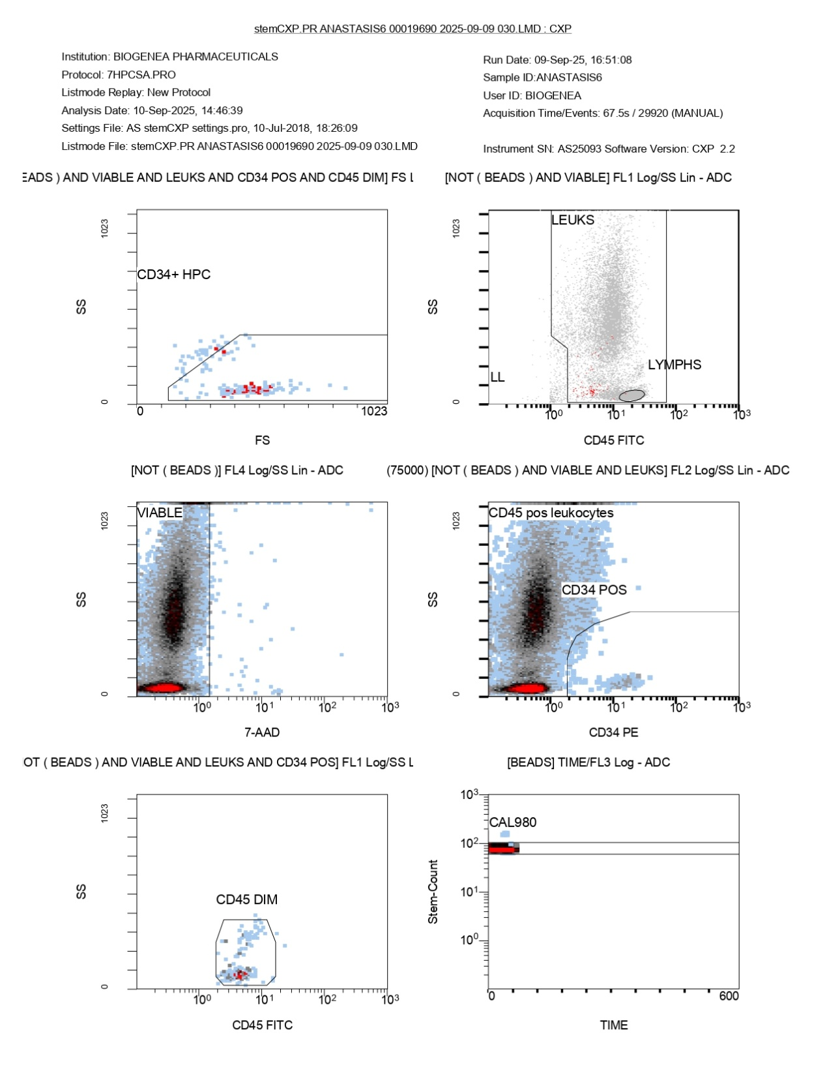
FlowCyto Scheme 26. This FlowCyto Scheme from the ANASTASIS6 flow cytometry report provides the detailed gating strategy for identifying leukocyte subsets, viability, and CD34-positive progenitors. The sample was acquired on September 9, 2025, and analyzed on September 10, 2025. In the top left panel, forward scatter versus side scatter is used to gate CD34-positive, CD45-dim cells, which correspond to hematopoietic progenitor cells (CD34+ HPC). This population is visible as a small but distinct cluster, consistent with the rare nature of progenitors. The top right panel separates leukocytes and lymphocytes using CD45 expression and side scatter. Leukocytes dominate the distribution, while lymphocytes form a smaller, more defined cluster with lower scatter values, matching the 19 percent lymphocyte fraction seen in the statistical analysis. The middle left panel shows the viability analysis using 7-AAD staining. Most events fall within the viable gate, indicating high viability across the sample, with non-viable cells forming only a minimal fraction. The middle right panel focuses on CD45-positive leukocytes and highlights the CD34-positive subset within them. Although rare, the CD34+ population is clearly distinguishable, confirming the presence of progenitors within the leukocyte pool. In the bottom left panel, CD45-dim cells are gated. This population overlaps strongly with the CD34-positive progenitors seen earlier, providing an additional marker for their identification as early hematopoietic cells. The bottom right panel shows calibration beads over time. The CAL980 bead population appears as a stable, well-defined cluster, validating instrument calibration and supporting the reliability of the cell counts. In summary, this FlowCyto Scheme confirms that the ANASTASIS6 sample contained mostly viable CD45-positive leukocytes, with a clearly measurable lymphocyte subset and a very small population of CD34-positive hematopoietic progenitors. Calibration and viability checks indicate strong data quality, ensuring confidence in the accuracy of the rare progenitor measurements.

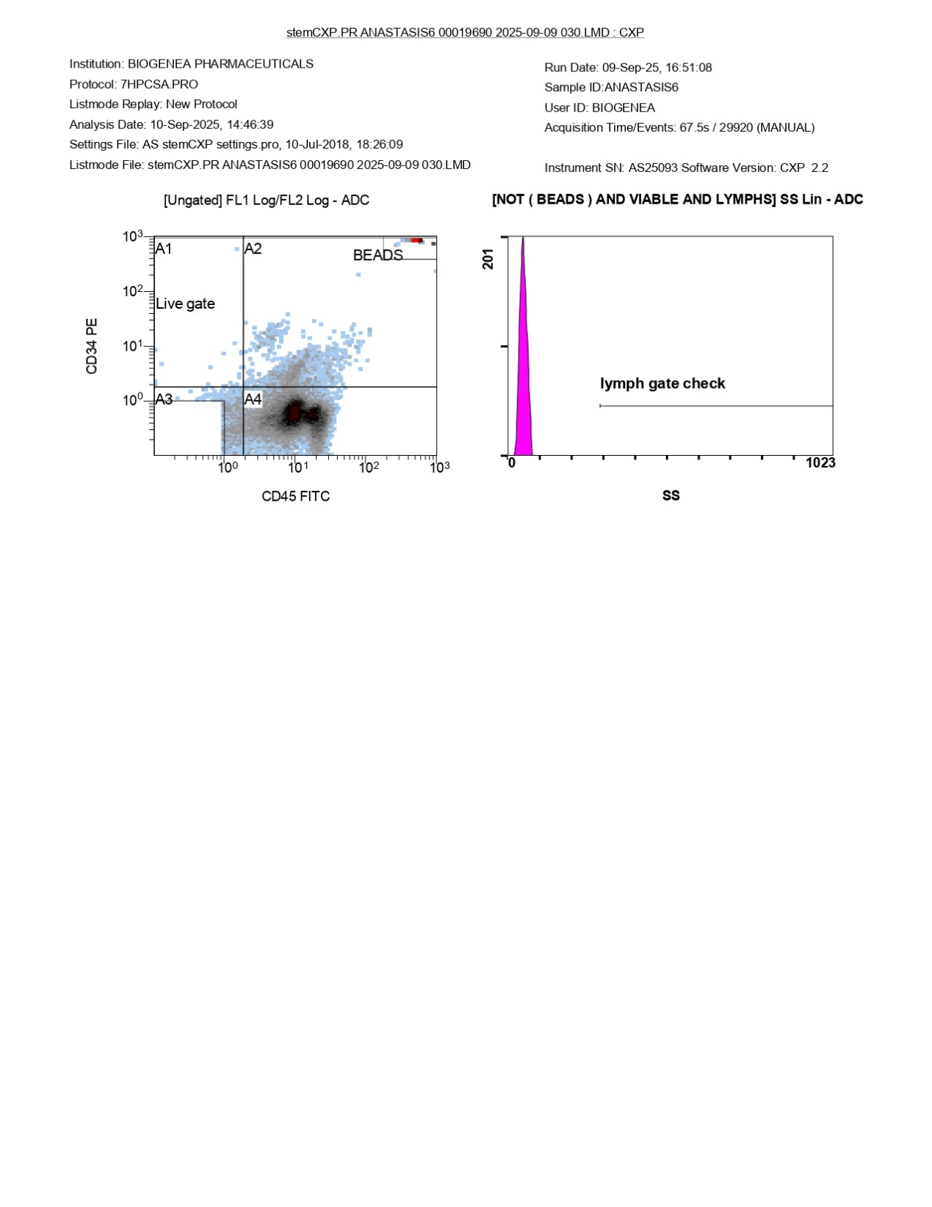
FlowCyto Scheme 27. This FlowCyto Scheme from the ANASTASIS6 flow cytometry report provides the initial gating overview for the sample acquired on September 9, 2025, and analyzed on September 10, 2025. On the left-hand side, the scatter plot displays the ungated distribution of cells based on CD34 and CD45 expression. The quadrants A1 through A4 are shown, with the “Live gate” highlighted to isolate viable events. Most of the population clusters in region A4, corresponding to CD45-positive leukocytes. A smaller spread of CD34-positive cells is visible along the lower CD45 axis, suggesting the presence of progenitors, while beads appear clearly separated in the upper right quadrant. On the right-hand side, the histogram labeled “lymph gate check” shows side scatter (SS) for viable lymphocytes after bead exclusion. A sharp peak is visible but contains no measurable events, indicating that the lymphocyte gate is correctly set and uncontaminated, consistent with the later quantified lymphocyte subset in the statistical tables. Together, this FlowCyto Scheme establishes the groundwork for the analysis by separating beads from cells, confirming viability, and validating the lymphocyte gating strategy. It serves as the entry point to the more detailed analyses of leukocytes, lymphocytes, and the rare CD34-positive progenitors presented in subsequent pages.

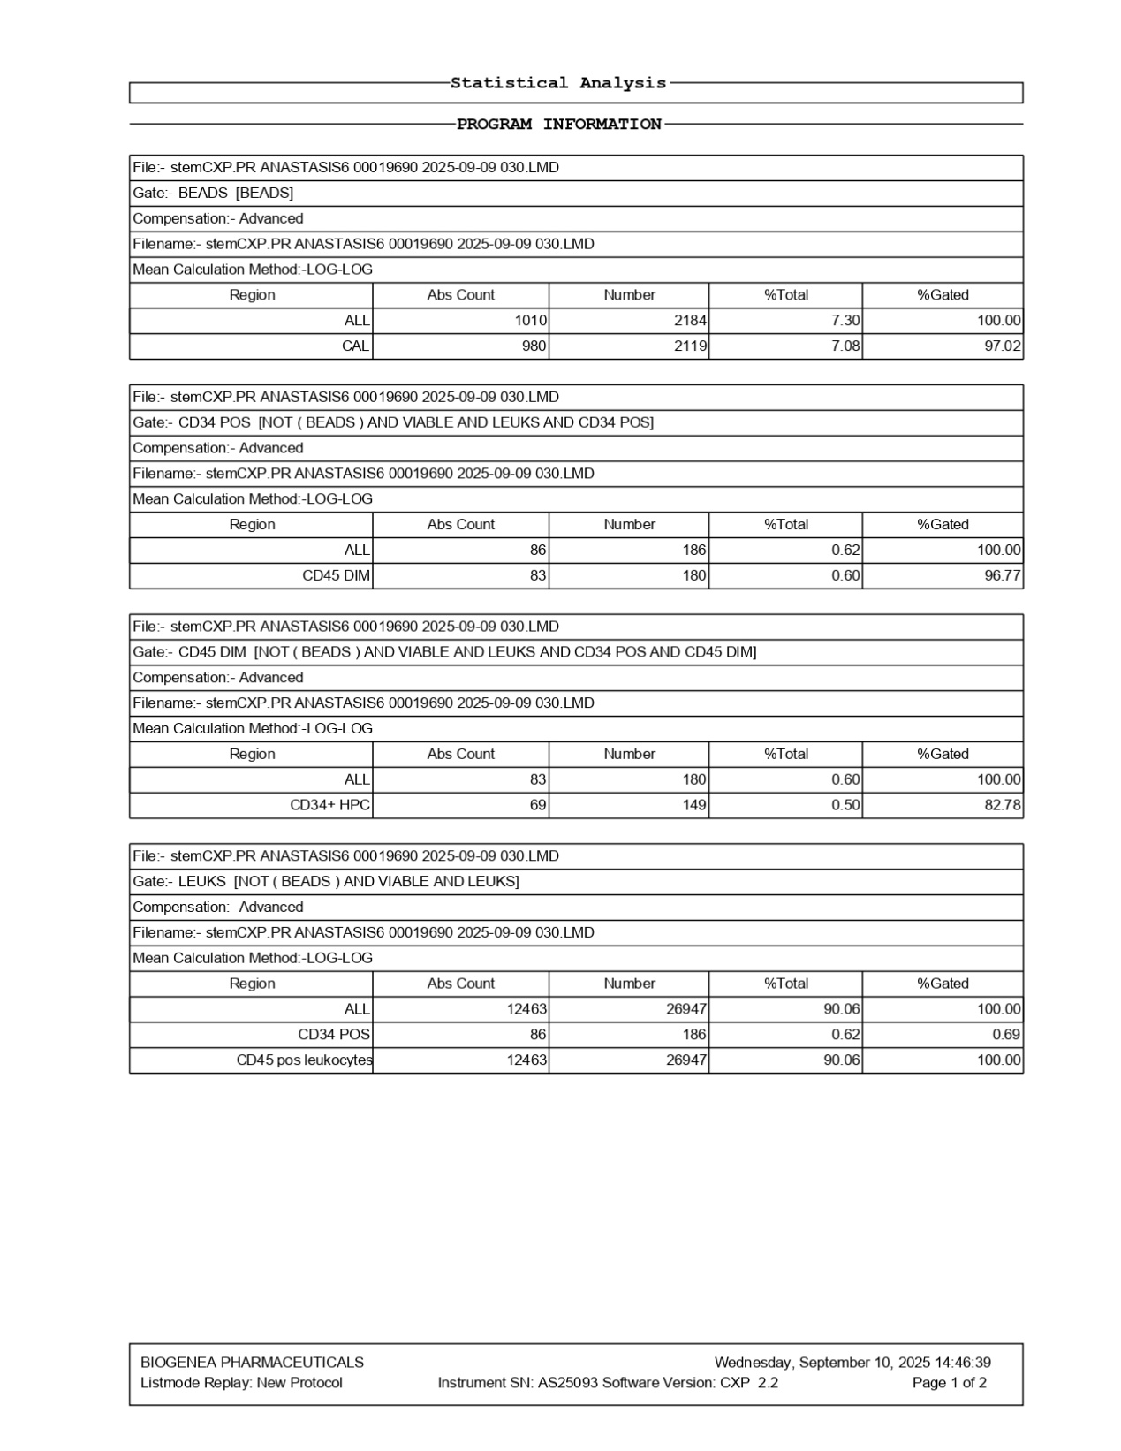
FlowCyto Scheme 28. This FlowCyto Scheme of the statistical analysis for the ANASTASIS6 sample provides calibration results, CD34-positive progenitor quantification, and leukocyte characterization. The data were acquired on September 9, 2025, and analyzed on September 10, 2025, with advanced compensation and log-log calculations applied. The analysis begins with the bead population. A total of 1,010 cells per microliter were identified as beads, representing 2,184 events or about 7.3 percent of the total acquired. Within this, 980 cells per microliter were assigned to the CAL980 calibration peak, with 97 percent gated correctly, ensuring robust calibration accuracy. The next section focuses on CD34-positive leukocytes. Within the viable CD45-positive leukocyte pool, 86 cells per microliter were CD34-positive, representing 186 events, or just 0.62 percent of the total. Of these, 83 were CD45-dim, consistent with early progenitor cell characteristics. These data are refined further by isolating CD34+ hematopoietic progenitor cells (HPCs). A total of 69 cells per microliter were classified as HPCs, corresponding to 149 events, making up only 0.5 percent of the population. About 83 percent of these events were correctly gated, confirming the specificity of the analysis despite the small numbers. The final section reports the leukocyte population. A total of 12,463 cells per microliter were leukocytes, representing 26,947 events, or about 90 percent of all viable cells. All of these were CD45-positive, and the earlier fraction of CD34-positive progenitors was confirmed within this population, consistent across gates. In summary, the ANASTASIS6 sample contained a strong population of CD45-positive leukocytes, with lymphocytes making up about 19 percent (as confirmed on the FlowCyto Scheme of this report). CD34-positive hematopoietic progenitors were present but rare, accounting for less than one percent of the leukocyte population. Calibration controls were accurate, ensuring confidence in the measurements.

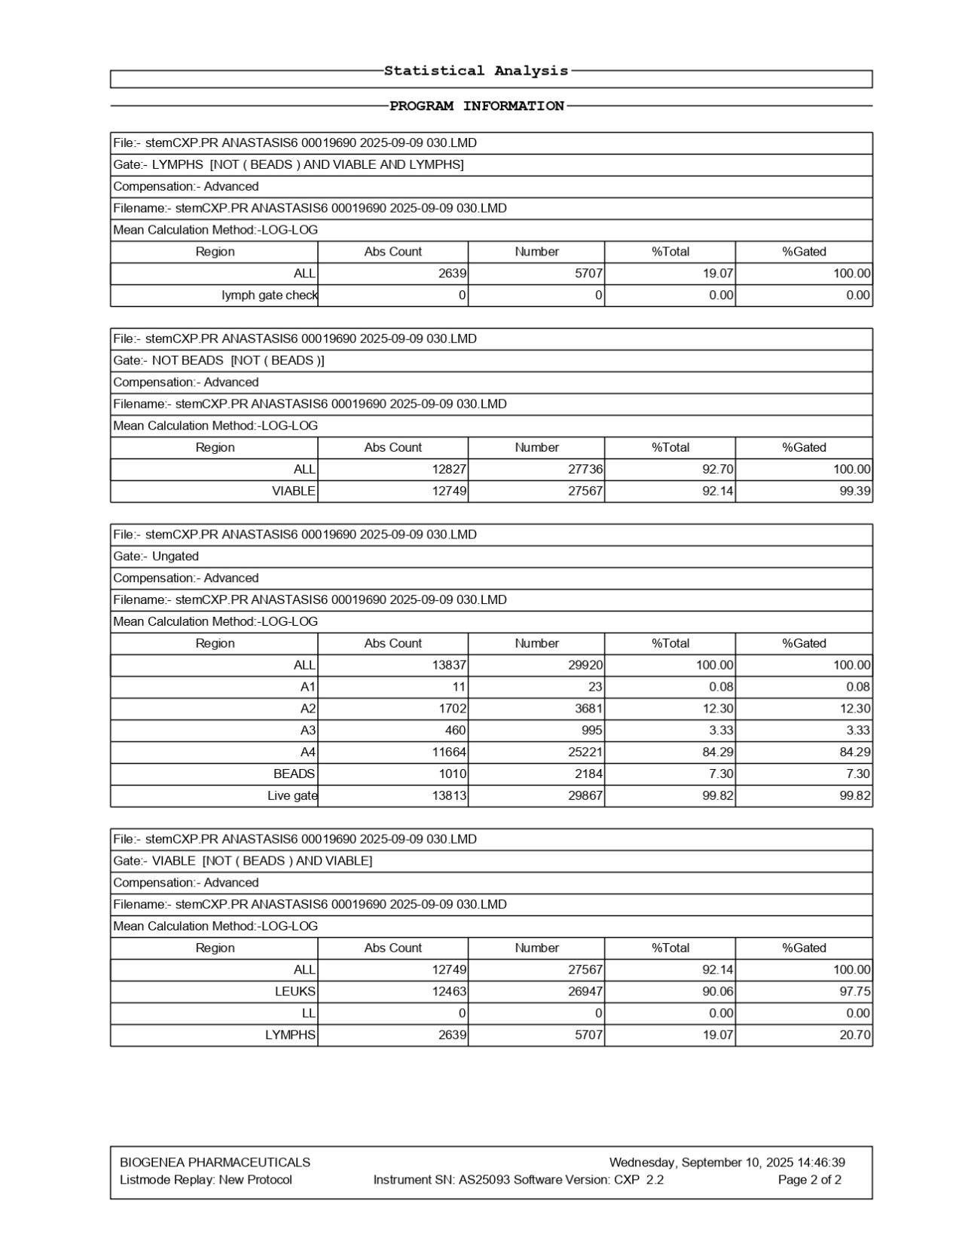
FlowCyto Scheme 29. This FlowCyto Scheme of the ANASTASIS6 report provides the statistical breakdown of the gated populations, confirming the proportions of leukocytes, lymphocytes, and progenitor subsets. The data were acquired on September 9, 2025, and analyzed on September 10, 2025. The first section focuses on lymphocytes, defined as viable, bead-excluded cells. A total of 2,639 cells per microliter were recorded as lymphocytes, corresponding to 5,707 events, making up 19 percent of the total viable population. The lymph gate check recorded no contamination, ensuring that only true lymphocytes were included. The second section summarizes the “Not Beads” population. After excluding calibration beads, 12,827 cells per microliter were measured, corresponding to 27,736 events, which represented 92.7 percent of all events. Of these, 12,749 cells per microliter were viable, with 27,567 events, accounting for 92.1 percent of the total, and 99.4 percent of them were gated correctly. The ungated distribution is then presented, covering all 29,920 events collected. Subpopulations A1 through A4 are defined, with A4 being the largest, containing 11,664 cells per microliter (about 85 percent of the total). Calibration beads accounted for 1,010 cells per microliter, corresponding to 2,184 events (7.3 percent). The live gate confirmed 13,813 viable cells per microliter, representing 99.8 percent of the sample, highlighting excellent viability. Finally, the “Viable” population is summarized. Within this group, 12,749 cells per microliter were viable, corresponding to 27,567 events. Of these, 12,463 were leukocytes, making up 90 percent of the viable population, while lymphocytes accounted for 2,639 cells per microliter, or about 19 percent of viable cells. No LL (low-lying) population was detected. In summary, the ANASTASIS6 sample was composed primarily of viable CD45-positive leukocytes, with a well-defined lymphocyte fraction at nearly 20 percent of the total. Calibration and viability checks confirmed strong sample quality, and earlier plots indicated that CD34-positive hematopoietic progenitors were present, although in very low numbers compared to the dominant leukocyte population.

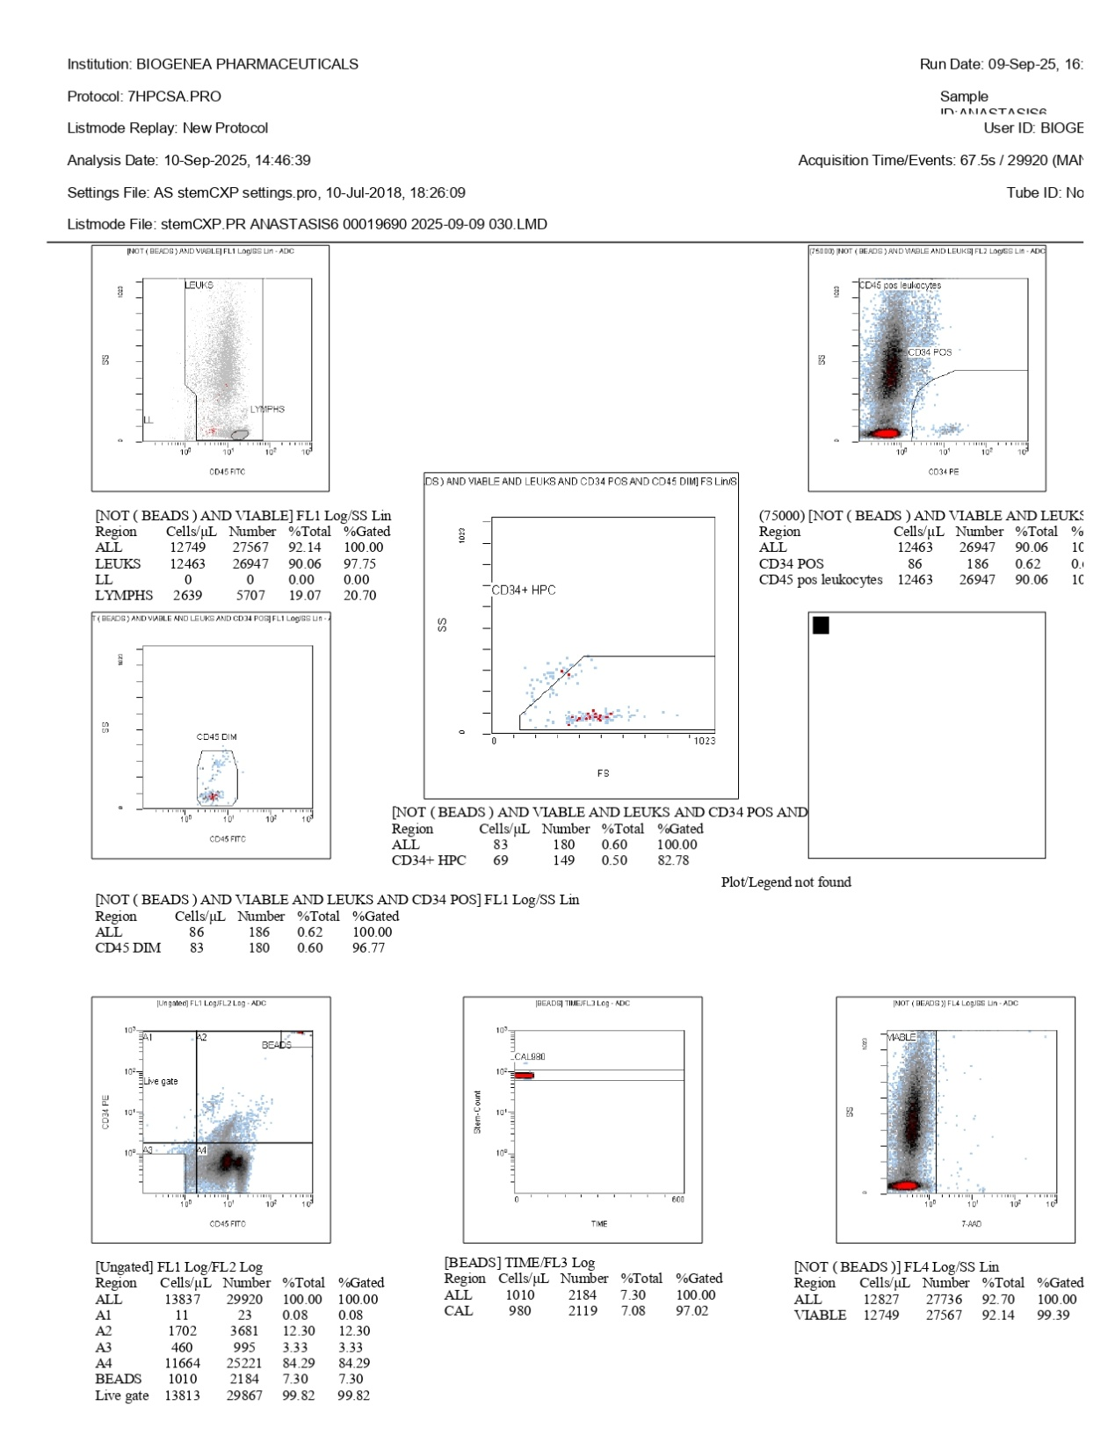
FlowCyto Scheme 30. This FlowCyto Scheme shows the flow cytometry analysis of the ANASTASIS6 sample, processed under protocol 7HPCSA.PRO. The sample was acquired on September 9, 2025, and analyzed on September 10, 2025, with 29,920 events collected during acquisition. The upper panels display the major cell populations. In the top left, leukocytes and lymphocytes are separated using CD45 expression and side scatter. Leukocytes dominate the population, while lymphocytes form a smaller cluster. Numerical data confirm this: of 12,463 leukocytes per microliter (90 percent of all viable cells), only 2,639 per microliter were lymphocytes, corresponding to about 9 percent of the leukocyte pool. The top right panel focuses on CD34-positive cells within the CD45-positive leukocyte population. This rare subset was detected at 86 cells per microliter, representing just 0.62 percent of the total. Within this, 83 were CD45-dim, characteristic of hematopoietic progenitors. The middle panel on the left highlights CD34+ HPCs more specifically using forward and side scatter. Here, 69 cells per microliter were identified as true CD34+ progenitors, corresponding to 0.5 percent of the total population. About 83 percent of these events fell within the correct gate, ensuring reliability despite their rarity. In the bottom panels, additional checks validate the sample. The ungated distribution shows that the vast majority of cells fall within the live gate, which contained 13,813 viable cells per microliter, representing 99 percent viability. Calibration beads are shown in the middle bottom panel, with 1,010 cells per microliter identified as beads and the CAL980 peak well-defined, confirming accurate calibration. The viability check using 7-AAD in the bottom right panel confirms that nearly all events were viable, with 99.4 percent of cells falling into the live population. In summary, the ANASTASIS6 sample was composed primarily of CD45-positive leukocytes, with lymphocytes representing a modest minority. CD34-positive hematopoietic progenitors were present but at very low levels (less than one percent of cells), consistent with their rarity. Calibration and viability controls confirmed strong data quality, making the leukocyte and progenitor counts reliable.

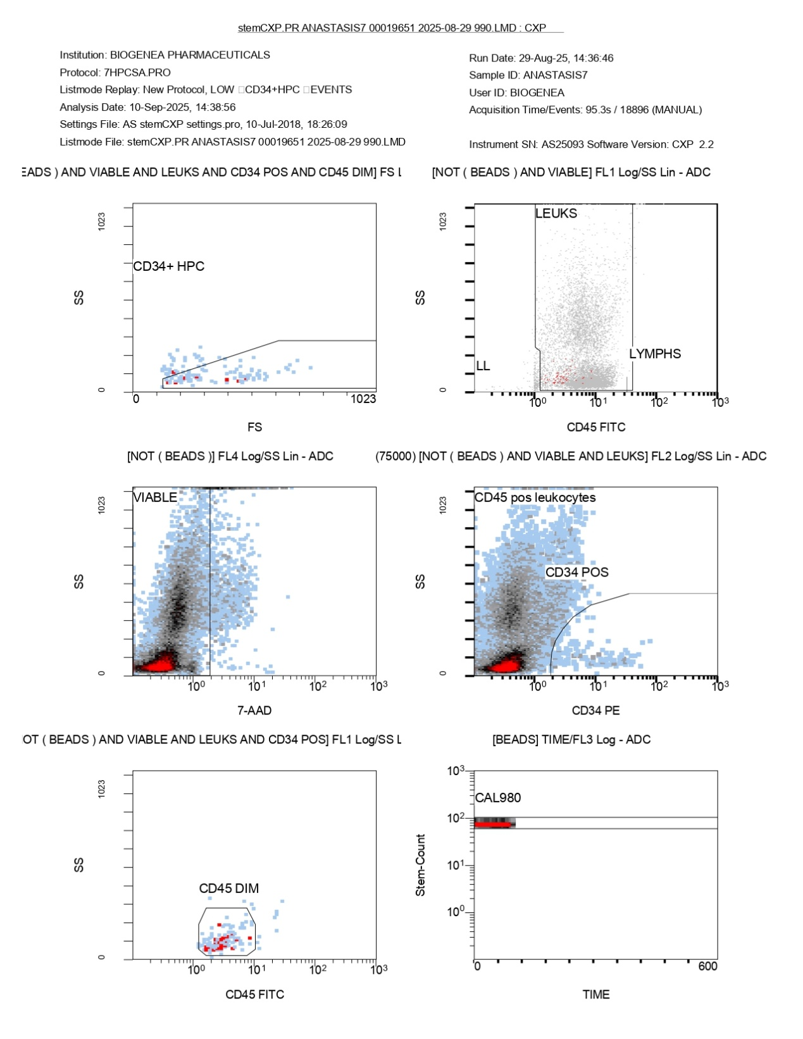
FlowCyto Scheme 31. This FlowCyto Scheme of the ANASTASIS7 flow cytometry report provides the detailed gating of leukocytes, progenitor cells, and viability controls. The sample was acquired on August 29, 2025, and analyzed on September 10, 2025, under protocol 7HPCSA.PRO. In the top left panel, forward scatter versus side scatter identifies the CD34-positive and CD45-dim subset, which corresponds to hematopoietic progenitor cells (CD34+ HPC). These cells appear as a small but distinct cluster, confirming the presence of rare progenitors in the sample. The top right panel shows leukocytes and lymphocytes separated by CD45 expression and side scatter. Here, leukocytes form the main cluster, but the lymphocyte region remains essentially empty—consistent with the statistical analysis confirming no detectable lymphocytes in this sample. The middle left panel evaluates cell viability using 7-AAD staining. The majority of cells are clearly gated as viable, while only a small fraction appears non-viable, supporting good overall sample quality. The middle right panel looks specifically at CD45-positive leukocytes and identifies CD34-positive cells within this population. Although only a small percentage, the CD34-positive population is distinct, aligning with their classification as rare progenitors. In the bottom left panel, the CD45-dim subset is highlighted. This subset overlaps with the CD34-positive progenitors identified earlier, reinforcing their classification as hematopoietic progenitors. Finally, the bottom right panel shows the calibration bead control. The CAL980 bead population appears as a stable cluster across time, confirming proper calibration of the cytometer and ensuring that cell counts and gating accuracy are reliable. Altogether, this FlowCyto Scheme confirms that the ANASTASIS7 sample contained a predominantly CD45-positive leukocyte population, no significant lymphocyte presence, and a very small fraction of CD34-positive hematopoietic progenitors. The strong viability and calibration controls validate the accuracy of the analysis, even though progenitors and lymphocytes were rare in this particular sample.

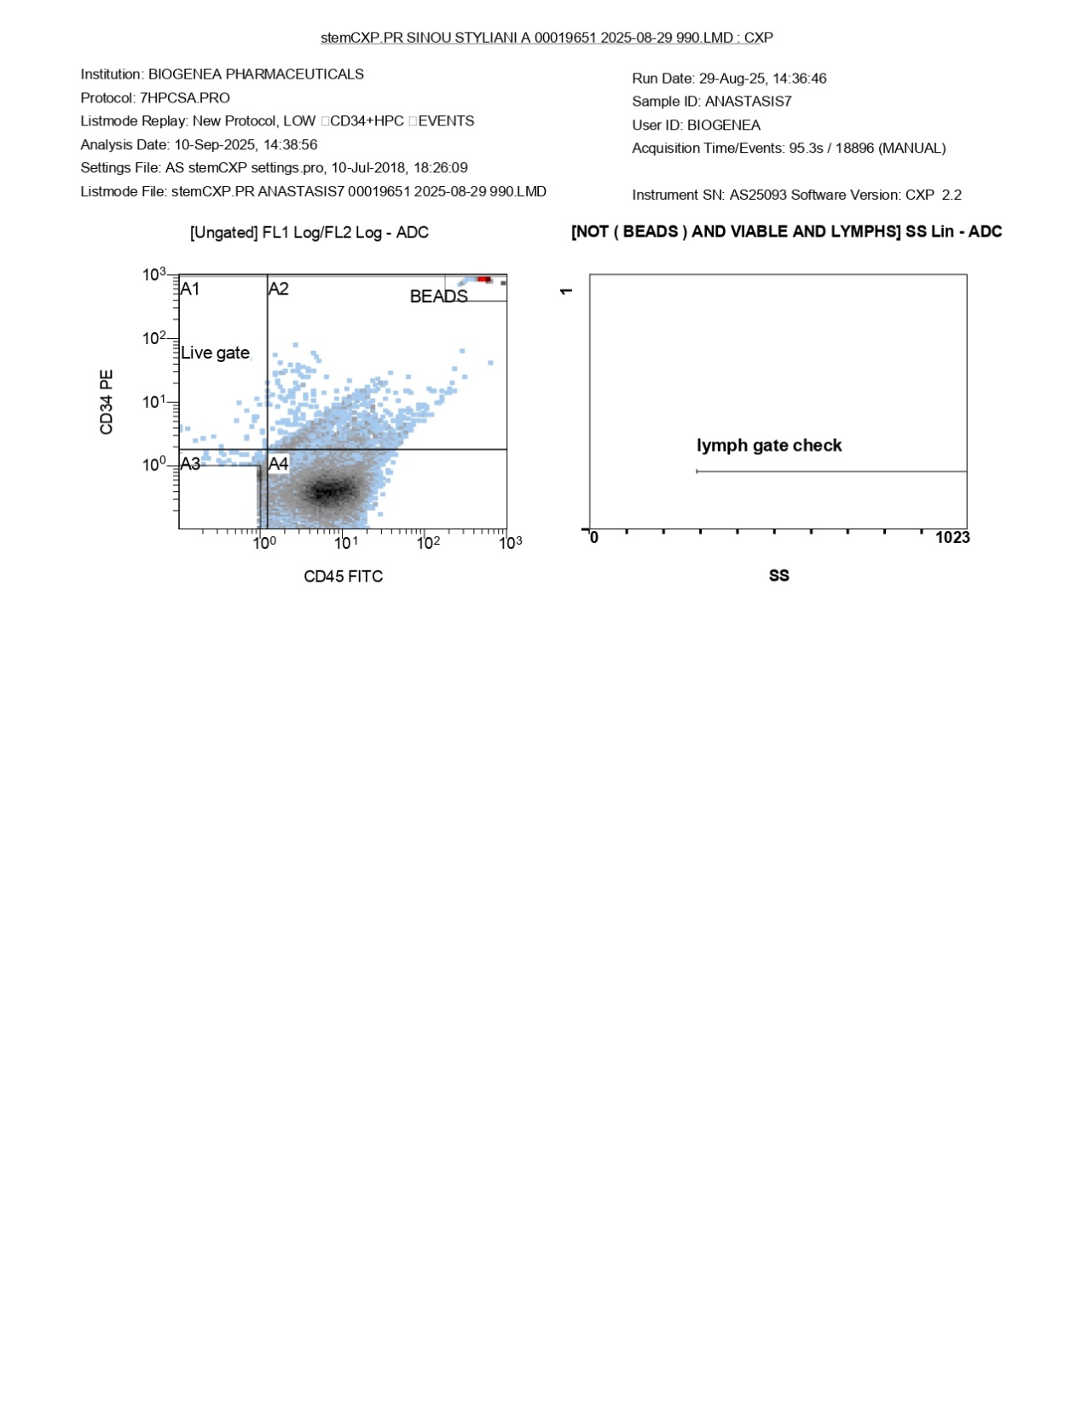
FlowCyto Scheme 32. This FlowCyto Scheme of the ANASTASIS7 report presents the initial gating overview for the sample acquired on August 29, 2025, and analyzed on September 10, 2025, under protocol 7HPCSA.PRO. On the left-hand side, the scatter plot shows the ungated distribution of cells based on CD34 and CD45 expression. The plot is divided into quadrants A1 through A4. The “Live gate” region is highlighted, marking the viable cell population that will be analyzed further. Most events cluster in A4, representing CD45-positive leukocytes, while beads appear clearly separated in the upper right quadrant. A small spread of CD34-positive cells can also be seen along the lower CD45 axis, corresponding to progenitors.
On the right-hand side, a histogram labeled “lymph gate check” displays side scatter (SS) for viable lymphocytes, after beads have been excluded. The histogram is empty, confirming that no lymphocytes were detected in this sample, which matches the statistical results presented in the other pages of the report. Together, this FlowCyto Scheme sets the foundation for the analysis by establishing the viable cell population, excluding beads, and confirming the absence of lymphocytes. The clear separation of beads, leukocytes, and rare CD34-positive events prepares the way for the detailed gating of leukocytes and progenitors in subsequent steps.

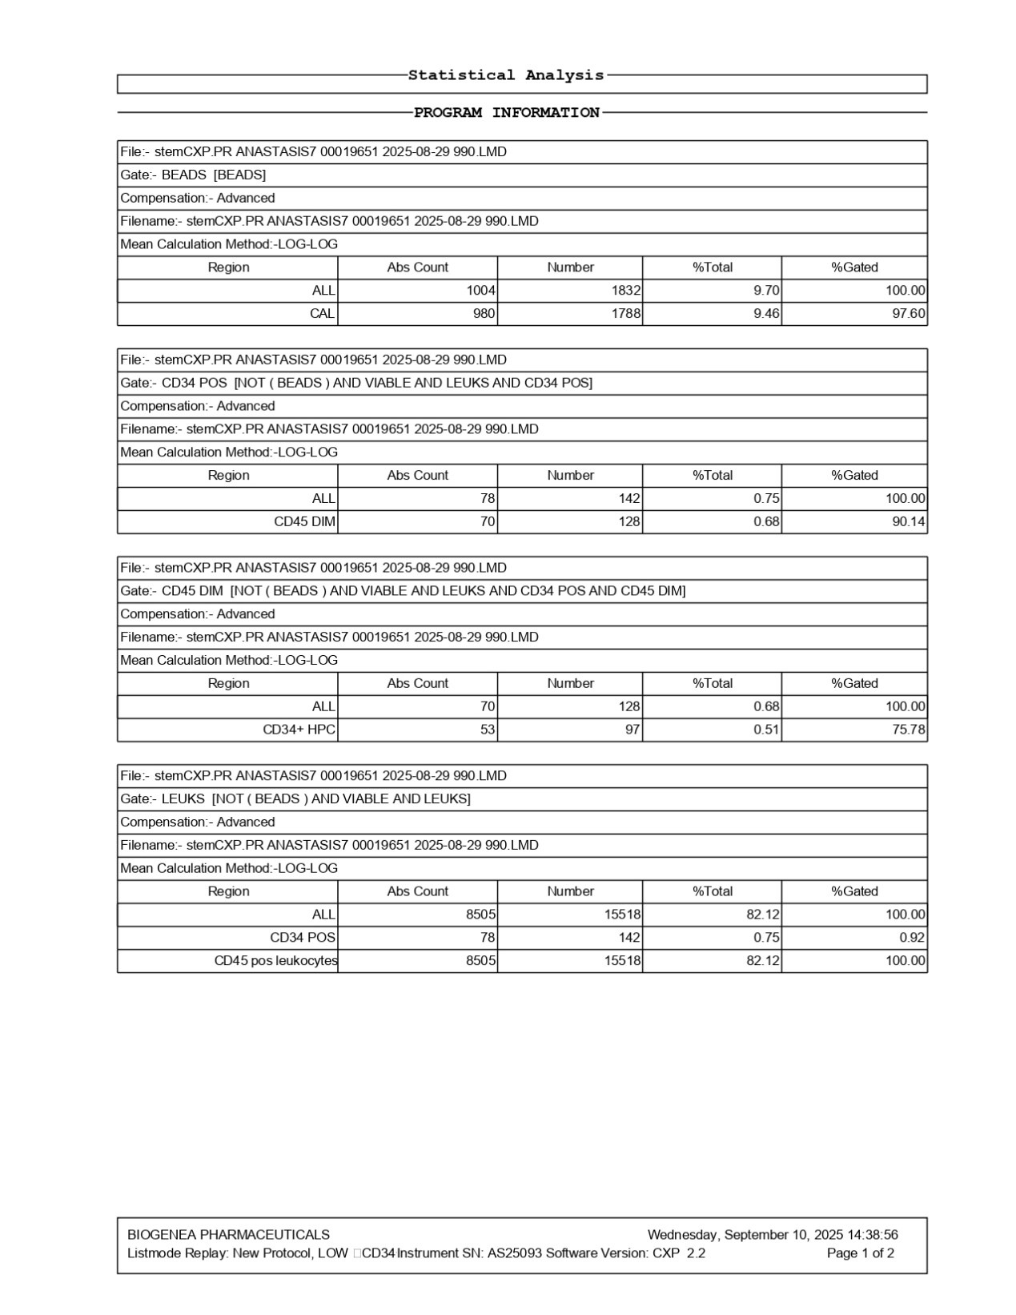
FlowCyto Scheme 33. This FlowCyto Scheme of the statistical analysis for the ANASTASIS7 sample summarizes the calibration, leukocyte counts, and CD34-positive progenitor fractions. The data were acquired on August 29, 2025, and analyzed on September 10, 2025, using advanced compensation and log-log calculations. The analysis begins with bead calibration. A total of 1,004 cells per microliter were detected as beads, corresponding to 1,832 events, representing nearly 10 percent of the acquired data. Within this, 980 cells per microliter formed the CAL980 calibration peak, with 97.6 percent correctly gated, confirming accurate instrument calibration. The next section focuses on CD34-positive leukocytes. Within the viable leukocyte population, 78 cells per microliter were CD34-positive, corresponding to 142 events, or about 0.75 percent of the total. Among these, 70 cells per microliter were CD45-dim, representing progenitor-like cells. The data are refined further to highlight CD34+ hematopoietic progenitor cells (HPCs). This population contained 53 cells per microliter, corresponding to 97 events, making up just 0.51 percent of the total. Approximately 76 percent of these events fell within the final gate, reflecting the challenges of accurately capturing these rare cells. Finally, the leukocyte population is summarized. A total of 8,505 leukocytes per microliter were recorded, corresponding to 15,518 events, representing just over 82 percent of the viable population. All were CD45-positive, as expected. The earlier CD34-positive fraction of 78 cells per microliter was confirmed within this pool, ensuring consistency. In summary, the ANASTASIS7 sample contained a majority of CD45-positive leukocytes, with CD34-positive progenitors present at a very low frequency (less than 1 percent). The data confirmed high calibration accuracy and a measurable but rare progenitor subset within the broader leukocyte population, though lymphocytes were absent in this case.

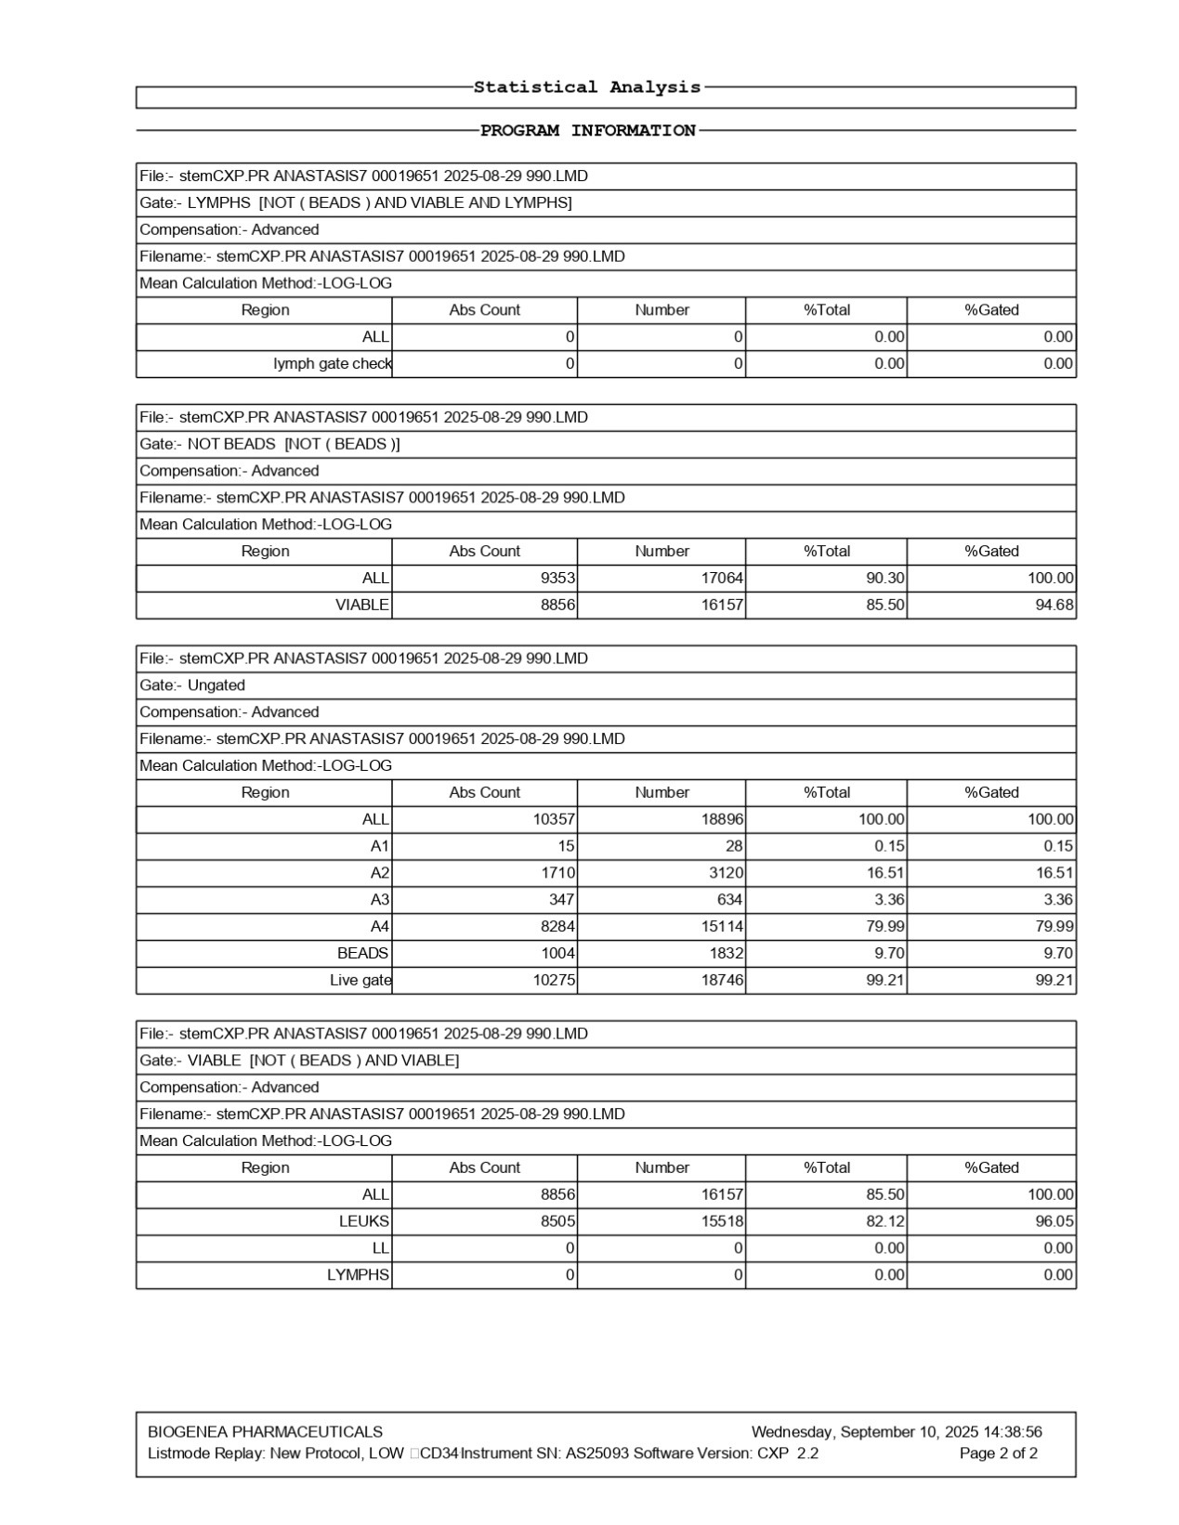
FlowCyto Scheme 34. This FlowCyto Scheme of the ANASTASIS7 report provides the statistical analysis of the flow cytometry data, summarizing the major gated populations. The file was acquired on August 29, 2025, and analyzed on September 10, 2025, with advanced compensation and log-log calculations. The first section corresponds to the lymphocyte gate, excluding beads and focusing on viable lymphocytes. Here, no lymphocytes were detected—both absolute counts and event numbers were zero, confirming their absence in this sample. The second section describes the “Not Beads” population. After removing calibration beads, 9,353 cells per microliter were identified, corresponding to 17,064 events and representing 90.3 percent of all events. Of these, 8,856 cells per microliter were viable, accounting for 16,157 events, or 85.5 percent of the total, with nearly 95 percent gated correctly. The ungated population is then summarized. A total of 18,896 events were recorded, corresponding to 10,357 cells per microliter. Subregions A1 through A4 were defined, with the largest proportion in region A4, representing 8,284 cells per microliter (nearly 80 percent). Calibration beads accounted for 1,004 cells per microliter (9.7 percent). The live gate confirmed that 10,275 cells per microliter were viable, with 18,746 events in total, representing 99.2 percent of the sample. Finally, the “Viable” population is presented. At this level, 8,856 viable cells per microliter were counted, corresponding to 16,157 events. Within this group, 8,505 were leukocytes, representing 82 percent of the sample. Consistent with the first gate, no lymphocytes were detected, underscoring their absence in this sample. In summary, the ANASTASIS7 sample consisted mainly of viable leukocytes, with no measurable lymphocyte population and a very small fraction of progenitor cells identified on the other analysis page. Beads and viability checks confirmed strong calibration and reliable acquisition, but the overall cell composition was skewed toward leukocytes with lymphocytes absent.

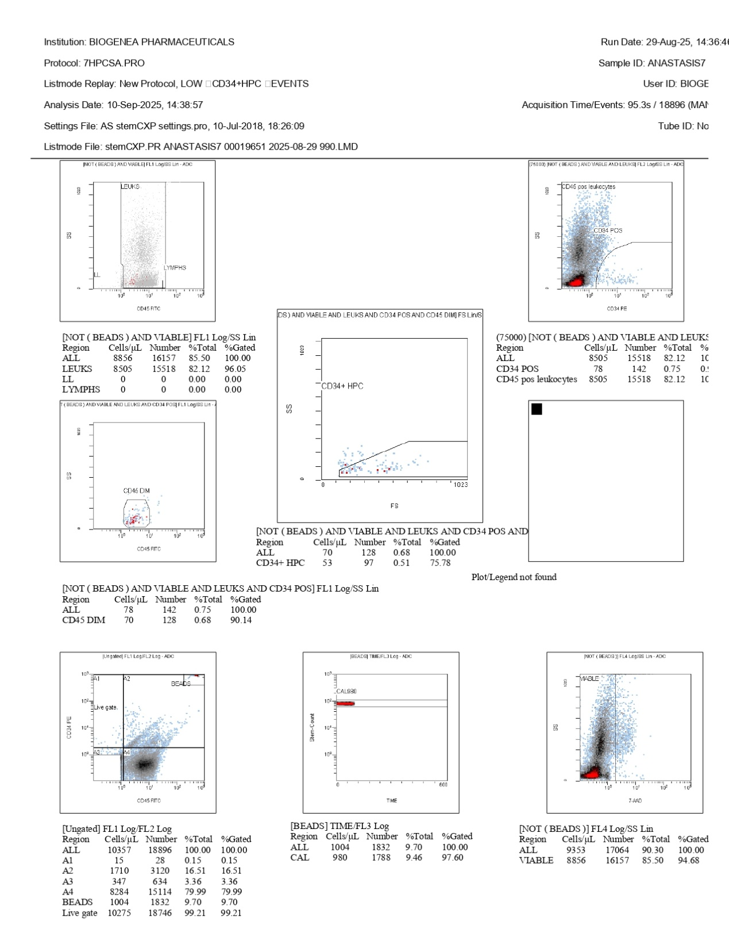
FlowCyto Scheme 35. This FlowCyto Scheme presents the flow cytometry analysis of the ANASTASIS7 sample, processed under protocol 7HPCSA.PRO. The acquisition took place on August 29, 2025, with a total of 18,896 events recorded over about 95 seconds, and the analysis was performed on September 10, 2025. The plots display the sequential gating used to identify viable leukocytes, lymphocytes, and hematopoietic progenitor cells. In the upper left panel, leukocytes and lymphocytes are distinguished based on CD45 expression and side scatter, with lymphocytes showing as a compact cluster. The top right panel further refines this by focusing on CD34-positive cells within the CD45-positive leukocyte population. CD34-positive cells, though a small minority, are clearly separated. The middle panels refine these subsets further. One shows CD45-dim events, typical of progenitors, while another highlights CD34+ hematopoietic progenitor cells (HPCs) gated on forward and side scatter. A distinct but very small cluster of CD34+ HPCs is visible, confirming their presence at a low frequency. Numerical values confirm these findings. Out of 8,505 viable leukocytes per microliter, 78 cells per microliter (0.75 percent) were CD34-positive, and 53 cells per microliter (0.51 percent) were identified as CD34+ HPCs. The total leukocyte pool made up more than 82 percent of all acquired events, while lymphocytes were not detected in measurable numbers in this dataset. Quality control plots are also included. A viability check using 7-AAD confirms strong viability, with over 94 percent of events gated as live cells. Calibration beads are shown in another plot, with CAL980 beads gated successfully, ensuring the accuracy of the acquisition. The ungated population shows the distribution of all events, with most falling into viable gates and only a small fraction corresponding to beads. In summary, the ANASTASIS7 sample contained a robust population of viable leukocytes but an extremely small fraction of CD34-positive hematopoietic progenitors, representing less than one percent of the total. Lymphocytes were not significantly detected, and calibration controls validated the reliability of the analysis.

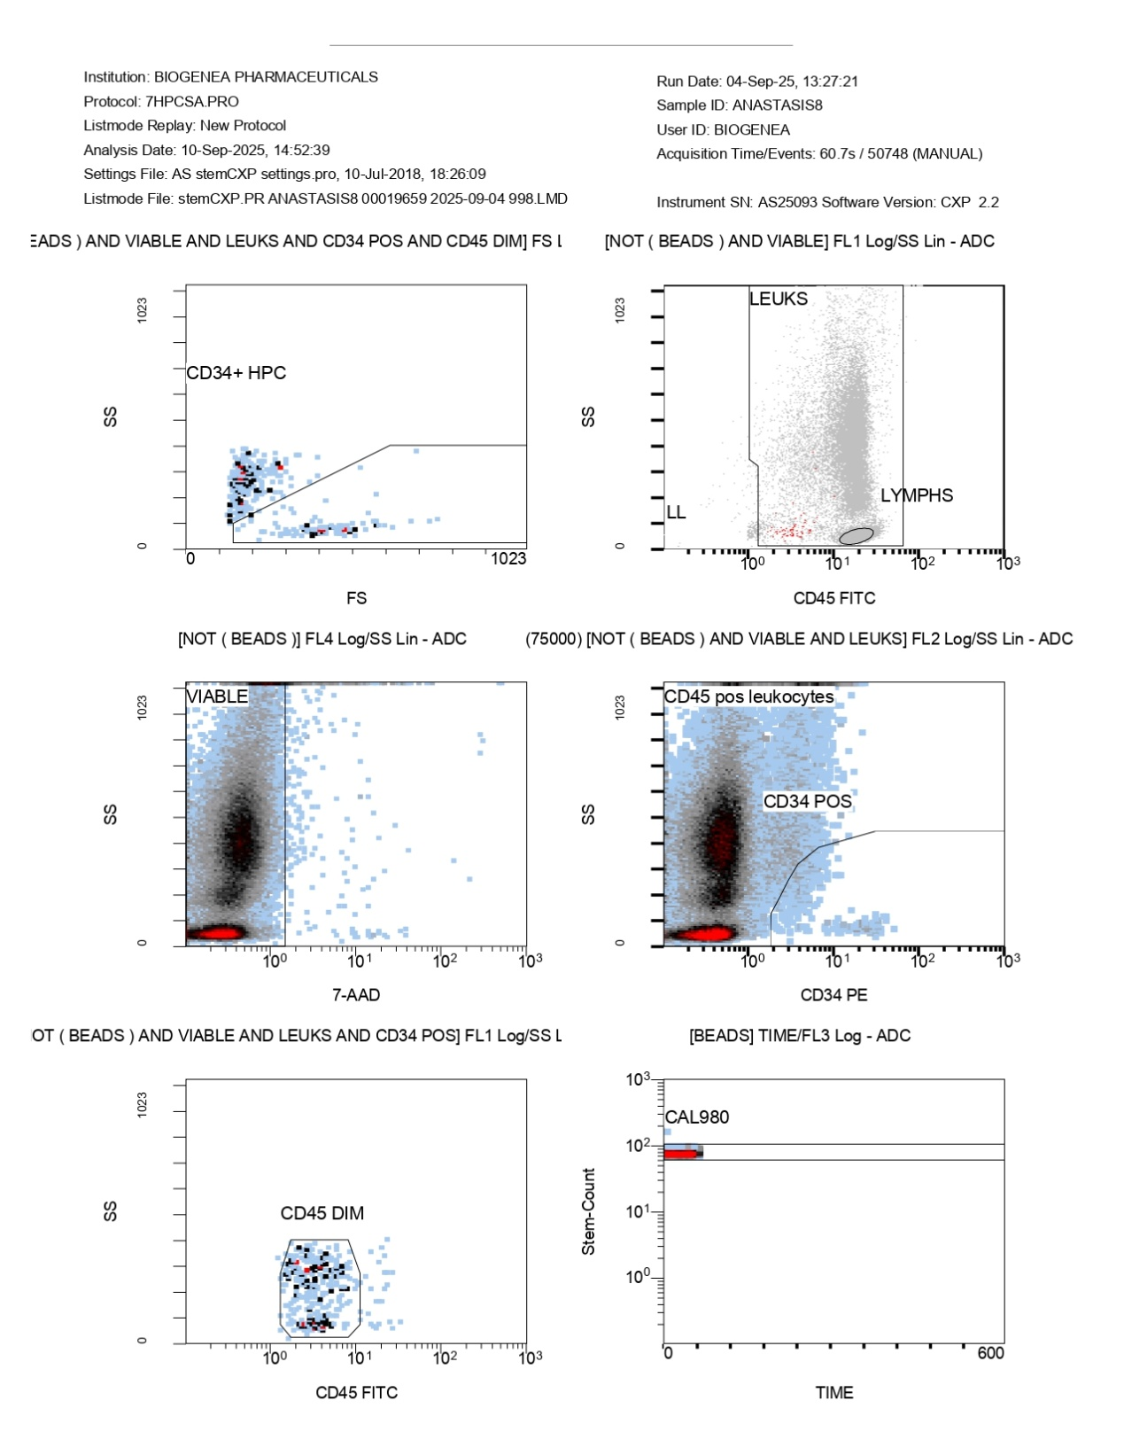
FlowCyto Scheme 36. This FlowCyto Scheme of the ANASTASIS8 flow cytometry report illustrates the detailed gating strategy used to refine leukocyte and progenitor populations, while also confirming viability and calibration. The sample was collected on September 4, 2025, and analyzed on September 10, 2025, under protocol 7HPCSA.PRO. In the top left panel, forward scatter versus side scatter is used to gate CD34-positive and CD45-dim cells, which represent hematopoietic progenitor cells (CD34+ HPC). This population appears as a small, distinct cluster, confirming their presence despite their rarity. The top right panel separates leukocytes from lymphocytes. Using CD45 expression and side scatter, leukocytes form the main body of events, while lymphocytes are visible as a compact cluster with lower scatter properties. In the middle left panel, a viability assay is displayed using 7-AAD staining. The majority of cells fall within the viable gate, confirming that nearly all of the acquired events are living cells. The middle right panel focuses on CD45-positive leukocytes and identifies CD34-positive cells within this population. Though small in number, the CD34-positive subset is distinct, consistent with the expected pattern for progenitor cells. The bottom left panel highlights CD45-dim cells, a hallmark feature of progenitors, which overlap with the CD34-positive subset identified in earlier steps. Finally, the bottom right panel presents the calibration bead population, showing the CAL980 beads detected over time. The bead cluster is stable and well-defined, confirming successful calibration and supporting the accuracy of the cell counts and gating strategy. Together, these plots depict the analytical workflow: from total leukocytes to viable subsets, to the rare CD34-positive progenitors, all validated by proper calibration and viability checks. The data confirm that the ANASTASIS8 sample is composed primarily of viable CD45-positive leukocytes, with a well-defined lymphocyte fraction and a very small but detectable population of CD34-positive hematopoietic progenitors.

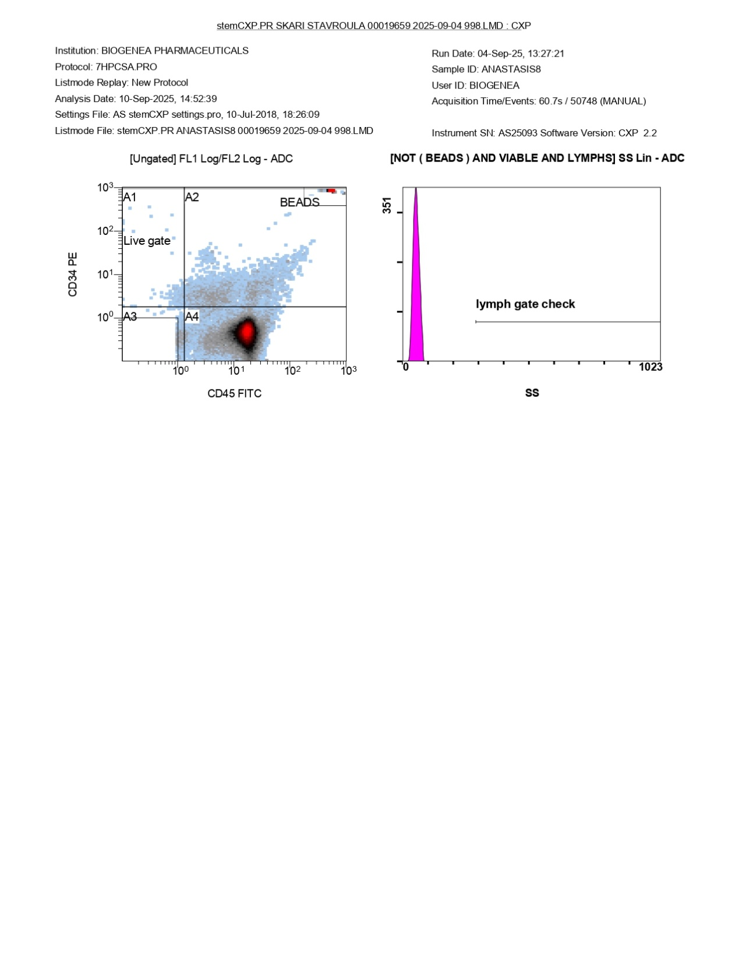
FlowCyto Scheme 37. This FlowCyto Scheme from the ANASTASIS8 flow cytometry report provides an overview of the initial gating strategy, which separates viable cells from beads and confirms the lymphocyte gate. The sample was acquired on September 4, 2025, and analyzed on September 10, 2025, under protocol 7HPCSA.PRO. On the left-hand side, a scatter plot shows the ungated population distributed by CD34 and CD45 expression. Several regions are defined: A1, A2, A3, and A4. The “Live gate” region is highlighted, marking the viable events that will move forward into subsequent analysis. Most of the events cluster within region A4, which corresponds to CD45-positive leukocytes, while a smaller fraction sits along the lower axis, where CD34-positive progenitors typically reside. The calibration beads form a distinct cluster in the upper right corner, separated from the cellular populations. On the right-hand side, a histogram labeled “lymph gate check” evaluates side scatter (SS) within the lymphocyte gate, excluding beads and focusing only on viable lymphocytes. The histogram shows a sharp peak but records zero events, confirming that the gate was applied correctly and without contamination by unrelated signals. Altogether, this FlowCyto Scheme establishes the foundation for the analysis of ANASTASIS8 by confirming the distinction between beads and cells, identifying viable populations, and verifying the accuracy of the lymphocyte gate before moving on to the deeper breakdown of leukocytes, lymphocytes, and rare progenitor fractions.

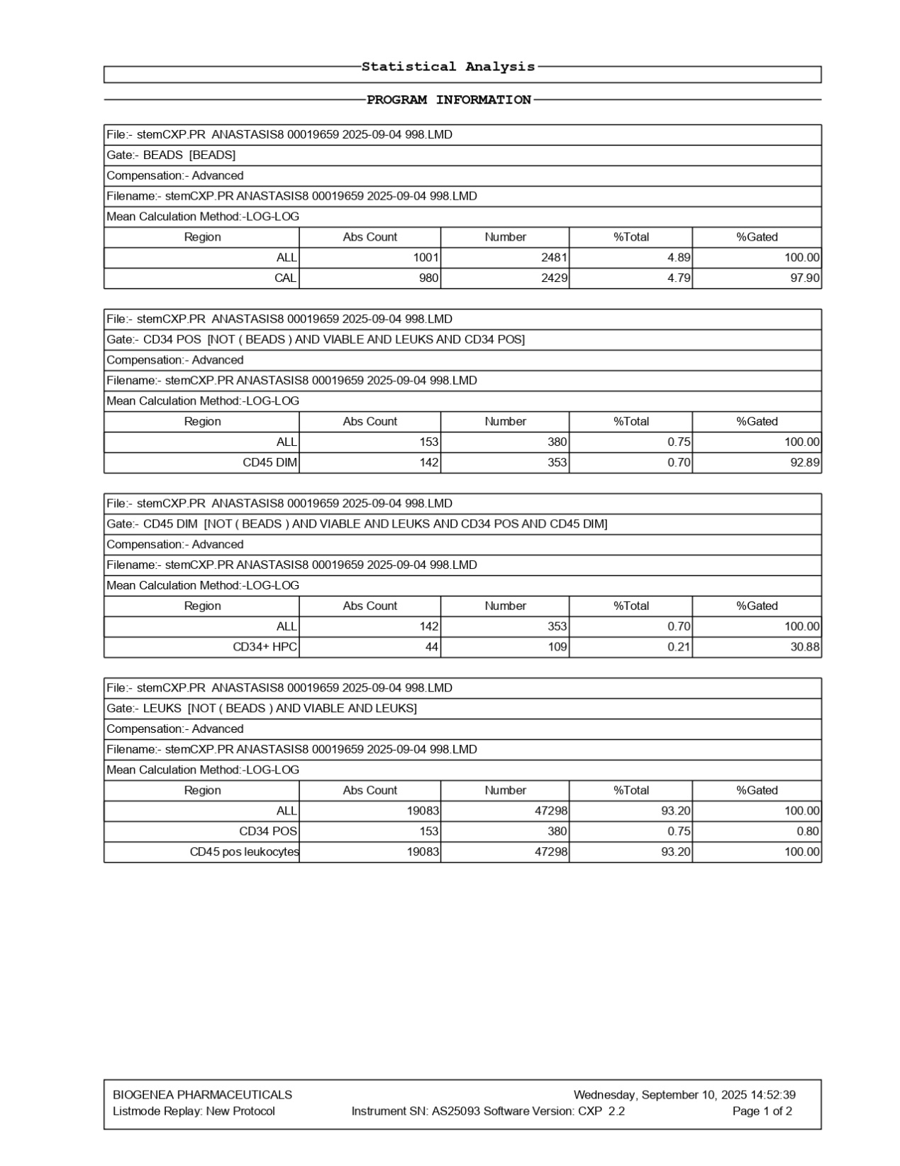
FlowCyto Scheme 38. This FlowCyto Scheme of the statistical analysis for the ANASTASIS8 sample summarizes the bead calibration, CD34-positive progenitors, and leukocyte populations. The file was acquired on September 4, 2025, and analyzed on September 10, 2025, using advanced compensation and log-log calculations. The analysis begins with the bead population, which provides an internal control for calibration. A total of 1,001 cells per microliter were recorded as beads, corresponding to 2,481 events. Within this, the CAL980 calibration peak represented 980 cells per microliter and 2,429 events, with 97.9 percent of them correctly gated, confirming accurate calibration performance. The next section identifies CD34-positive leukocytes. Out of the viable leukocytes, 153 cells per microliter were CD34-positive, corresponding to 380 events, which amounted to about 0.75 percent of the total. Within this, 142 cells per microliter expressed dim CD45, typical of progenitors, representing 0.70 percent of the total with 92.9 percent falling within the gate. Further refinement isolates CD34+ hematopoietic progenitor cells (HPCs), which numbered 44 cells per microliter and 109 events. These rare progenitors accounted for only 0.21 percent of the total population, and approximately 31 percent of the population was correctly gated, highlighting the difficulty of capturing such rare cells. The final section focuses on leukocytes. A total of 19,083 cells per microliter were leukocytes, corresponding to 47,298 events, representing 93.2 percent of the viable population. All of these were CD45-positive, as expected, and the same CD34-positive subset identified earlier (153 cells/µL) was confirmed within this population, ensuring consistency across gating levels. In summary, the ANASTASIS8 sample showed robust calibration, a predominance of CD45-positive leukocytes, and a small but clearly measurable CD34-positive progenitor fraction. Hematopoietic progenitors represented less than one percent of the population, consistent with their rarity, while the overall leukocyte pool was strong and highly viable.

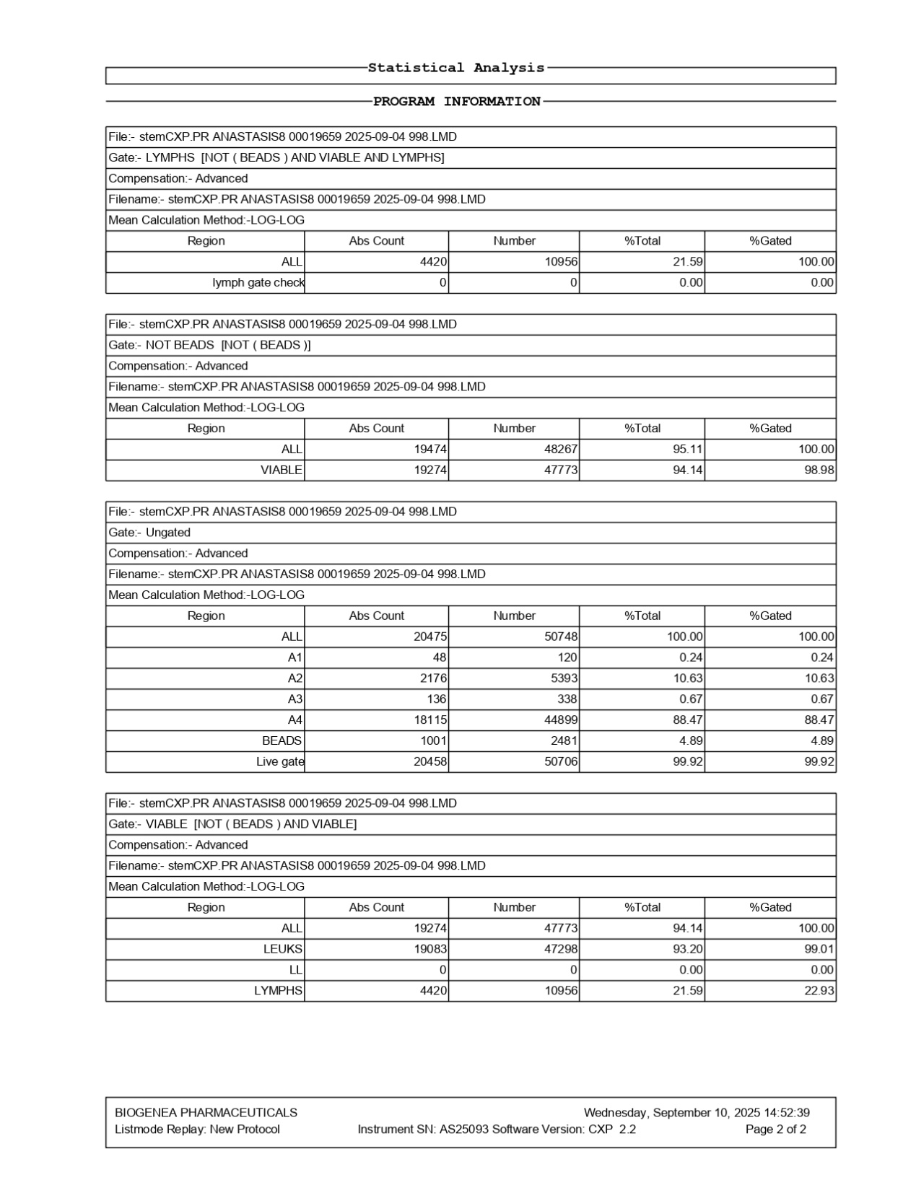
FlowCyto Scheme 39. This FlowCyto Scheme of the ANASTASIS8 report provides the statistical analysis of the flow cytometry results, summarizing the populations identified through the gating strategy. The sample was acquired on September 4, 2025, and analyzed on September 10, 2025, using advanced compensation and a log-log calculation method. The first section describes the lymphocyte gate, where beads were excluded and only viable lymphocytes were analyzed. A total of 4,420 cells per microliter were identified, corresponding to 10,956 events, which made up 21.6 percent of the viable population at this level. A lymph gate check was also performed, confirming zero extraneous events, meaning the gate was applied cleanly. The next section looks at the “Not Beads” population. After excluding calibration beads, 19,474 cells per microliter were counted, corresponding to 48,267 events, or 95.1 percent of the total. Of these, 19,274 cells per microliter were viable, representing 94.1 percent of the total events. The ungated population is then summarized. A total of 50,748 events were recorded, corresponding to 20,475 cells per microliter. Four subregions (A1–A4) were defined, with the majority of cells falling into region A4, which contained 18,115 cells per microliter, or nearly 89 percent of the sample. Calibration beads made up a small proportion, with 1,001 cells per microliter detected, corresponding to 2,481 events (4.9 percent of the total). The live gate was very strong, with 20,458 cells per microliter, representing 99.9 percent of events, confirming excellent viability. Finally, the “Viable” population is presented. At this stage, 19,274 viable cells per microliter were recorded, totaling 47,773 events. Within this group, 19,083 were leukocytes, accounting for 93.2 percent of the viable cells, while lymphocytes made up 4,420 cells per microliter, or 21.6 percent of the viable leukocyte pool. In summary, the ANASTASIS8 sample contained a high proportion of viable leukocytes, with lymphocytes forming about one-fifth of the population. Calibration beads and live-dead gating confirmed the accuracy of the acquisition and the high quality of the sample, while the overall counts highlighted a robust leukocyte presence and excellent viability.

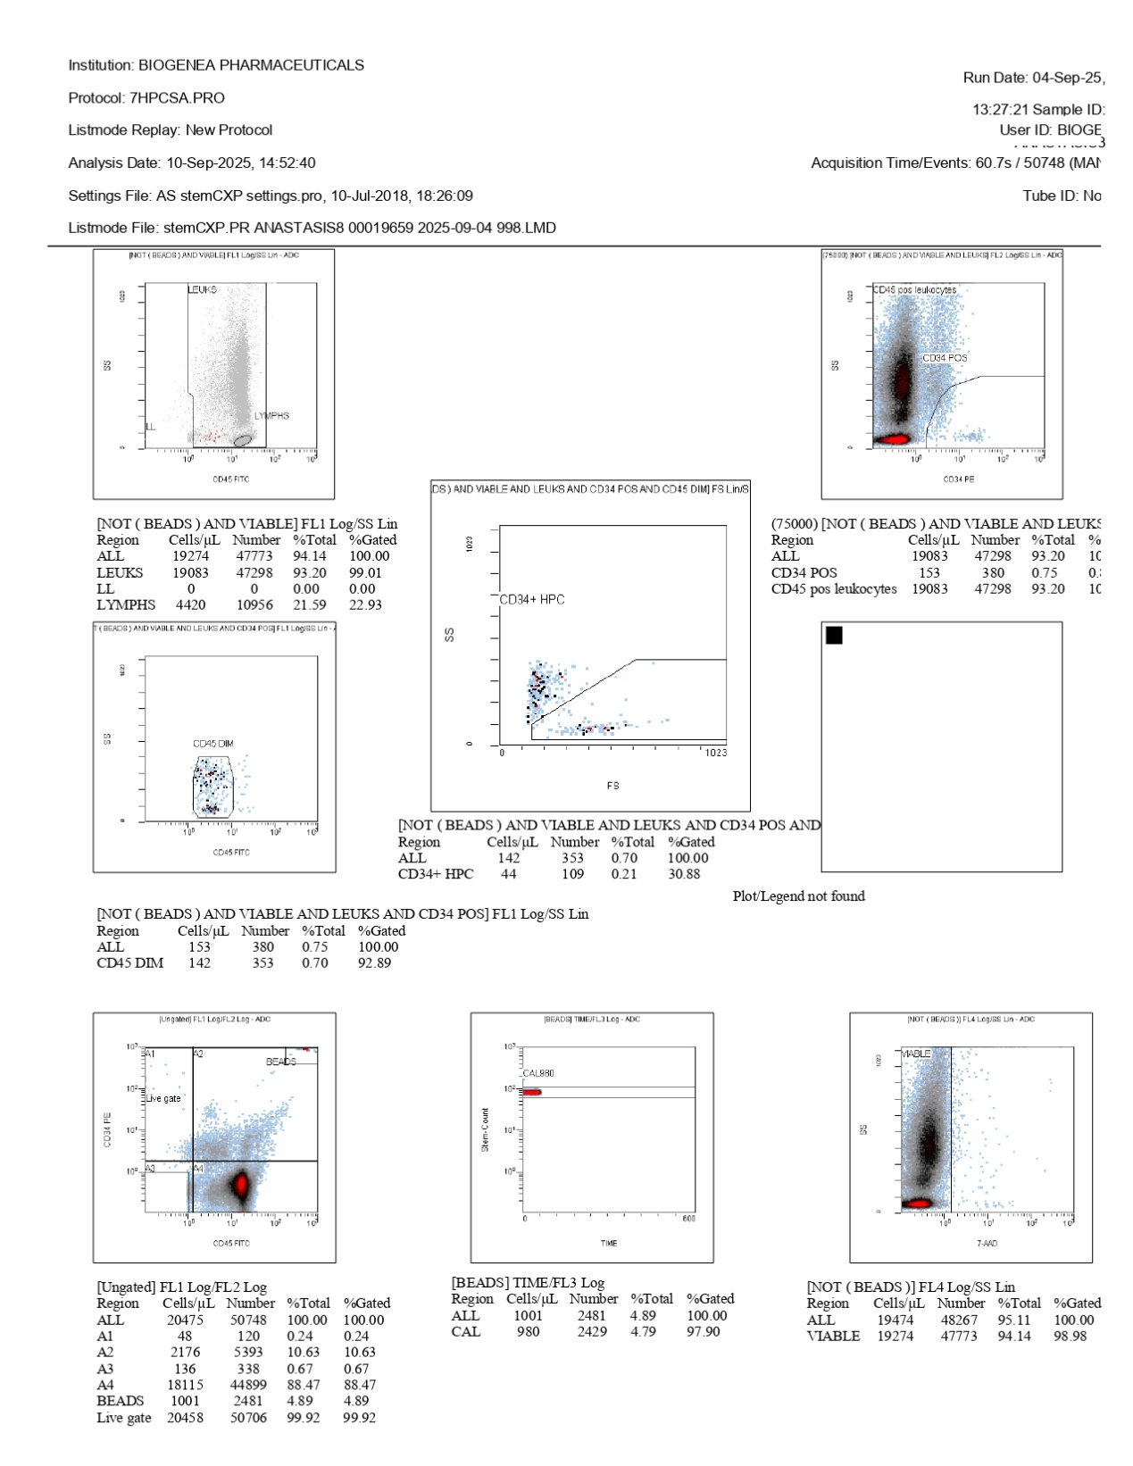
FlowCyto Scheme 40. This FlowCyto Scheme presents a flow cytometry analysis for the sample labeled ANASTASIS8, carried out under protocol 7HPCSA.PRO. The acquisition took place on September 4, 2025, with more than fifty thousand events recorded over about 60 seconds, and the analysis was completed on September 10, 2025. The plots show the gating process used to identify leukocytes, lymphocytes, and hematopoietic progenitor cells. In the top left panel, CD45 expression versus side scatter separates leukocytes from lymphocytes. Lymphocytes appear as a smaller, compact subset compared with the broader leukocyte cluster. In the top right panel, CD34-positive cells are identified within the CD45-positive leukocyte population. This distinct subset is relatively rare, consistent with progenitor cells. The central panels further refine this identification. One highlights CD45-dim cells, typical of progenitors, while another isolates CD34+ hematopoietic progenitor cells using forward and side scatter. These progenitors are shown as a small but clearly gated population, confirming their presence within the broader leukocyte pool. Numerical results support these findings. Out of all viable leukocytes, 19,043 cells per microliter were detected, making up more than 93 percent of all acquired events. Within this population, 153 cells per microliter were CD34-positive, about 0.75 percent of the total. Of these, 42 cells per microliter were classified as CD34+ hematopoietic progenitor cells, representing only 0.21 percent. Quality control checks are also included. The viability plot, using 7-AAD staining, shows that the vast majority of cells are alive, with nearly 99 percent of the events within the live gate. Calibration beads appear in a separate panel as a distinct CAL980 peak, demonstrating successful system calibration. The ungated population distribution confirms that the majority of events fell into viable gates, while beads made up only a small fraction. In summary, the ANASTASIS8 sample contained predominantly viable leukocytes with a well-defined lymphocyte subset and a very small fraction of CD34-positive hematopoietic progenitor cells. The data confirm both the rarity of progenitors and the robustness of the sample, supported by strong viability and successful calibration.

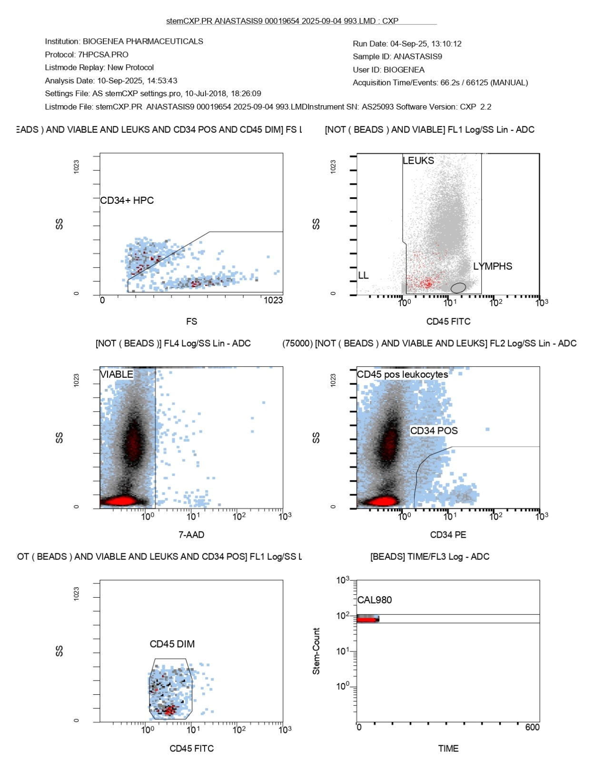
FlowCyto Scheme 41. This FlowCyto Scheme of the ANASTASIS9 flow cytometry report shows the detailed gating strategy used to isolate leukocytes, lymphocytes, and hematopoietic progenitor cells. The analysis was performed on September 10, 2025, from a sample acquired on September 4, 2025, using the 7HPCSA.PRO protocol. In the top left panel, a forward scatter versus side scatter plot isolates CD34-positive and CD45-dim events, marking the hematopoietic progenitor cell (CD34+ HPC) population. These are rare cells, located at the boundary of low CD45 expression and positive CD34 staining, consistent with progenitor characteristics. The top right panel shows a broad population of leukocytes distinguished from lymphocytes. Using CD45 expression and side scatter, leukocytes cluster across the main field, while lymphocytes are positioned as a more compact, low-scatter subset. The middle left panel is a viability plot based on 7-AAD staining. The viable cells, which exclude 7-AAD uptake, form a dense population on one side of the gate, while non-viable events are excluded. This confirms a very high proportion of living cells within the sample. The middle right panel examines CD34-positive leukocytes, displaying a distinct though small population of CD34+ events within the broader CD45-positive leukocyte group. In the lower left panel, CD45-dim cells are highlighted, representing the progenitor subset, which overlaps with the CD34-positive population identified earlier. The lower right panel shows the calibration beads (CAL980) detected during acquisition. The bead population appears as a distinct, stable peak across time, confirming that the instrument calibration worked as intended and validating the reliability of the gating. Together, these plots trace the progression from total leukocytes to viable cells, lymphocytes, CD34-positive progenitors, and CD45-dim subsets, while also confirming sample viability and instrument accuracy. The results highlight a predominantly CD45-positive leukocyte population, a defined lymphocyte subset, and a rare but measurable population of CD34-positive hematopoietic progenitor cells.

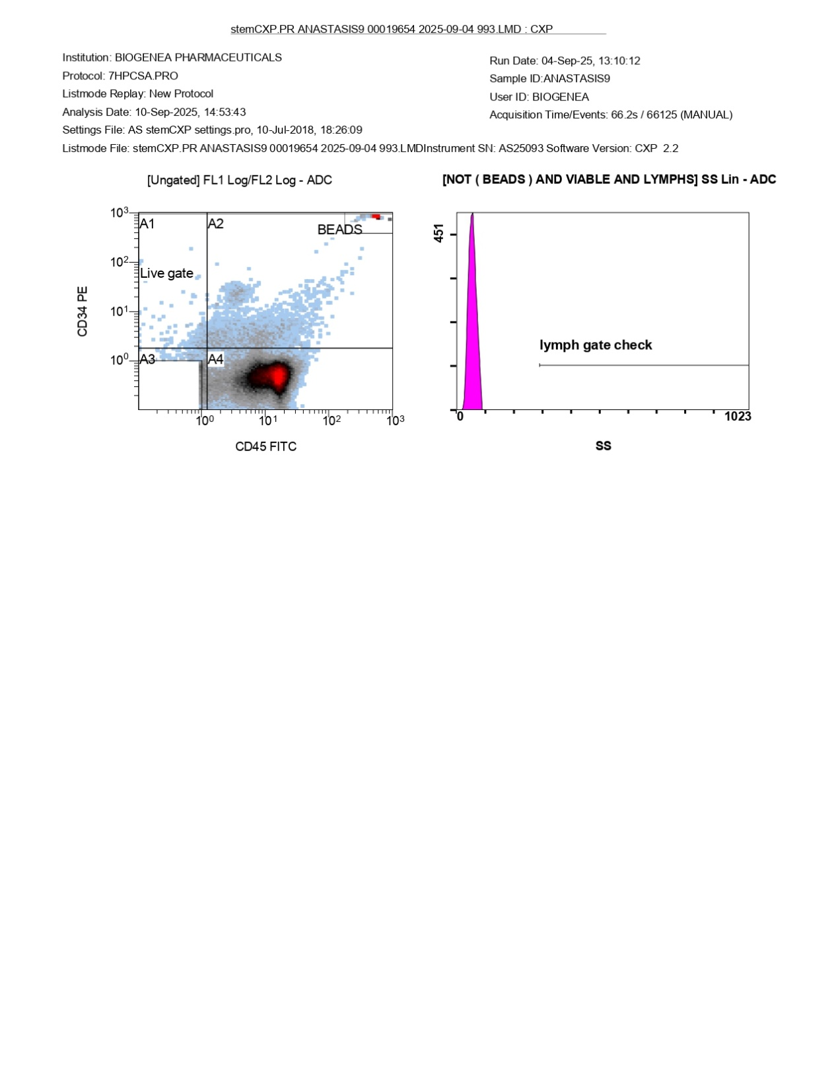
FlowCyto Scheme 42. This FlowCyto Scheme of the ANASTASIS9 report provides the initial gating overview for the sample acquired on September 4, 2025, and analyzed on September 10, 2025. On the left-hand side, a scatter plot displays the ungated population distributed by CD34 and CD45 expression. Several regions are marked (A1 through A4), with beads clearly separated in the upper right quadrant. The “Live gate” region is highlighted, containing the viable cells carried forward into subsequent analysis. The majority of events are clustered within region A4, representing CD45-positive leukocytes, while CD34-positive events are scattered at the lower edge of the CD45 axis, indicating the rare progenitor population. On the right-hand side, a histogram shows the lymph gate check, focusing on side scatter within the lymphocyte gate after beads are excluded. The histogram demonstrates a sharp, narrow peak, confirming that the lymphocyte gate was applied correctly and cleanly, without excess background signal. Altogether, this FlowCyto Scheme sets the foundation for the more detailed subset analysis that follows. It establishes the separation of beads from cells, defines the viable population, and verifies the lymphocyte gate, ensuring accuracy before narrowing down to leukocytes, lymphocytes, and rare progenitor fractions.

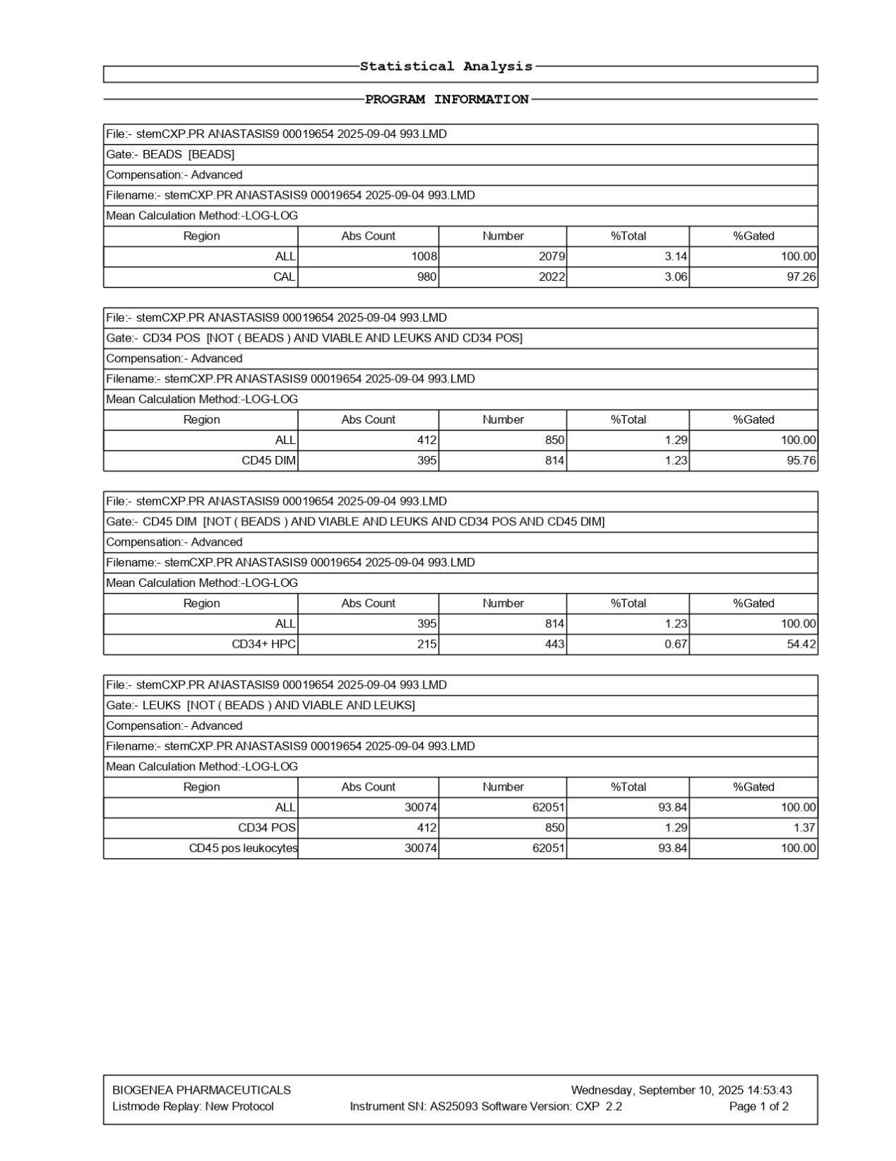
FlowCyto Scheme 43. This FlowCyto Scheme of the statistical analysis for the ANASTASIS9 sample focuses on beads, CD34-positive progenitor cells, and leukocyte subsets. The file was acquired on September 4, 2025, and processed on September 10, 2025, with advanced compensation and a log-log calculation method. The analysis begins with the bead population used for calibration. A total of 1,008 cells per microliter were recorded as beads, corresponding to 2,079 events, which made up just over 3 percent of the total. Within this, the CAL980 bead peak accounted for 980 cells per microliter and 2,022 events, with more than 97 percent gated correctly, confirming accurate instrument calibration. The next section focuses on CD34-positive leukocytes. Out of all viable leukocytes, 412 cells per microliter were CD34-positive, representing 850 events, about 1.29 percent of the total. Within this population, 395 cells per microliter displayed dim CD45 expression, consistent with progenitor characteristics. The gating strategy then refines this further to highlight CD34+ hematopoietic progenitor cells. This subset contained 215 cells per microliter, corresponding to 443 events, making up 0.67 percent of the overall population. Importantly, only about 54 percent of this population fell within the final gated region, reflecting the challenges of accurately isolating rare progenitor cells. Finally, the leukocyte population is summarized. A total of 30,074 leukocytes per microliter were measured, corresponding to 62,051 events and accounting for 93.8 percent of all viable cells. All of these leukocytes were CD45-positive, as expected. Within this pool, the same CD34-positive fraction of 412 cells per microliter was detected, confirming consistency across gating levels. In summary, this analysis demonstrates strong calibration with beads, a predominantly CD45-positive leukocyte population, and a measurable fraction of CD34-positive progenitor cells. The data highlight the rarity of hematopoietic progenitors—less than one percent of the total—while confirming high viability and robust leukocyte representation in the sample.

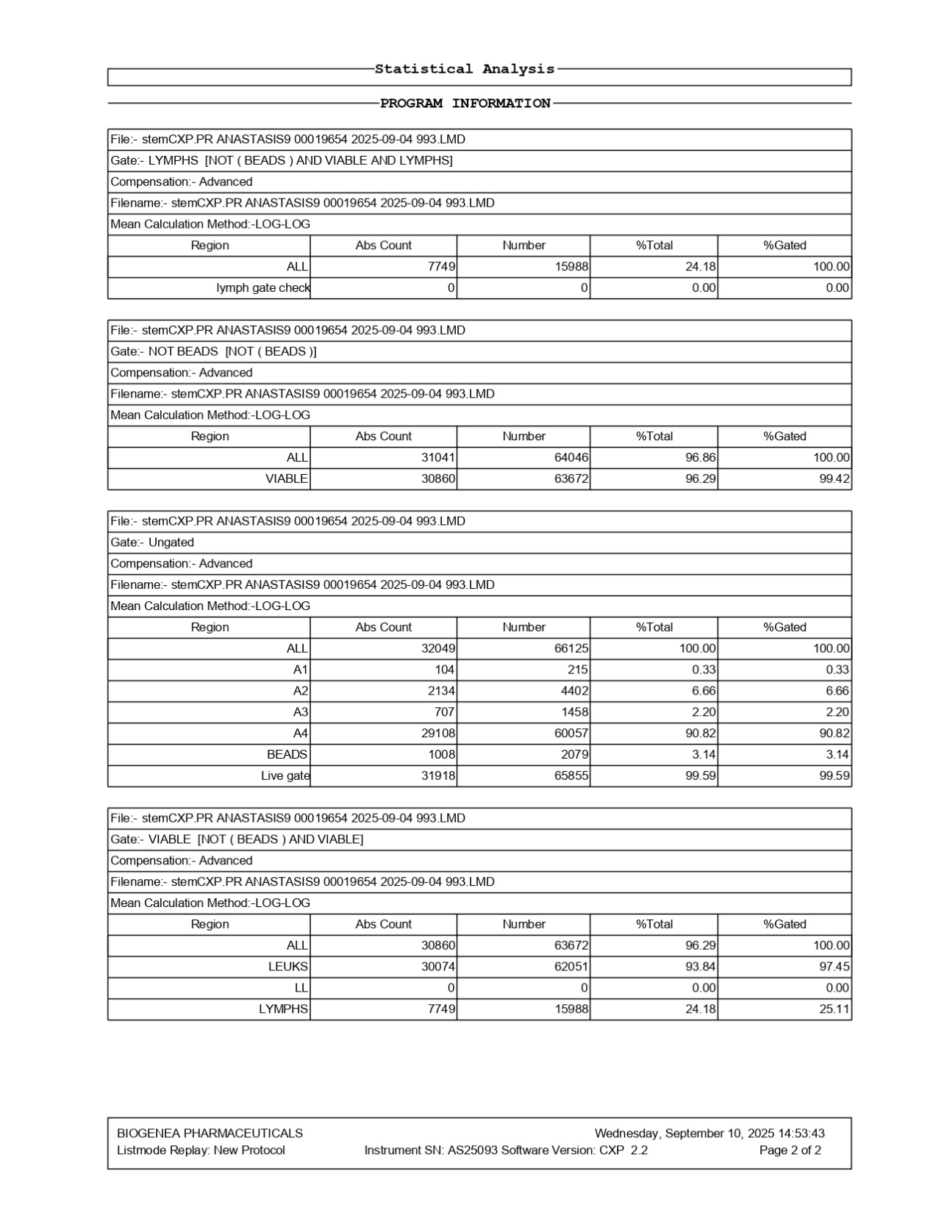
FlowCyto Scheme 44. This FlowCyto Scheme of the ANASTASIS9 report presents the statistical breakdown of the flow cytometry data, showing how different populations were quantified after sequential gating. The file analyzed was recorded on September 4, 2025, and processed on September 10, 2025, using advanced compensation and a log-log calculation method. The first section reports on the lymphocyte gate, which excludes beads and focuses only on viable lymphocytes. Here, 7,749 cells per microliter were counted, corresponding to 15,988 total events. These lymphocytes made up about 24 percent of the population at this gating level. A lymph gate check was also performed, which returned zero events, confirming that gating was clean and specific. The next section describes the “Not Beads” gate. This step excluded calibration beads, leaving 64,046 events, equal to 31,041 cells per microliter. Of these, 30,860 cells per microliter were viable, which represented just over 96 percent of the population. The ungated population is then summarized. A total of 66,125 events were recorded, corresponding to 32,049 cells per microliter. Within this population, four subregions were identified (A1 through A4), each representing a progressively larger proportion. The vast majority fell into region A4, with 29,108 cells per microliter, accounting for more than 90 percent of the population. Beads were also accounted for separately, with 1,008 cells per microliter corresponding to 2,079 events, about 3 percent of the total. The live gate was robust, containing 31,918 cells per microliter, or nearly 99.6 percent of the events, confirming excellent sample viability. Finally, the “Viable” gate summarizes the clean population of interest after all refinements. At this level, 63,672 events were counted, equal to 30,860 viable cells per microliter. Within this pool, 30,074 were leukocytes, representing more than 93 percent of viable cells. Lymphocytes accounted for 7,749 cells per microliter, about 24 percent of the viable leukocyte population. Altogether, this analysis demonstrates that the ANASTASIS9 sample was predominantly composed of viable leukocytes, with high overall viability and a healthy proportion of lymphocytes. Calibration beads and subpopulation gating confirmed both the accuracy of the acquisition and the biological distribution of the cells.

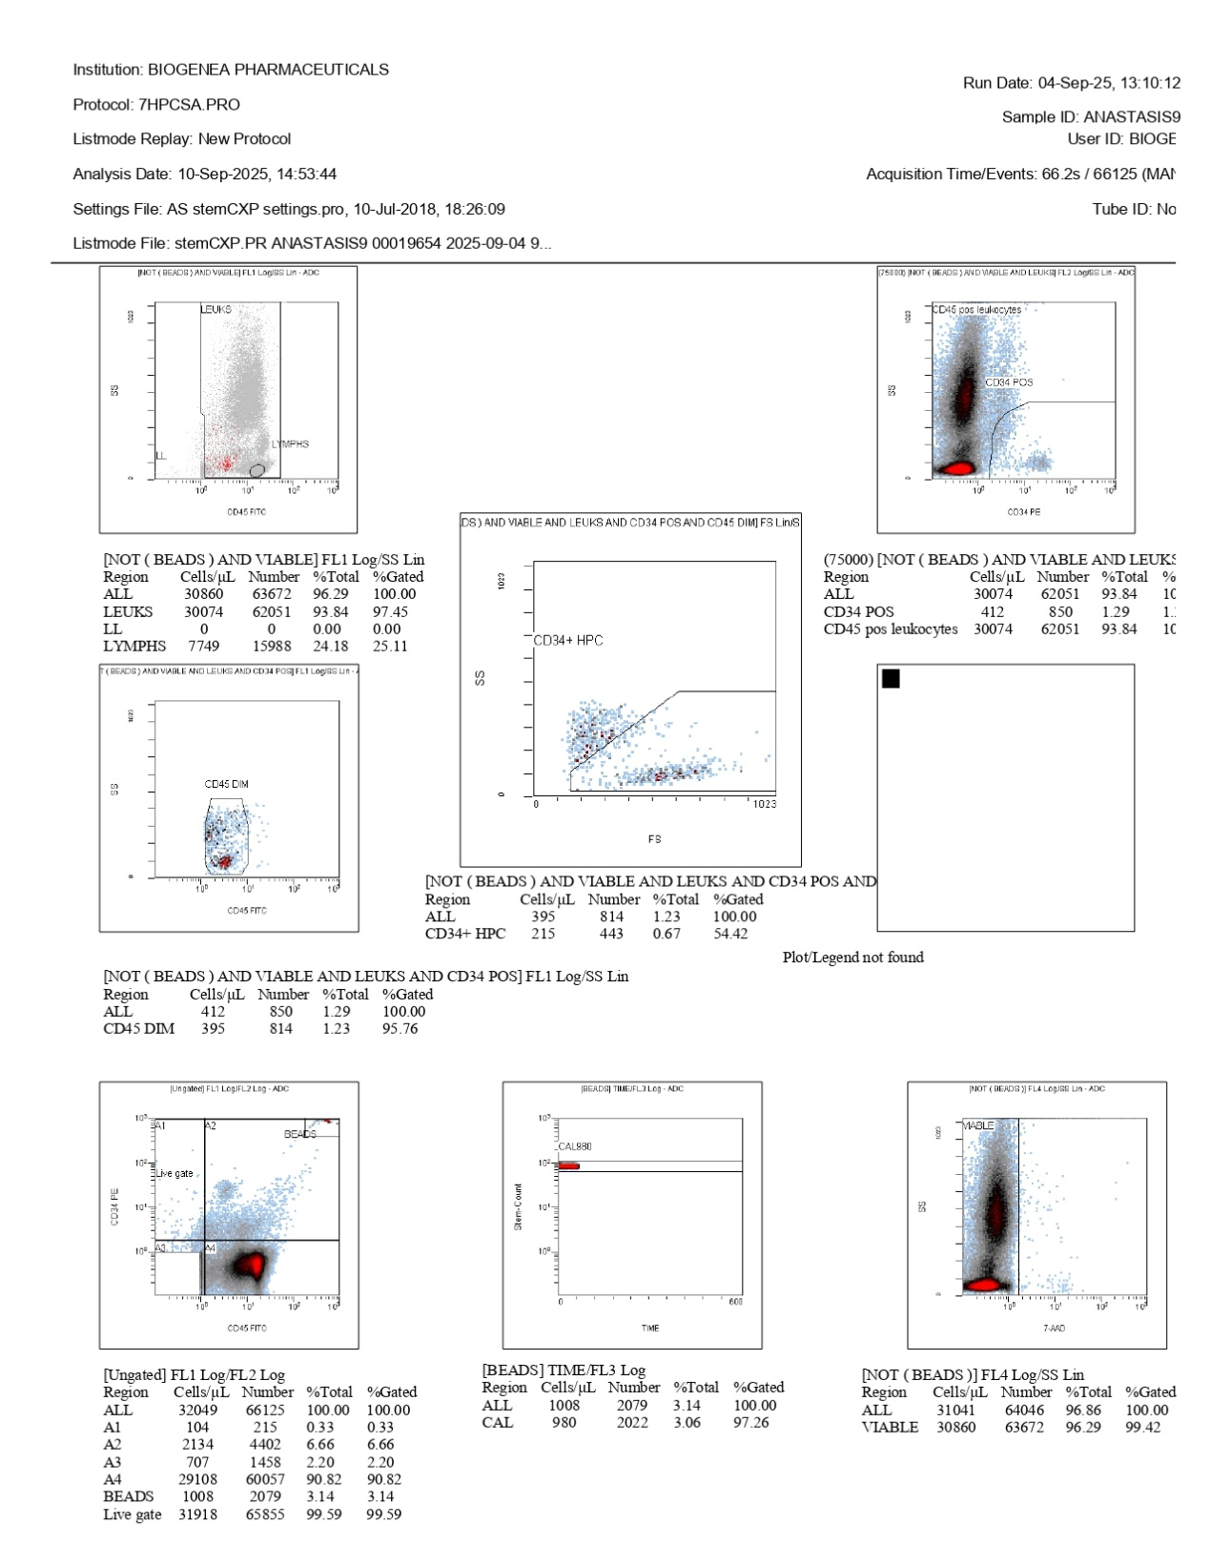
FlowCyto Scheme 45. This report FlowCyto Scheme presents a flow cytometry analysis performed for the sample labeled ANASTASIS9 under protocol 7HPCSA.PRO, acquired on September 4, 2025. More than sixty-six thousand events were recorded over approximately 66 seconds, and the analysis date is noted as September 10, 2025. The plots show the gating strategy applied to identify and quantify leukocyte subsets and hematopoietic progenitor cells. In the top left plot, leukocytes and lymphocytes are separated based on CD45 expression and side scatter. Lymphocytes form a defined cluster, while other leukocytes are spread across a broader region. The upper right plot focuses on CD34-positive cells within the CD45-positive leukocyte population. A distinct but small population of CD34-positive cells can be seen, confirming the presence of progenitor cells. In the central plots, subsets are refined further. One shows CD45-dim cells, typically associated with progenitors, while another highlights CD34+ hematopoietic progenitor cells gated on forward scatter and side scatter, confirming their low-frequency but measurable presence. The numerical data beneath these plots provide absolute counts and percentages. Out of the total viable leukocytes, 30,074 cells per microliter were measured, representing over 93 percent of all acquired events. Within this population, 412 cells per microliter were CD34-positive (1.29 percent), and 215 cells per microliter were CD34+ hematopoietic progenitors, representing about 0.67 percent of the total. Quality control plots are also included. A viability plot using 7-AAD confirms that the vast majority of cells are live, with over 99 percent viability. Calibration beads are shown in another panel, with the CAL980 bead peak gated successfully, confirming system accuracy. The ungated population plot further shows the distribution of events across different regions, with the majority falling within viable gates, while beads represent only a small fraction. In summary, this analysis demonstrates a strong predominance of viable leukocytes, a clearly defined lymphocyte subset, and a small but detectable fraction of CD34-positive hematopoietic progenitor cells. The calibration beads and viability check confirm the reliability and accuracy of the measurement, reinforcing the validity of the results.

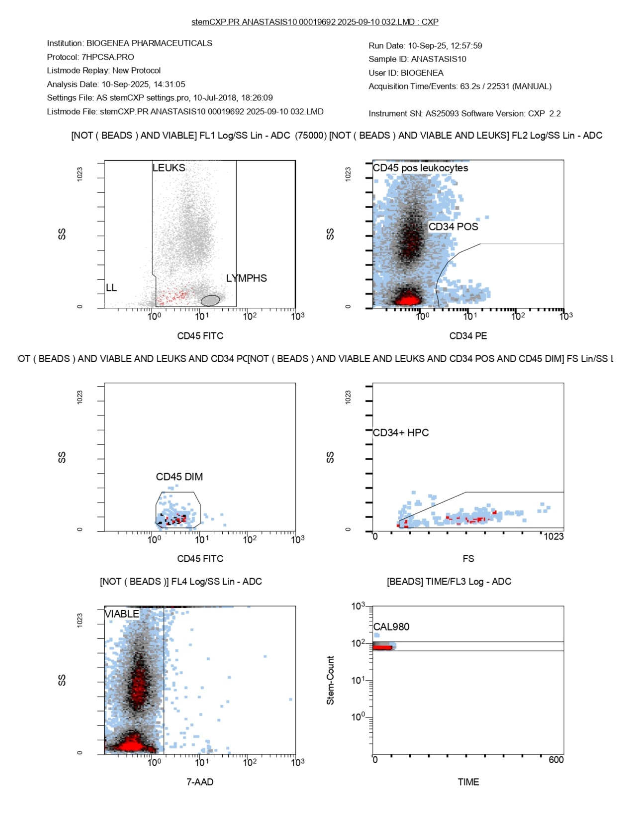
FlowCyto Scheme 46. This FlowCyto Scheme illustrates the sequential gating strategy used to analyze the sample labeled ANASTASIS10, processed on September 10, 2025, under protocol 7HPCSA.PRO. The data acquisition involved more than twenty-two thousand events over a little more than a minute. In the top left plot, leukocytes and lymphocytes are separated using CD45 expression and side scatter. Leukocytes form the main cluster, while lymphocytes are gated as a smaller, distinct population. This serves as the foundation for narrowing down the broader white blood cell population into specific subsets.
The top right plot focuses on CD45-positive leukocytes, identifying a fraction of CD34-positive cells within them. These CD34-positive events, though few, are clearly marked and represent hematopoietic progenitors. The middle row of plots further refines these subsets. On the left, CD45-dim cells are displayed, which include progenitors typically showing lower CD45 expression. On the right, the population of CD34-positive and CD45-dim cells is highlighted, defining the CD34+ hematopoietic progenitor cells (HPCs) more precisely. This subset is small but distinct, confirming the presence of progenitors within the leukocyte pool. The bottom row includes quality control gates. On the left, a viability plot using 7-AAD staining separates live cells from non-viable ones. The viable population is clearly identified, supporting the reliability of the downstream analysis. On the right, a calibration bead plot is shown, with the CAL980 population appearing as expected. This ensures that internal controls were properly detected and validates the accuracy of the measurement process. Taken together, these plots demonstrate the layered approach of flow cytometry: beginning with leukocytes, filtering for viability, identifying progenitor characteristics through CD34 and CD45 expression, and verifying the process with calibration beads. The result shows a predominantly CD45-positive leukocyte population with a small but distinct subset of CD34-positive hematopoietic progenitors.

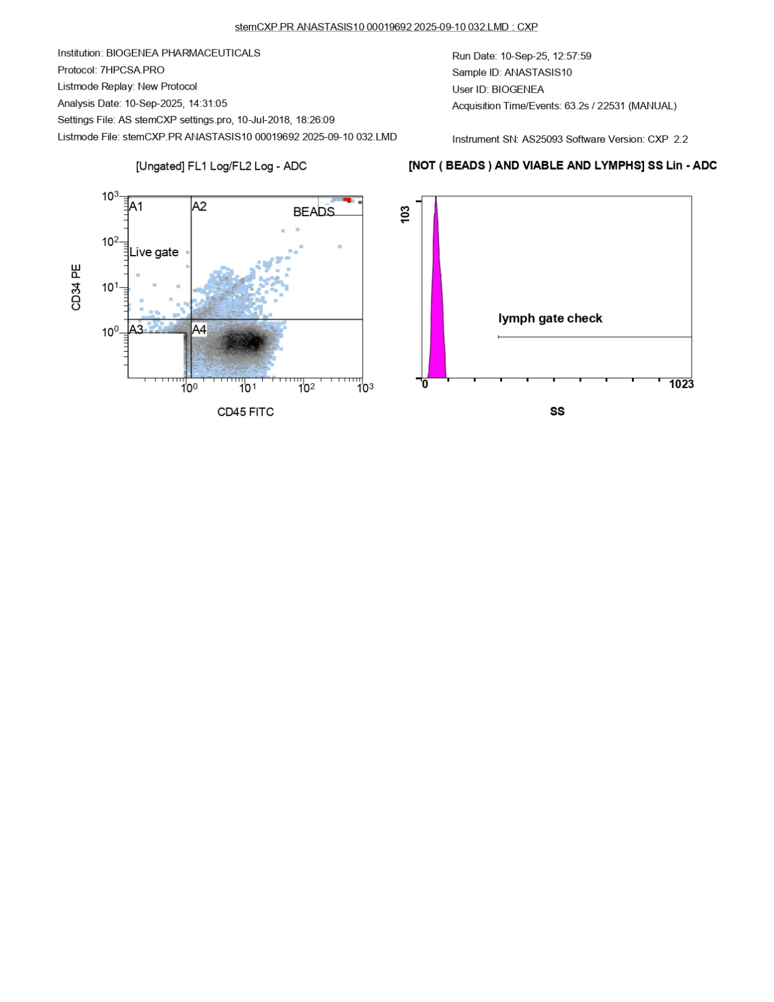
FlowCyto Scheme 47. This FlowCyto Scheme presents additional flow cytometry plots for the sample labeled ANASTASIS10, analyzed under protocol 7HPCSA.PRO on September 10, 2025. The acquisition captured over twenty-two thousand events in just over a minute of measurement. On the left-hand side, a scatter plot shows the ungated population distributed by CD34 and CD45 expression. Several regions are defined within this plot: A1, A2, A3, and A4, along with the bead population located in the upper right corner. The “Live gate” region is clearly marked, representing the viable cells that will be carried forward in subsequent analysis steps. Most of the events cluster in the A4 region, which likely corresponds to the majority of CD45-positive leukocytes, while the bead cluster is distinctly separated. On the right-hand side, a histogram labeled “lymph gate check” is displayed. This plot examines side scatter (SS) within the lymphocyte gate, excluding beads and focusing on viable lymphocytes. The histogram shows a sharp peak, but the gate check reports no measurable lymphocyte events within this particular region, confirming that the lymphocyte discrimination step has been verified. Together, these figures demonstrate the foundational gating strategy: the first step isolates viable events while distinguishing beads from cells, and the second confirms the quality of the lymphocyte gate. This ensures that only meaningful cellular populations move forward into the detailed subset analysis described in the other parts of the report.

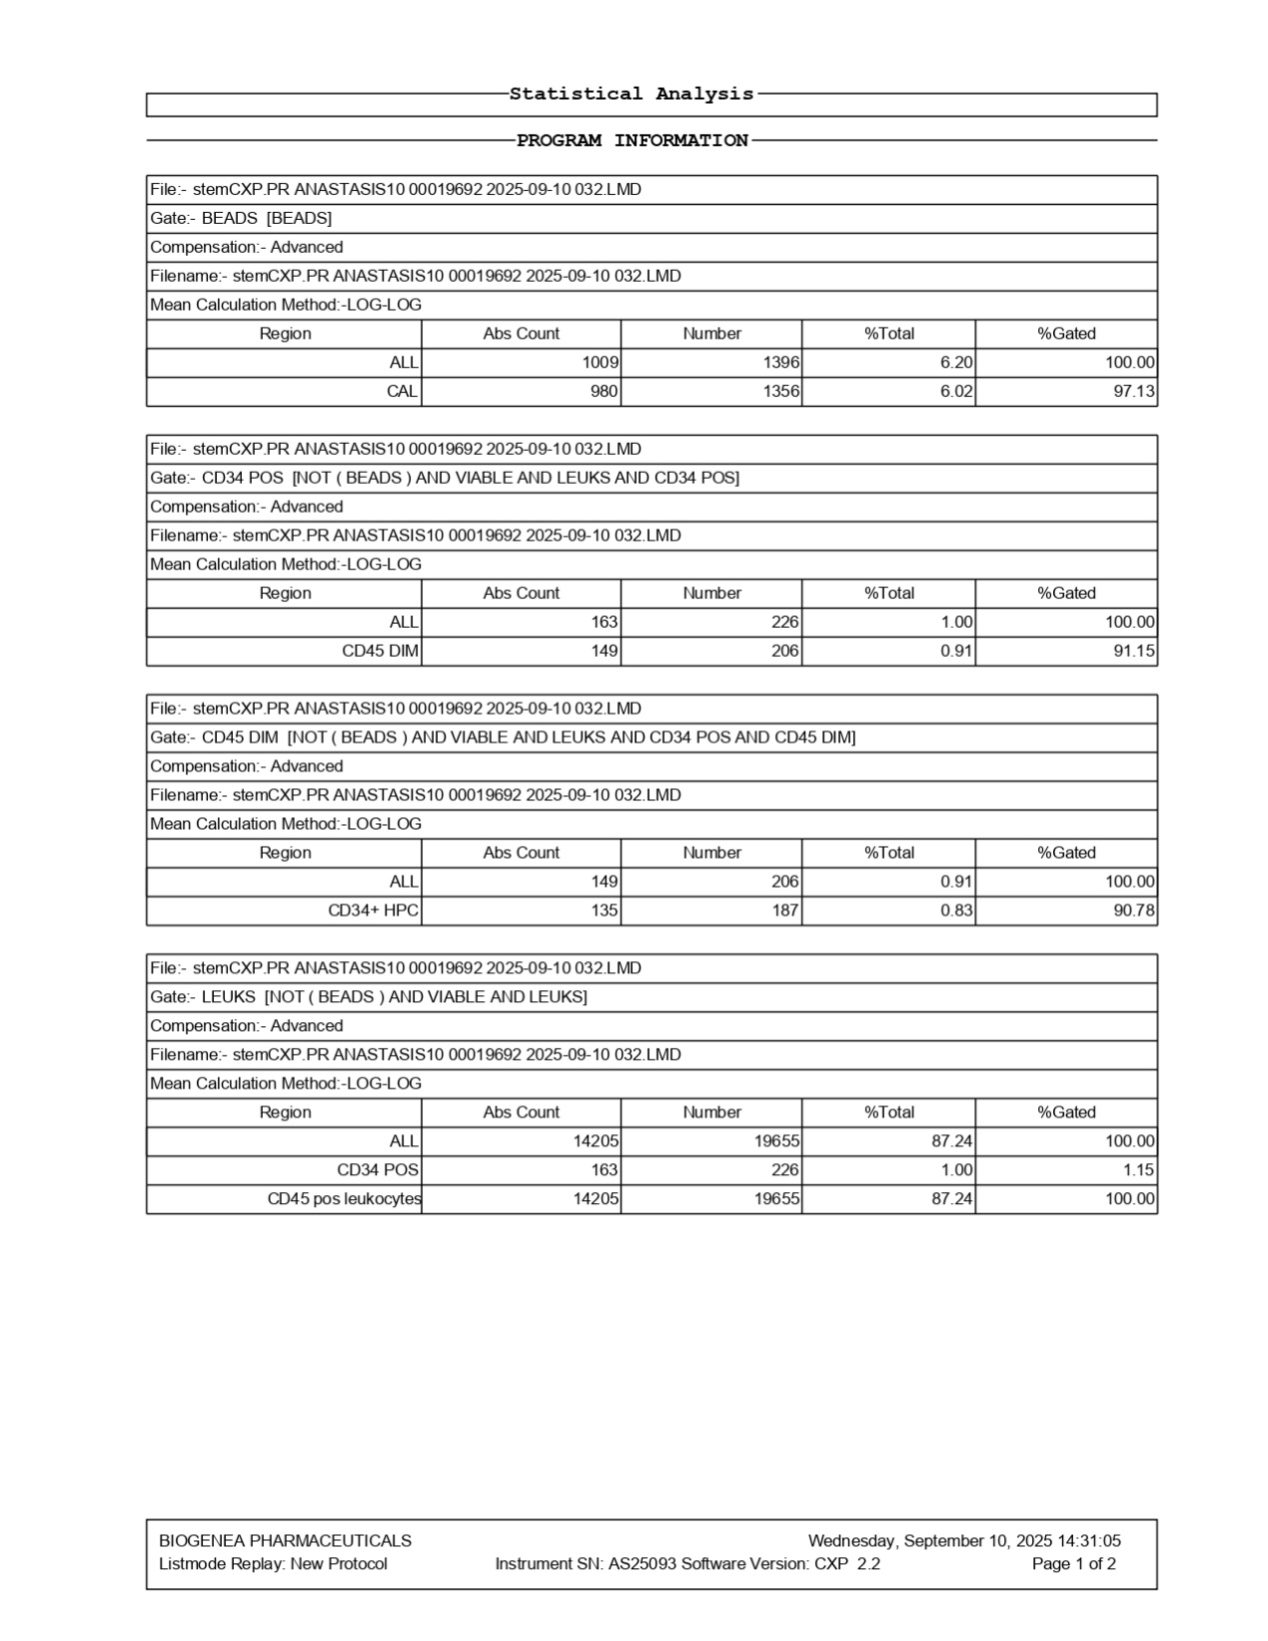
FlowCyto Scheme 48. This panel presents the first half of the statistical analysis for the sample, focusing on beads, CD34-positive populations, and leukocytes. The data comes from the same file and protocol as before and uses advanced compensation with calculations performed on a logarithmic scale. The opening section describes the bead population, which is essential for calibration. A total of 1,009 cells per microliter were identified as beads, corresponding to 1,396 events, making up just over six percent of the total events recorded. Within this bead group, the calibration subset accounted for 980 cells per microliter and 1,356 events, with 97 percent of them successfully gated for calibration purposes. The next section focuses on CD34-positive cells, excluding beads but including only viable leukocytes. Here, 163 cells per microliter were found to be CD34 positive, representing 226 events and approximately one percent of the total. A subset of these were also CD45 dim, amounting to 149 cells per microliter and 206 events, equivalent to 0.91 percent of the total, with over 91 percent falling within the gate. The report then narrows further to the CD34-positive and CD45-dim population, which corresponds to hematopoietic progenitor cells. This subset contained 135 cells per microliter, representing 187 events and about 0.83 percent of all analyzed cells. More than 90 percent of this population was correctly gated, reinforcing the precision of the measurement. Finally, the leukocyte gate summarizes the viable white blood cell population after excluding beads. A total of 14,205 cells per microliter were recorded, accounting for 19,655 events and representing 87 percent of the total cells acquired. Within this pool, the CD34-positive fraction accounted for the same 163 cells per microliter identified earlier, reinforcing the consistency across gates. All of the 14,205 viable leukocytes were CD45 positive, as expected for white blood cells. Together, this FlowCyto Scheme shows the reliability of the bead calibration, the accurate quantification of leukocytes, and the precise identification of rare CD34-positive hematopoietic progenitors within the broader white blood cell population.

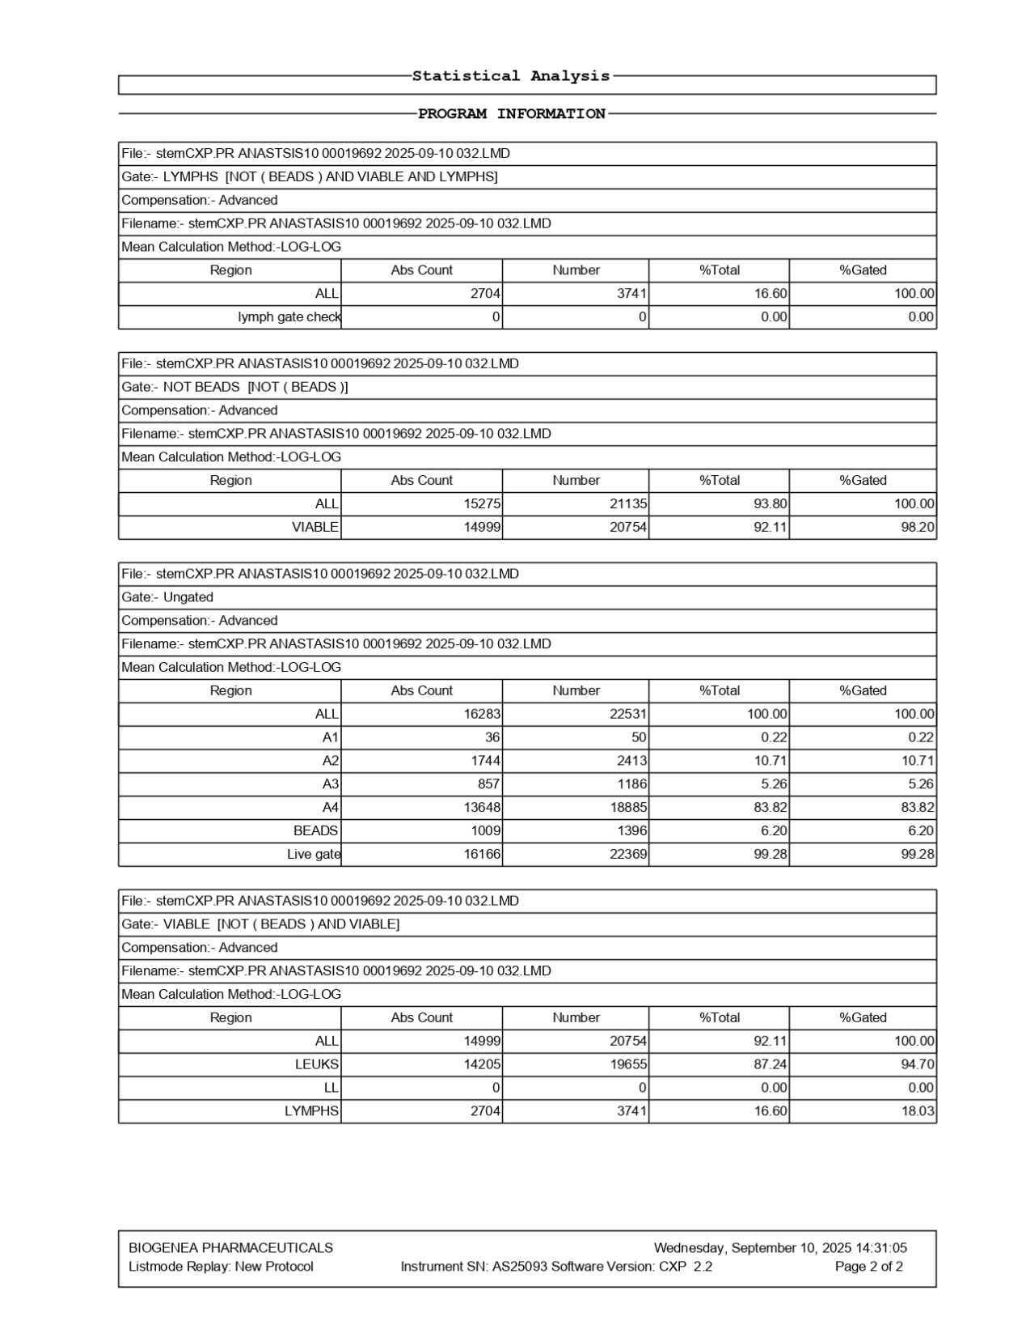
FlowCyto Scheme 49. This panel presents the statistical analysis and program information corresponding to the flow cytometry data. It summarizes the results of the different gating strategies applied to the sample identified as ANASTASIS10, using the file stemCXP.PR ANASTASIS10 00019692 2025-09-10 032.LMD. Each section describes a specific gate, the type of compensation used, and the calculation method, followed by the numerical output for absolute counts, total event numbers, percentages, and gated proportions. The first section refers to the lymphocyte gate, which excludes beads and focuses on viable lymphocytes. Here, 2,704 cells per microliter were identified, corresponding to 3,741 total events, making up 16.6 percent of all cells in that analysis window. A lymph gate check was also reported, though it shows no additional events, confirming zero percent contribution.
The second section describes the “Not Beads” gate, which ensures that calibration beads are excluded. In this category, the total count of cells was 21,135 events, with an absolute concentration of 15,275 cells per microliter. Among these, 14,999 cells per microliter were viable, representing just over 92 percent of the total population analyzed, and 98.2 percent when gated specifically for viability. The third section provides an overview of the ungated population, where all events are considered. A total of 22,531 events were recorded, corresponding to 16,283 cells per microliter. This ungated pool is further divided into subregions labeled A1 through A4, representing progressively larger proportions of the population, as well as a bead fraction. Most of the events fell into region A4, with 13,648 cells per microliter, while the live gate contained 16,166 cells per microliter, covering over 99 percent of the acquired events. The final section narrows down the viable population, excluding beads once again. Within this group, 20,754 total events were recorded, corresponding to 14,999 viable cells per microliter. Of these, 14,205 were leukocytes, accounting for about 87 percent of the viable cells. Lymphocytes were measured at 2,704 cells per microliter, representing 16.6 percent of the viable pool and just over 18 percent of the gated subset. Altogether, the data confirm that the vast majority of acquired events are viable leukocytes, with lymphocytes representing a notable minority. Calibration beads were correctly excluded, and the gating process successfully refined the sample into meaningful biological subsets, providing both absolute and relative quantifications.

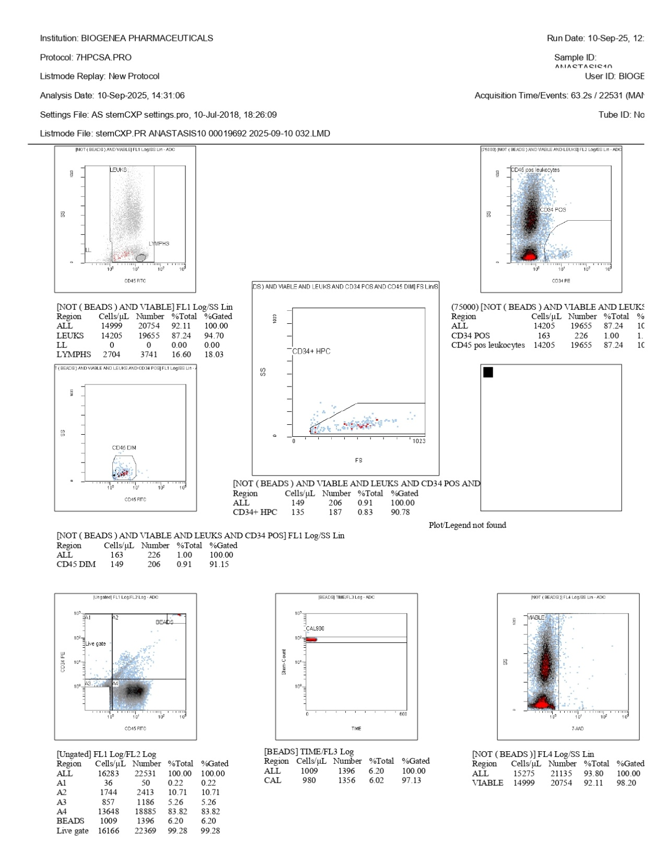
FlowCyto Scheme 50. This FlowCyto Scheme is a flow cytometry analysis report from Biogenea Pharmaceuticals, performed under the protocol 7HPCSA.PRO. The analysis was carried out on September 10, 2025, with acquisition covering 22,531 events and around 63 seconds of collection time. The patient or sample identifier is listed as ANASTAS10, and the data was processed using a protocol file created in July 2018. The report includes a series of scatter plots and gating strategies used to identify different cell populations. These plots show the separation of leukocytes, lymphocytes, and beads, as well as subpopulations defined by CD34 and CD45 markers. Each plot corresponds to a specific gating step, refining the selection from all acquired events down to viable leukocytes and specific subsets of interest. The first set of plots distinguishes leukocytes from lymphocytes, with lymphocytes appearing as a distinct population. Another set highlights CD34-positive and CD45-dim cells, which are typically associated with hematopoietic progenitor cells. A gating region is drawn around CD34+ HPCs to identify and quantify them. Several numeric tables accompany these plots, listing the absolute cell counts per microliter, total numbers, and percentages relative to gated populations. For instance, within viable leukocytes, CD34-positive cells represent a small fraction, with 163 cells per microliter identified. The data also captures CD34+ hematopoietic progenitor cells at slightly lower counts, and confirms that the majority of events belong to CD45-positive leukocytes. Other sections account for beads used for calibration, as well as live-dead discrimination, showing a high proportion of viable cells. Overall, the report narrates a detailed stepwise gating strategy, beginning with all acquired events, excluding beads and dead cells, isolating leukocytes, and finally quantifying stem or progenitor cells based on CD34 and CD45 expression. The majority of the cells analyzed are viable leukocytes, with a small but measurable fraction identified as CD34-positive progenitors.

